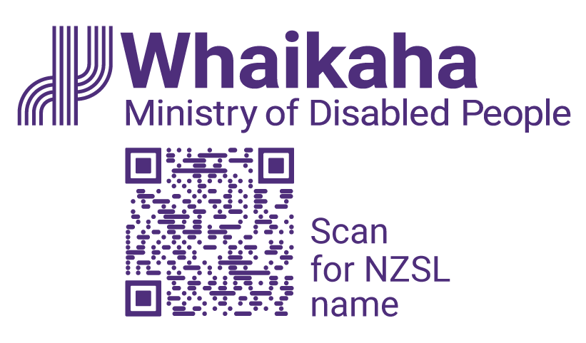
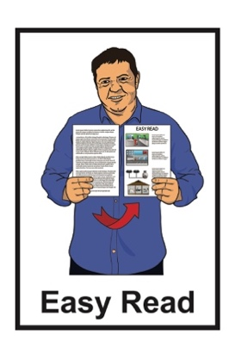

Summary of IDEA Services Review

Published: January 2024

What you will find in this document

Page number:

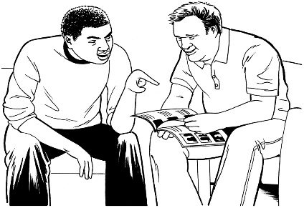
Before you start 3

What this document is about 5

How the Review started 10

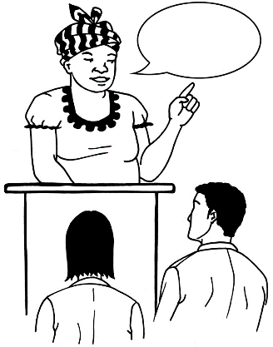
What we said when the report of the review came out 14

What the Review needed to
find out 18

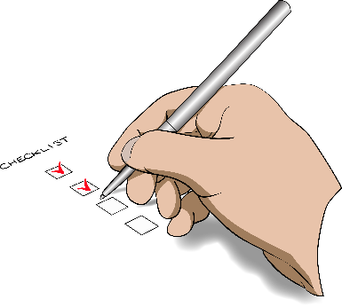
What are the
recommendations? 23

What happens next? 39

Where to find more information 41

Before you start

The information in this document may upset some people when they are reading it.

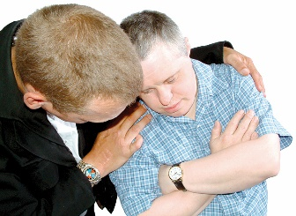
This information is not meant to scare anyone.

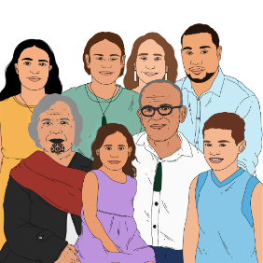
If you are upset after reading this document you can talk to your:
whānau / family
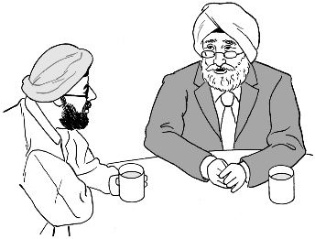
friends.

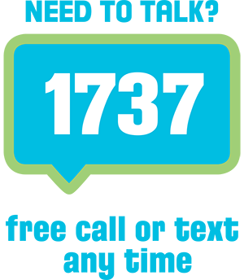
You can also contact Need to Talk by:
calling 1737
texting 1737

It does not cost any money to call / text 1737.

What this document is about

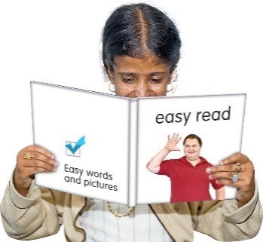
This Easy Read document is a summary of the Final Report: Review for Whaikaha of policies processes and practices for managing complaints about IDEA Services Ltd.

A summary is:
- shorter than the main report
- tells you the main ideas.

A policy is a set of rules that supports the decisions being made by:
- the Government
- an organisation.
In this document the Final Report: Review for Whaikaha of policies processes and practices for managing complaints about IDEA Services Limited will be called the Review.

The summary of the Review was written by Whaikaha – Ministry of Disabled People.

In this document we means Whaikaha – Ministry of Disabled People.

IDEA Services is the part of IHC that supports adults with intellectual disabilities to:
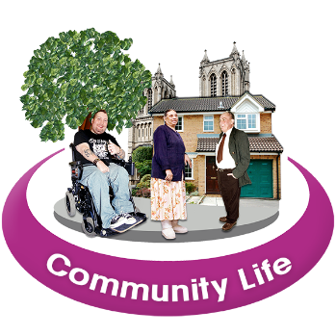
- live independently
- be part of their community.

Live independently means:
- living where you choose
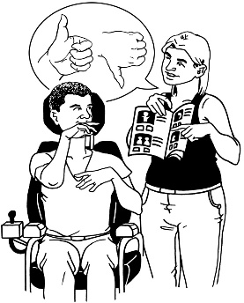
- doing things for yourself
- making your own decisions.

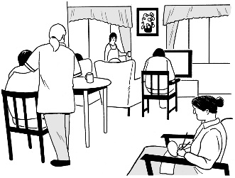
IDEA Services also supports people to live in residential care with support workers.

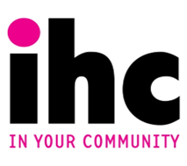
IHC is an organisation that works for people with intellectual disabilities.

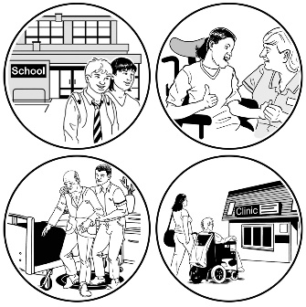
IHC supports people with intellectual disabilities in lots of different ways.

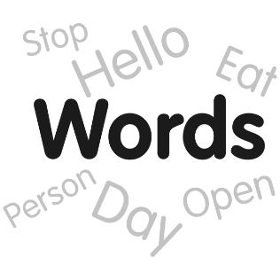
We know some people prefer the words learning disability.

We have used intellectual disabilities in this document because those are the words used in the Review.

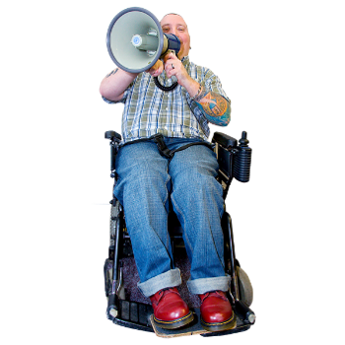
IHC also speaks up for people with intellectual disabilities to:
- live good lives
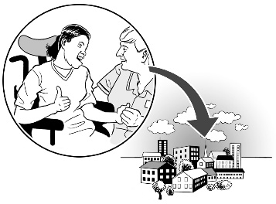
- be part of the community
- have rights.

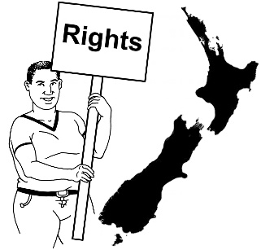
Rights are things the law says everyone should:
- have
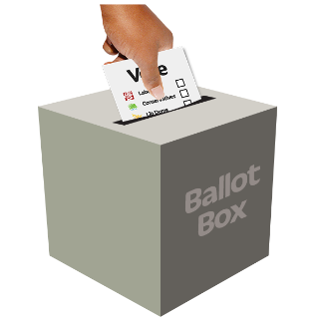
- be able to do like:
- vote
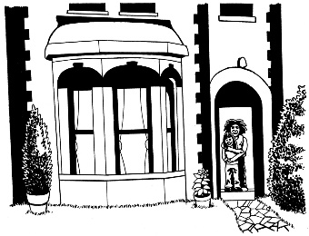
- have a job
- live somewhere safe.

How the Review started

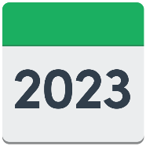
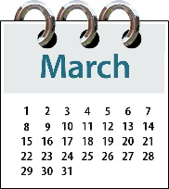
In March 2023 we asked for a review of how things were done when complaints were made about IDEA Services.

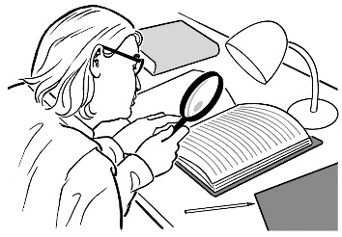
A review means to:
- look at something carefully
and
- write a report about it.

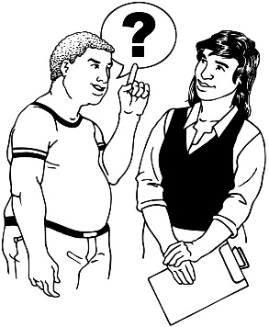
We asked for a review when we found out about the quality of service provided by IDEA Services.

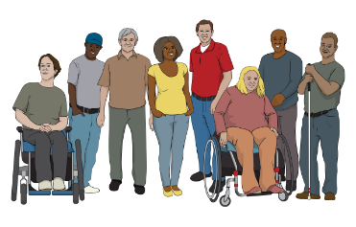
This included how IDEA Services worked with:
- the people they support
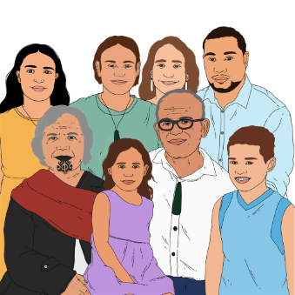
and
- their whānau / families.

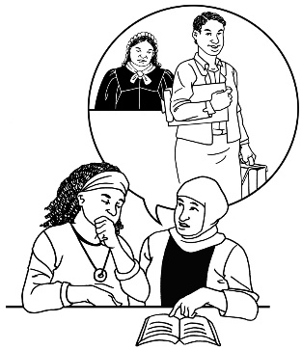
We asked Rachael
Schmidt-McCleave to do the Review.

Rachael Schmidt-McCleave is an independent barrister which is a kind of lawyer.

We did not ask Rachael
Schmidt-McCleave to tell us what they thought about any of the complaints made by people.

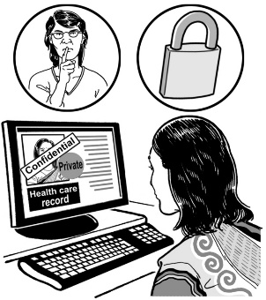
This is because the complaints are private.

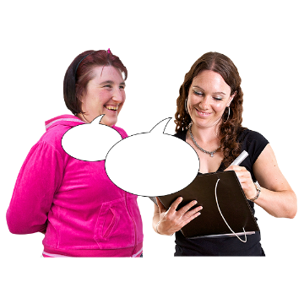
Doing the Review included:
- talking to whānau / families of disabled people
- talking to carers
- reading information from:
- IDEA Services
- Whaikaha
- talking to other people like:
- the Health and Disability Commissioner
- the Royal Commission of Inquiry into Abuse in Care.

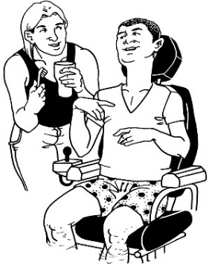
Carers are people who are taking care of disabled people.

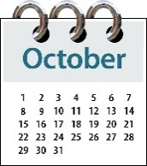
We got the full report of the Review in October 2023.

What we said when the report of the Review came out

We let everyone see the report of the Review at the end of October 2023.

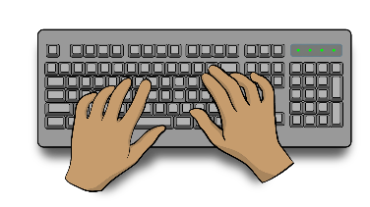
We put out a statement with the report.

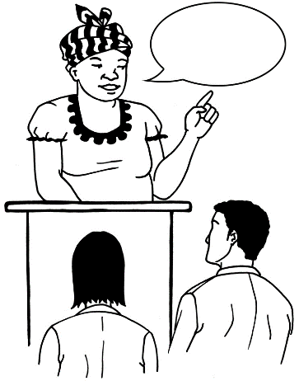
A statement is:
- putting into words what someone thinks about something
- sharing those words with others.

The statement was made by Amanda Bleckmann.

Amanda Bleckmann is the Deputy Chief Executive for Commissioning Design and Delivery at Whaikaha.

This means she is part of the team in charge at Whaikaha.

Amanda Bleckmann had these things to say about the report:

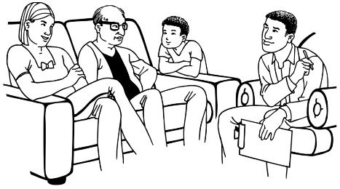
Whaikaha welcomes the report into the processes and practices for managing complaints about the delivery of disability support services by IDEA Services.

Amanda Bleckmann also said:

The process has been thorough, and I particularly want to acknowledge the whānau who have contributed to the review by sharing their stories.
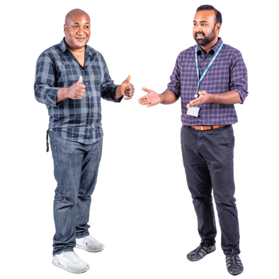
Acknowledge means that you say you have seen someone doing something.

Amanda Bleckmann also said:

We would like to acknowledge the cooperation of IHC and IDEA Services, and the other agencies who have participated in this process.

Cooperation means doing something when you are asked to.

Participated means taking part in something.

Amanda Bleckmann also said:
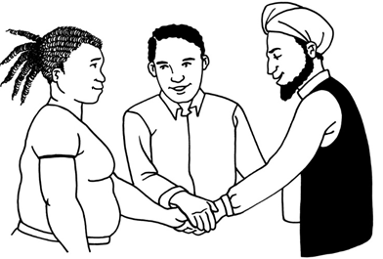
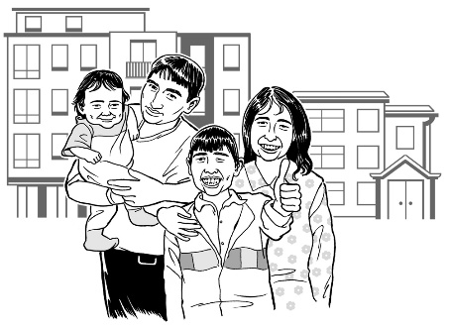
We commit to continuing to work collaboratively with IDEA Services, our other service providers and the disabled community to rebuild trust.

We all want to see improved experiences of disabled people and their family supported through IDEA and other Whaikaha funded providers, as a result of this review.

Collaboratively means people working together to get something done.

What the Review needed to find out

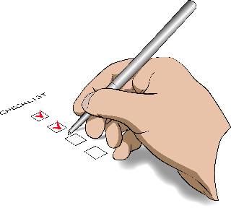
There were 4 main things we wanted the Review to find out.

1
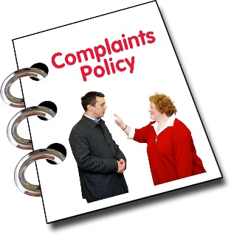
We wanted to know what Whaikaha should do when responding to complaints about IDEA Services.

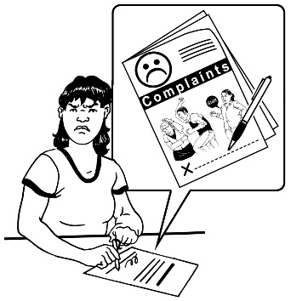
A complaint is telling someone:
- there is a problem
- something is wrong.

We wanted to know how Whaikaha should deal with complaints along with:
IDEA Services
other agencies like the Health and Disability Commissioner.

2

We wanted to know when we should do something about a complaint
made about:
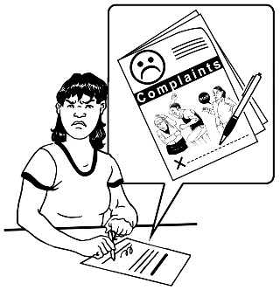
IDEA Services
other service providers.

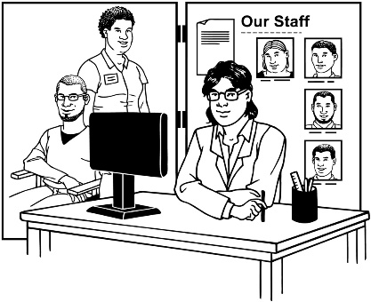
Here a service provider is an organisation that is funded by Whaikaha to support disabled people.

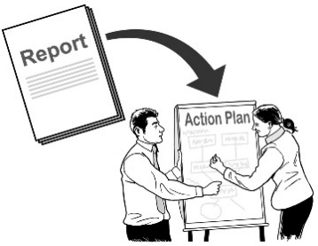
We wanted to know what would be good things to do about the complaint.

3

We wanted to know how well IDEA Services handled their complaints.

We wanted to know if IDEA Services handled their complaints using the rules of the Outcome Agreement we have with them.

The Outcome Agreement is a list of:
- things that need to be done by a service provider
- ways to show the service provider did their job correctly.

4

We wanted to know how well Whaikaha did when dealing with complaints about IDEA Services.

We also wanted to know what we should do to make sure the complaints are handled properly.

What are the recommendations?

The Review made 13 recommendations for:
- Whaikaha
- IDEA Services
- other service providers Whaikaha uses.

A recommendation is an idea that is good to do.

These recommendations are about how complaints should be handled.

We have accepted all the 13 recommendations for Whaikaha.

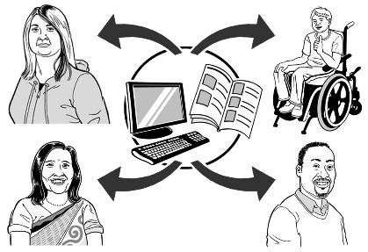
1

We will share our rules for managing complaints with service providers.

This is so everyone knows what to do when a complaint happens.

2
The tool used to talk to providers used by some Whaikaha portfolio managers must be used by all portfolio managers.

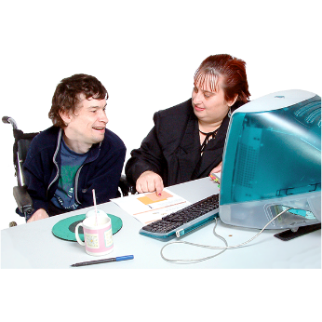
Here a tool could mean:
- computer software
- a spreadsheet
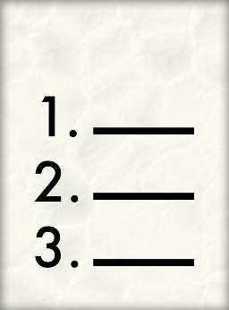
- important lists of:
- names
- phone numbers
- email addresses
- information about people.

A portfolio manager is someone who is the head of 1 part of an organisation.

3

The Contract Management Plan should be made into a document everyone can read including:
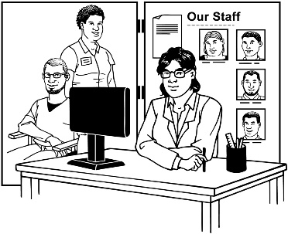
service providers
disabled people
whānau / families.

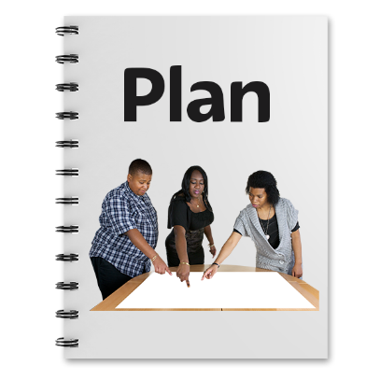
The Contract Management Plan is a document that shows:
- how an organisation is doing something
- how they get on with the people they are working with.
This is so everyone knows what will happen when dealing with Whaikaha.

4
We need to set out our quality framework in writing.

Quality framework is the rules used to make sure people get the best service possible.

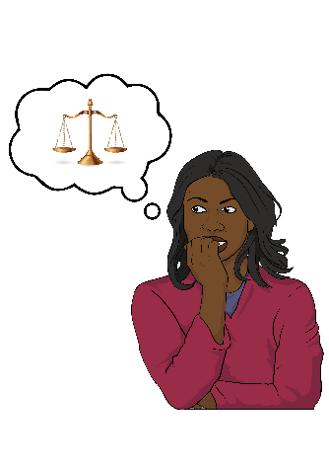
This will include:
- how natural justice will be used
- using the steps set out in the Outcome Agreement
- working together with service providers.

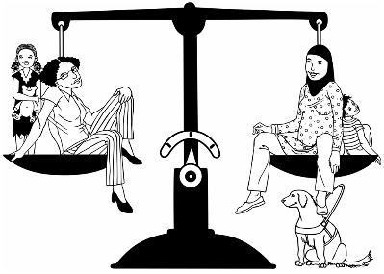
Natural justice is the legal idea which means you get treated fairly.

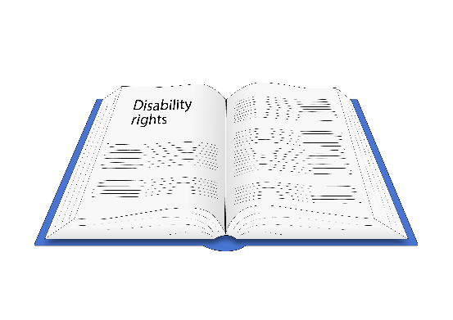
The quality framework document must be written so that everyone does what is right using the Health and Disability Code of Rights.

The Health and Disability Code of Rights are rules that must be followed by:
- Whaikaha
- IDEA Services
- other service providers.

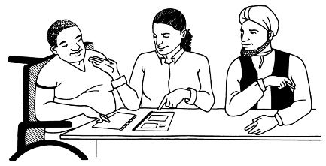
These rules make sure you are treated fairly when you use their services.

The quality framework document will include how everyone must pay attention to:
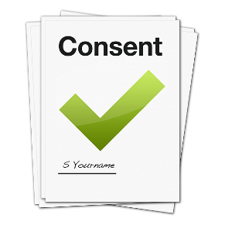
- the right to privacy
- the right to informed consent.

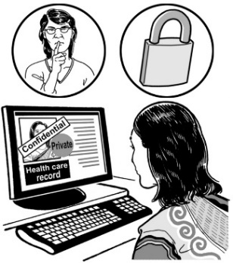
Privacy means when you tell somebody something they do not tell another person.

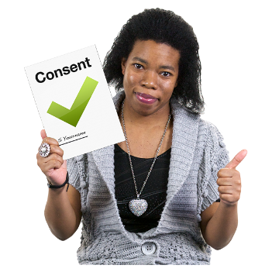
Informed consent means being asked if you agree to something.

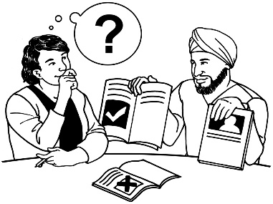
To give your informed consent you need to be able to:
- understand what is being asked
- remember the information
- think about what is good for you
- say what your choice is.

5

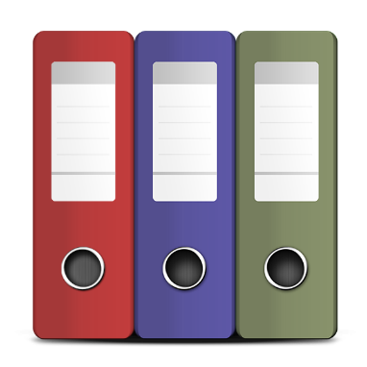
We will set up good ways to:
record things
file things.

To file something means to put a document somewhere it is:
- easy to find
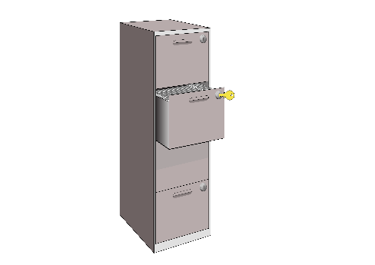
- easy to get
- safe.

6

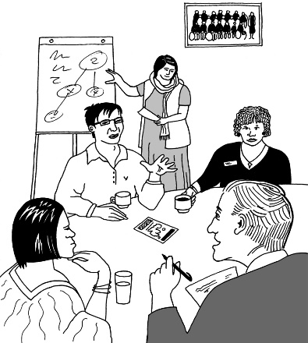
Regular meetings will take place between:
- Whaikaha
- IDEA Services.

The meetings will be used to talk about:
- how things are handled
- how well people are working together
- the quality of services being done
- the people using the services.

The meetings will also be used to share lots more information about what IDEA Services are doing.

7

Working together will continue between:
- Whaikaha
- IDEA Services
- other disability organisations.

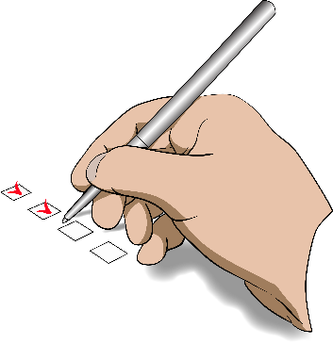
This will include the work already being done on:
- important problems
- the complaints register.
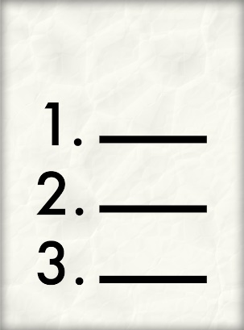

A complaints register is a list of complaints made to an organisation.

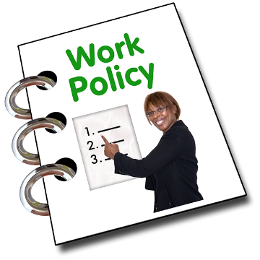
8

We will make a way for service providers to bring up things that impact what they do like:
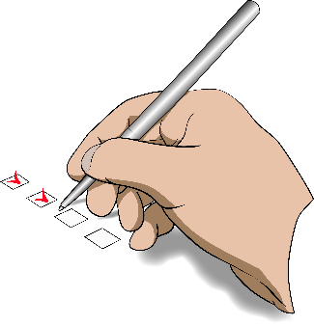
- policies
- rules.

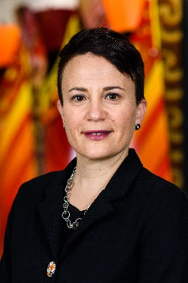
This must be done separate from our:
- Chief Executive
- portfolio managers
- other officials who deal with the service provider.

This is so good relationships can be kept between:
- Whaikaha
and
- the service provider.

9

We will list the steps we will follow when a problem is brought up by a service provider.

This will include how we will give information about what we did to fix the problem.

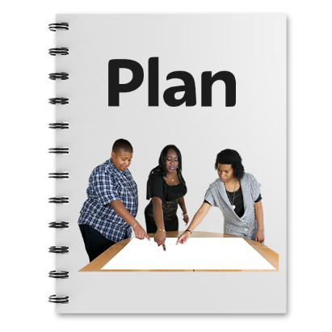
These steps must be listed in:
- the Contract Management Plan that is going to be written
- the public expectation document.

A public expectation document is something everyone can read so they know what an organisation is doing.

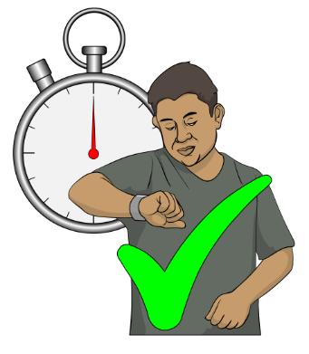
10

We will figure out how long it will take to make the changes to how complaints are made.

This will be done with IDEA Services.

11

We will look at how other service providers deal with their complaints.

This is to make sure they follow the changes the Review says should be made.

12

We will start working on a policy.

This policy will let the Health and Disability Commissioner be a bigger part of the work being done to support disabled people.

This policy will be made by:
- working with the Government
- working with other service providers
- using the Health and Disability Commissioner Code of Rights.

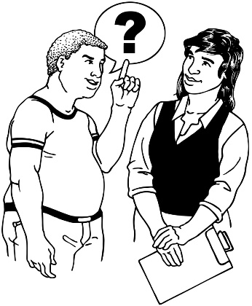
13

We will work with IDEA Services to understand what to do if a problem cannot be solved well.

What happens next?

We think it is important to build trust with the disability community.

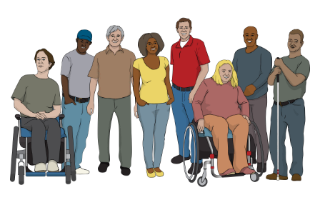
To understand how to make the changes the Review talks about we will work with:
- disabled people
- their whānau / families
- IDEA Services
- other service providers.

We want to do all the right things to make sure the changes happen.

We will make ways for others to be part of making the changes.

This will include:
- IHC
- other service providers.

Where to find more information

You can read the full review on our website:

tinyurl.com/3vvdw954
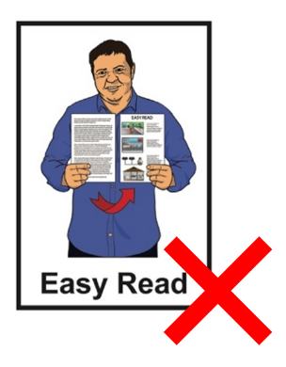

This website is not in Easy Read.

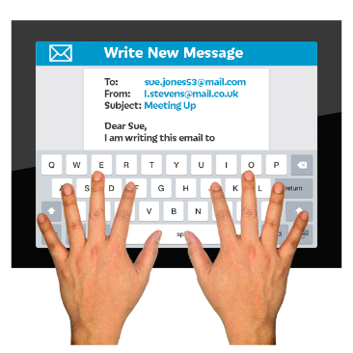
If you have any more questions you can contact Whaikaha by:
- email at:
contact@whaikaha.govt.nz
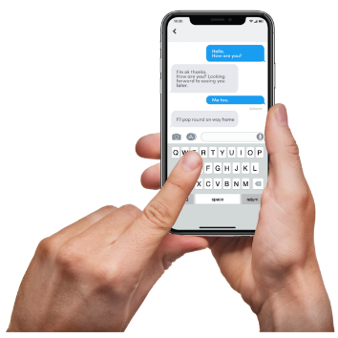
- text message on:
4206

You can contact Whaikaha by:
- phone at:
0800 566 601

If you find it hard to use the phone the New Zealand Relay service is for people who are:

- Deaf / hard of hearing
- deafblind
- speech impaired / find it hard to talk.

You can find out more about the New Zealand Relay service at:

www.nzrelay.co.nz

This information has been written by Whaikaha – Ministry of Disabled People.

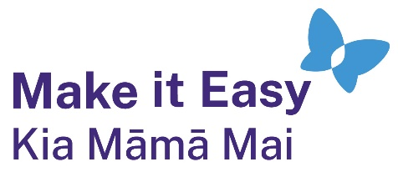
It has been translated into Easy Read by the Make it Easy Kia Māmā Mai service of People First New Zealand Ngā Tāngata Tuatahi.
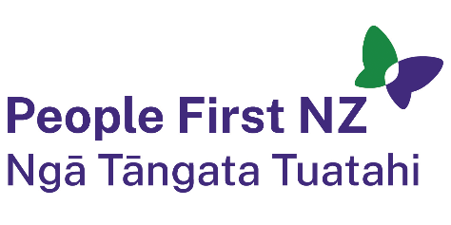
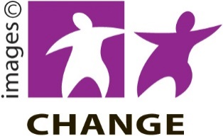
The ideas in this document are not the ideas of People First New Zealand Ngā Tāngata Tuatahi.

Make it Easy uses images from:

- Changepeople.org

            - Photosymbols.com

- SGC Image Works
- Huriana Kopeke-Te Aho
- T. Wood.
All images used in this Easy Read document are subject to copyright rules and cannot be used without permission.

