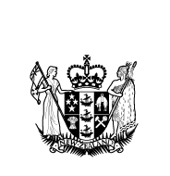

Work in Progress 2010
The annual report from the Minister for Disability Issues
to the House of Representatives on implementing the
New Zealand Disability Strategy

Work in Progress 2010 was published in December 2010 by the
Office for Disability Issues, Ministry of Social Development.

This report was presented to Parliament by the Minister for Disability Issues under section 8 of the New Zealand Public Health and Disability Act 2000.

ISSN 1178-5349 (Online)

This document is available electronically at:
http://www.odi.govt.nz

Contents
Minister’s foreword 4
Disability in New Zealand 6
Policy setting 6
Information about disabled people 8
Government implementation 10
Ministerial Committee on Disability Issues 10
Key work underway in 2010/2011 by government agencies 13
Office for Disability Issues 17
Independent monitoring 19
Next steps 20

Minister’s foreword
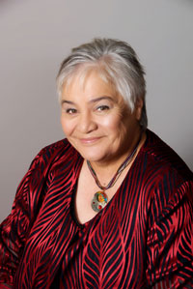
I will remember 2010 as the year when things changed for disabled people. New Zealand has stepped up its commitment to our disabled citizens by laying the ground work for more robust promotion and monitoring of disabled people’s rights.

Most importantly, this year the Government set out how New Zealand will go about implementing the UN Convention on the Rights of Persons with Disabilities. The new framework to promote, protect and monitor implementation is a partnership between government, independent rights-based public agenices, and disabled people themselves.

The Government has recognised that we are more likely to advance change and realise our goals by having different sectors working together. Putting into practice this commitment, Budget 2010 gave funding over three years for the Human Rights Commission, the Ombudsmen and the Convention Coalition of disabled people’s organisations to carry out their functions as the independent mechanism of the framework.

My aspiration is that the UN Convention, alongside the New Zealand Disability Strategy, will be living documents that focus action by government agencies, wider society and individuals. I am not interested in the past tendency for treating such documents as compliance exercises.

This is why the Ministerial Committee on Disability Issues is developing a whole-of-government action plan. As well as work that government has already begun, it identifies three areas where government agencies will work together to rethink how disabled people are supported to live an everyday life.

This work also responds to recommendations from the Social Services Select Committee Inquiry into the Quality of Care and Service Provision for People with Disabilities. One of its strong messages was the need for government to rethink what it was doing, as there was not enough of a difference being felt by disabled people.

With the ongoing constraint due to economic uncertainties, taking a more focused and strategic approach should enable government to be smarter in what it prioritises to do, and ensure the most effective use of public money.

I have appreciated the chance to meet with many people over the last year. I am regularly pleased and amazed at what a small country like New Zealand can achieve. I see it is a role of government to share what has been done, bring together best practice and good ideas, and to help make things happen.

My goal for 2011 is to activate the UN Convention framework so that together we can harvest real gains for disabled people, and make a better world of difference.

Hon Tariana Turia
Minister for Disability Issues

Disability in New Zealand

Policy setting
The two most important documents that impact on disabled people are the New Zealand Disability Strategy and the UN Convention on the Rights of Persons with Disabilities. These two documents work together with domestic legislation (such as the Human Rights Act 1993 and the Building Act 2004) and other treaties to provide a context for realising disabled people’s rights in New Zealand.

Making this future happen needs wide ranging action across New Zealand society. A role for the Government is to show leadership that others can follow.

In October 2010, the Government stepped up its commitment to disabled people by meeting an important obligation in the UN Convention. Following discussions by the Office for Disability Issues with disability sector organisations over the last two years, the Government agreed a framework to promote, protect and monitor implementation of the UN Convention. This framework meets the obligation in article 33 of the UN Convention and sets out roles and functions within government and independent of government.

The government mechanism is the Ministerial Committee on Disability Issues, which has the job of co-ordinating implementation across government, and the Office for Disability Issues is the focal point on disability issues.

The independent mechanism is made up of three parts:
- the Human Rights Commission, which has an existing mandate for human rights, has a broad role across all three functions of promotion, protection and monitoring (including the proposal to establish a full-time Disability Rights Commissioner)
- the Office of the Ombudsmen has a role in the areas of protection and monitoring within its existing mandate, which is confined to agencies in the state sector
- the Convention Coalition, a governance-level steering group formed by six major disabled people’s organisations to run a rights monitoring programme (using the Disability Rights Promotion International methodology).

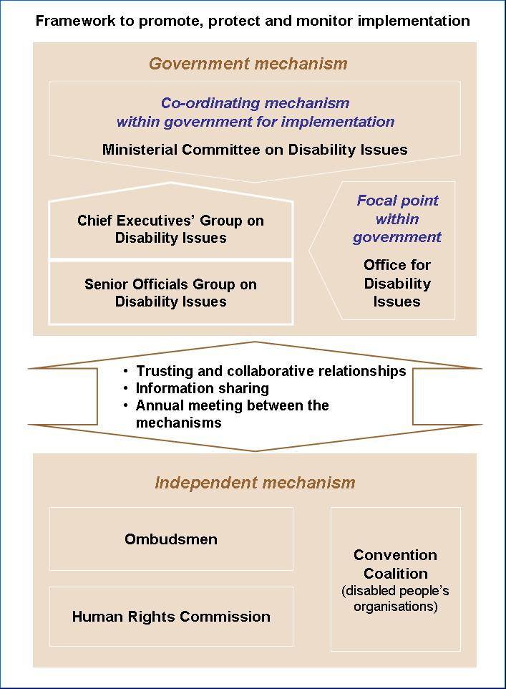

Budget 2010 provided funding of $2.34 million over three years for the independent mechanism and consists of $900,000 for the Human Rights Commission, $690,000 for the Office of the Ombudsmen and $750,000 for the Convention Coalition.

The Government also agreed that the Ministerial Committee on Disability Issues meet once a year with the independent mechanism participants to discuss progress and priorities with implementation.

The Ministerial Committee’s supporting officials are also expected to have ongoing engagement with the independent mechanism participants.

Information about disabled people
Growing what we know about disabled people as a population group is an ongoing priority. Better information will help inform decision making and ensure that actions which make a difference are identified and implemented.

As part of improving our knowledge base, in 2009, the Office for Disability Issues commissioned a review of statistical data from the 1996, 2001 and 2006 Disability Surveys to compare key social and economic outcomes for disabled people and non-disabled people over time. It has also been a useful contribution to New Zealand’s first report on implementing the UN Convention.

An important factor to keep in mind when interpreting this data is that disabled people are on average older than non-disabled people. This may partly account for some of the differences in social and economic outcomes for disabled people compared with others. Also, differences between the three surveys makes analysing trends over the period difficult.

However, given these factors, there was no clear overall pattern of improvement or deterioration over the period 1996 to 2006 in the position of disabled people relative to non-disabled people.

In each of the three surveys, when compared with non-disabled people of all ages, disabled people were:
- less likely to be living in one-family households and more likely to live alone
- more likely to have a low annual household income
- more likely to live in the more deprived areas of New Zealand.

Compared with non-disabled adults, disabled adults were:
- more likely to have no educational qualifications and less likely to have post-school qualifications
- more likely to not be in the labour force and less likely to be employed
- more likely to have a lower annual personal income
- less likely to be partnered.

In each of the three surveys, rates of disability were much higher among older people than younger people.

Also, Māori had consistently higher rates of disability than people in the European and ‘Other’ ethnic group.

Government implementation

Ministerial Committee on Disability Issues
The Government established the Ministerial Committee on Disability Issues in early 2009 to improve leadership, co-ordination and accountability across government. This decision was in response to recommendations from the Social Services Select Committee’s Inquiry into the Quality of Care and Service Provision for People with Disabilities. Disabled people had said that despite lots of activity by government agencies over the last 10 years they were not seeing enough difference in their lives or their ability to lead an ordinary, everyday life.

In late 2009, the Ministerial Committee asked the Chief Executive of the Ministry of Social Development to convene a Chief Executives’ Group on Disability Issues. Its purpose is to lead action by government agencies to implement decisions of the Ministerial Committee and to report progress.

In 2010, there have been three meetings of the Ministerial Committee.

A key task given to the Chief Executives’ Group in 2010 was to develop a whole-of-government action plan on disability issues. Ministers want to have a clear direction operating across government that sets priorities for action. This approach moves away from individual government agencies working separately to plan and report activity from year-to-year.

In October 2010, the Ministerial Committee agreed to the Disability Action Plan presented by the Chief Executives' Group, which focuses on three key areas where there are opportunities for rethinking how the government supports disabled people to live an everyday life.

These three areas are:
- supports for living (how government funding of supports for disabled people can align with the Ministry of Health's new model for disability supports)
- mobility and access (what government can do to enable disabled people to move around their community and access the built environment)
- jobs (what government can do to promote disabled people getting into paid work).
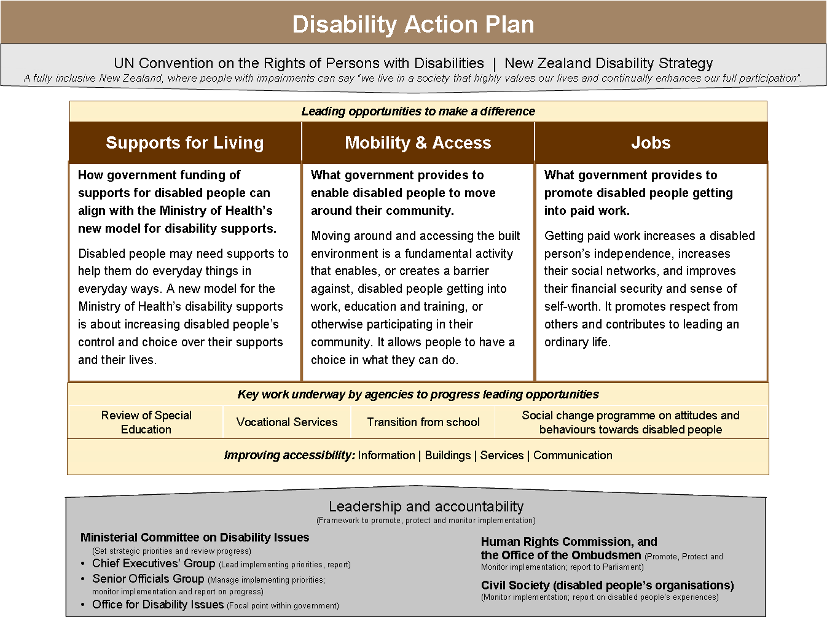

These three areas were chosen based on what disabled people have said are important issues to them and which have not yet been addressed adequately by government.

The Ministerial Committee asked that the Office for Disability Issues use its public consultation on the draft report on implementation of the UN Convention (from November to December 2010) to get feedback from disabled people on the three key areas.

The Chief Executives' Group will report back to the Ministerial Committee in 2011 with options for implementing the Disability Action Plan.

Other matters discussed by the Ministerial Committee during 2010 included:
- progress with recommendations in the Government Response to the Social Services Select Committee Inquiry into the Quality of Care and Service Provision for People with Disabilities
- Budget 2010 initiatives impacting on disabled people
- the Ministry of Health's new model for supporting disabled people, which includes measures to increase disabled people's choice and control over disability supports, allowing more flexibility in how funding is allocated, and introducing a local area co-ordination type service
- the Review of Special Education
- the Ministry of Justice plan to improve the government's system for reporting on international human rights treaties
- work in Auckland to make the Rugby World Cup accessible to disabled people, and how to take this approach around the country
- working with the Minister of Broadcasting to progress the current work by the Ministry for Culture and Heritage to promote access to broadcasting by disabled people.

Two disability sector organisations were invited to present issues to the Ministerial Committee during 2010. They were the:
- Convention Coalition of six disabled people’s organisations running a monitoring programme on disabled people’s experience of rights
- Association of Blind Citizens on access barriers experienced by vision impaired people.

Key work underway in 2010/2011 by government agencies
While not headlined in the Disability Action Plan, other areas of life, such as education or promoting accessibility, remain priorities for government agencies. Some examples of key initiatives are described below.

Review of Special Education
In August 2009, a Review of Special Education began. Its key aims were to ensure that policies and processes are fair, consistent, reach those most in need, provide choices for families and make the best use of government funding. Over 2,000 contributions were received during the public consultation.

In October 2010, recommendations from the Review were released. In Success for All – Every School, Every Child four key goals were set so that in four years time:
- all schools are welcoming and include every child
- all children are learning and succeeding, and get the extra help they need when they need it
- parents can see that their child belongs, has friends and is learning and succeeding
- parents receive good information.

New model for disability support from the Ministry of Health
The Ministry of Health has been developing a new model for supporting disabled people, following direction by the Ministerial Committee on Disability Issues. The new model is an approach to disability supports based on four characteristics:
- a stronger focus on providing information and personal assistance through introducing Local Area Co-ordinators
- moving towards allocating an indicative dollar value of support and providing clear guidance on what funding can and cannot be used for, rather than allocating particular types of service
- more choice and control for people over the support they purchase through making individualised funding available to most people and for most support, and making contracted supports and services more flexible and focused on outcomes
- broadening accountability arrangements to cover the Ministry of Health, providers and disabled people, and a stronger focus within quality monitoring on whether people are living an everyday life.

In November 2010, the Ministry of Health appointed Inclusion Aotearoa as the implementation support organisation to help with the design, implementation, testing and refinement of the demonstration project for the new model.

Employers Disability Network
In September 2010, the Employers Disability Network was recognised at Parliament in an event showcasing the launch of its website. The Employers Disability Network is an employer-led organisation aimed at driving employer change and creating a barrier-free employment and business sector. Its aim is to create a disability-confident employer sector. The Network shares best practice on working with disability in all areas of business.

The Ministry of Social Development has been a key player in supporting the Network through providing a secretariat service and an advisory group to assist with its development. The Ministry confirmed it will provide a full-time staff equivalent to support the Network.

Telecommunications Relay Service
In August 2010, the Government agreed that the Video Relay Service will be a permanent feature of the Telecommunications Relay Service.

Also, the Ministry of Economic Development has committed funding to continue New Zealand Sign Language Interpreting Scholarships, which will help sustain the interpreter workforce and support operation of the Video Relay Service. This funding includes:
- $30,000 to fund six scholarships (each of $5,000) for the Victoria University of Wellington/MacQuarie University postgraduate diploma course
- $70,000 to fund 14 scholarships (each of $5,000) for the diploma in New Zealand Sign Language Interpreting course at AUT.

Review of the New Zealand Sign Language Act 2006
In 2010, the Office for Disability Issues began reviewing the implementation and operation of the New Zealand Sign Language Act 2006. This work is mandated in the Act itself. The Office consulted with a sector reference group from the Deaf community to help plan the Review. The Office will seek feedback from the wider Deaf community in early 2011.

The Office also worked with the sector reference group to identify priorities for removing barriers experienced by Deaf people in accessing government services.

Guidance on reasonable accommodation
The Ministry of Justice is developing a guide to interpreting the ‘reasonable accommodation’ provisions in the Human Rights Act 1993 and how to go about implementing them. Resources are planned to be available in 2011.

Statistics on disabled people
The Office for Disability Issues worked with Statistics New Zealand to release reports with more information from the 2006 Post Census Disability Survey. These reports were in the areas of:
- labour market participation
- education
- informal care
- transport
- Māori.
The Office is working with Statistics New Zealand on what further information will be made available from the Disability Survey, as well as improving data collection to help measure progress with implementing the New Zealand Disability Strategy and the UN Convention.
Statistics New Zealand has confirmed that the next Disability Survey will run following the 2011 Census. There is a new disability question in the 2011 Census, and the Disability Survey has been revised.

Budget 2010 disability initiatives
Three packages of funding were announced in the Budget 2010 in the Disability Issues portfolio. In total $6.8 million over three years, made up of:
- $1.5 million to help promote design standards for homes that are accessible over a person's lifetime
- $2.34 million for independent promotion, protection and monitoring of the UN Convention
- $3 million for a public awareness campaign to change attitudes and behaviours that limit opportunities of disabled people.

Focus on disabled Pacific people
In October 2010, the Faiva Ora National Pasifika Disability Plan was released. It sets out the Government’s priorities for Pacific disability in the health sector over the next three years.

The report looks at improving the training and career path for Pacific disability workers, ensuring support services meet the needs of Pacific disabled people and their families and increasing the number of services delivered locally in the community.

In May 2010, the Lu'i Ola Church Engagement Toolkit was released. It intends to guide Pacific churches on how to include disabled people in their communities and set an example that other people and groups can follow.

Audio-description trial for television
In August 2010, NZ On Air confirmed $500,000 will be made available to trial an audio-description service on TVNZ's digital channels in 2011. Audio description is a special audio track built into broadcast programmes that describes the non verbal on-screen action in a programme alongside the normal soundtrack. It enables vision-impaired people to better access the programmes.

This initiative complements NZ On Air’s ongoing funding of captioning and the Attitude television programme on disability issues.

Emergency information more accessible
The Ministry for Civil Defence and Emergency Management worked with disability sector organisations to produce information specifically aimed at disabled people.

In 2010, they produced:
- a DVD in New Zealand Sign Language for deaf people
- public education resources for hearing impaired people to enhance the availability of civil defence emergency management information that were distributed to all local councils.

In 2011, public education resources for vision impaired people will be distributed.

Also in October 2010, a new system that enables deaf and hearing impaired people to contact the emergency 111 service by text was launched by the Police. Police have installed new technology that enables texts to be received and responded to by their communications centres.

New Zealand’s first report on implementation of the UN Convention
The Office for Disability Issues is responsible for developing the New Zealand reports on implementation of the UN Convention.

This year saw the development of New Zealand’s first UN Convention report. It is intended to be a baseline of implementation against the UN Convention, which future periodic reports will be based on.

The Office started planning the report in late 2009. It expanded a sector reference group of individuals in the disability sector who had previous experience of the UN Convention or current involvement with implementing it. The group’s function is to provide advice and feedback on the report and the government’s engagement with disabled people and the wider public.

Working with support from the Ministry of Social Development, the Office organised public consultation on the draft report, running from November to December 2010. The consultation was diverse and involved nine face-to-face meetings, an online discussion forum and the ability for individual submissions.

The final report will be reviewed by Ministers in early 2011, with the aim to have it submitted to the UN in March 2011.

Office for Disability Issues
Since its establishment in 2002, the Office for Disability Issues (located within the Ministry of Social Development) has supported the Minister for Disability Issues in promoting implementation of the New Zealand Disability Strategy.

More recently, the Office for Disability Issues has taken on responsibility for promoting implementation of the UN Convention. This role, of the focal point within government on the UN Convention, is now formally recognised.

The Office’s other key responsibilities include:
- supporting the Ministerial Committee, and its Chief Executives’ Group
- adding value to the work of government agencies by providing advice on matters impacting on disabled people
- advising the Department of Building and Housing on determinations in relation to accessibility for disabled people under the Building Act 2004
- nominating suitably qualified disabled people for appointment to government boards and positions
- the New Zealand Sign Language Act 2006
- the Minister for Disability Issues’ annual report to Parliament
- periodic reporting on implementing the UN Convention
- fostering relationships with disability sector organisations, and supporting the involvement of disabled people with government agencies.

One achievement to help promote understanding of the UN Convention was to make publically available the UN Convention in Māori, New Zealand Sign Language, audio and Braille. An easy read version was also made available in Māori and English.

Independent monitoring
A modern approach to government is involving and getting information on problems from affected individuals, representative groups and other organisations from outside of central government. Better solutions to problems are likely to result if more ideas and information can be generated and more different perspectives gathered to start with. The Government has actively engaged in this way in disability issues as part of implementing the UN Convention.

This year, 2010, saw four significant reports on the status of disabled people released.

- Deaf Aotearoa’s Deaf Way report in February 2010. This report presented recommendations on increasing access by Deaf people to government services and support.

- The Cost of Disability research report, produced by the Disability Resource Centre Auckland with the participation of the Centre for Health Services Research and Policy at the University of Auckland in August 2010.

- The Human Rights Commission included a chapter on disabled people in its report on Human Rights in New Zealand 2010 in December 2010.

- The Convention Coalition reported on its programme to monitor disabled people’s individual experiences of rights, Disability Rights in Aotearoa New Zealand 2010, in December 2010.

Each of these reports provides information and perspectives that help us to understand the situation of disabled people.

Also of relevance is the annual reporting by the Human Rights Commission, the Ombudsmen and the other national preventative mechanisms under the Optional Protocol to the UN Convention against Torture and Other Cruel, Inhuman or Degrading Treatment or Punishment.

These reports, and other advocacy by the disability sector, is useful for government agencies when looking at their work priorities and responsiveness to disabled people.

Next steps
In the future, this annual report on progress will monitor and highlight implementation of the Disability Action Plan. I also expect that government will need to have an ongoing involvement with the disability sector as the Disability Action Plan is implemented.

The next step in the reporting process on the UN Convention will be for the government to present the final report to the UN Committee on the Rights of Persons with Disabilities, sometime in 2011 or 2012. The UN Committee will ask questions about New Zealand’s implementation and make recommendations, which the Government will need to respond to.

Next year, 2011, should see the ground work we have prepared begin to bear fruit, as we get further along the track to disabled people being able to experience real benefit in their lives.





The Disability Surveys were carried out by Statistics New Zealand following each Census.
Information from this review will be published by the Office for Disability Issues in early 2011.
Adults are defined as people who are aged 15 years and over.
For example, in 2006, 45% of people aged 65 and older had an impairment compared with 10% for people under 15, 9% for people 15–44, and 20% for people 45–64.
For example, in 2006, 19% of Māori had an impairment, 18% of European people had an impairment, and 11% of “other” ethnicity had an impairment.
Funding support for scholarships has also been provided by the Ministry of Education and the Office for Disability Issues.

