Work in Progress
2007
The annual report from the Minister for Disability Issues to the House of Representatives on implementing the New Zealand Disability Strategy
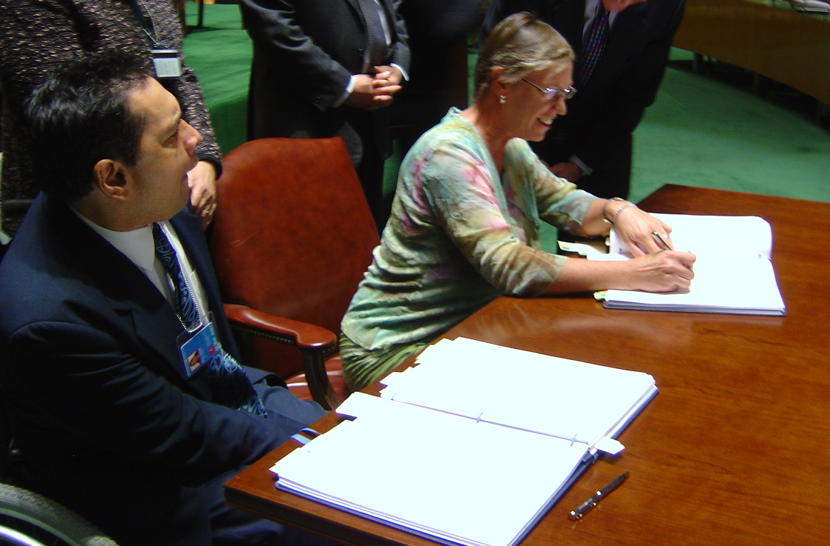

The signing of the United Nations Convention on the Rights of Persons with Disabilities

Work in Progress 2007 was published in December 2007 by the Office for Disability Issues, Ministry of Social Development.

This report is presented to Parliament by the Minister for Disability Issues under section 8 of the New Zealand Public Health and Disability Act 2000.

ISSN 1177-3049 (Print)
ISSN 1178-5349 (Online)

This document is available electronically at:
www.odi.govt.nz

Office for Disability Issues
Ministry of Social Development
PO Box 1556
Wellington 6140
phone: (04) 916 3300
fax: (04) 918 0075
email: odi@msd.govt.nz

Cover photo: The Minister for Disability Issues, Hon Ruth Dyson, signing the United Nations Convention on the Rights of Persons with Disabilities. Seated beside the Minister is Gary Williams, from the Disabled Persons Assembly.
Contents
Minister’s foreword 5
Message from the Disabled Persons Assembly 6
Vision and objectives 8
Highlights 9
Introduction 10
Structure of this report 10
How has reporting changed from last year? 11
Process for gathering information 11
Leading work that makes a difference 12
Citizenship 14
Government capacity 16
Disability supports 18
Participation 20
Education 20
Transport 21
Employment and income 22
Sport, recreation, culture and broadcasting 24
Buildings (including housing) 25
Diversity of need 27
Including a disability perspective 29
Disability Perspective Toolkit 29
Disability advisory / reference groups 29
Accessible government 32
Issues with data reported in this section 32
Accessible information 34
Online information (see graph one) 35
Hardcopy information (see graph two) 37
Audio-visual and other information (see graph two) 37
Accessible services 39
Data on accessible services (see graph three) 39
Being a good employer 42
Data on being a good employer (see graph four) 42
Accessible buildings 45
Key achievements in having accessible buildings (see graph five) 45
Implementation of the New Zealand Sign Language Act 2006 48
To Have an ‘Ordinary’ Life 52
Review of New Zealand Disability Strategy implementation 54
Appendix one – Agencies that have provided plans and reports 55

Minister’s foreword
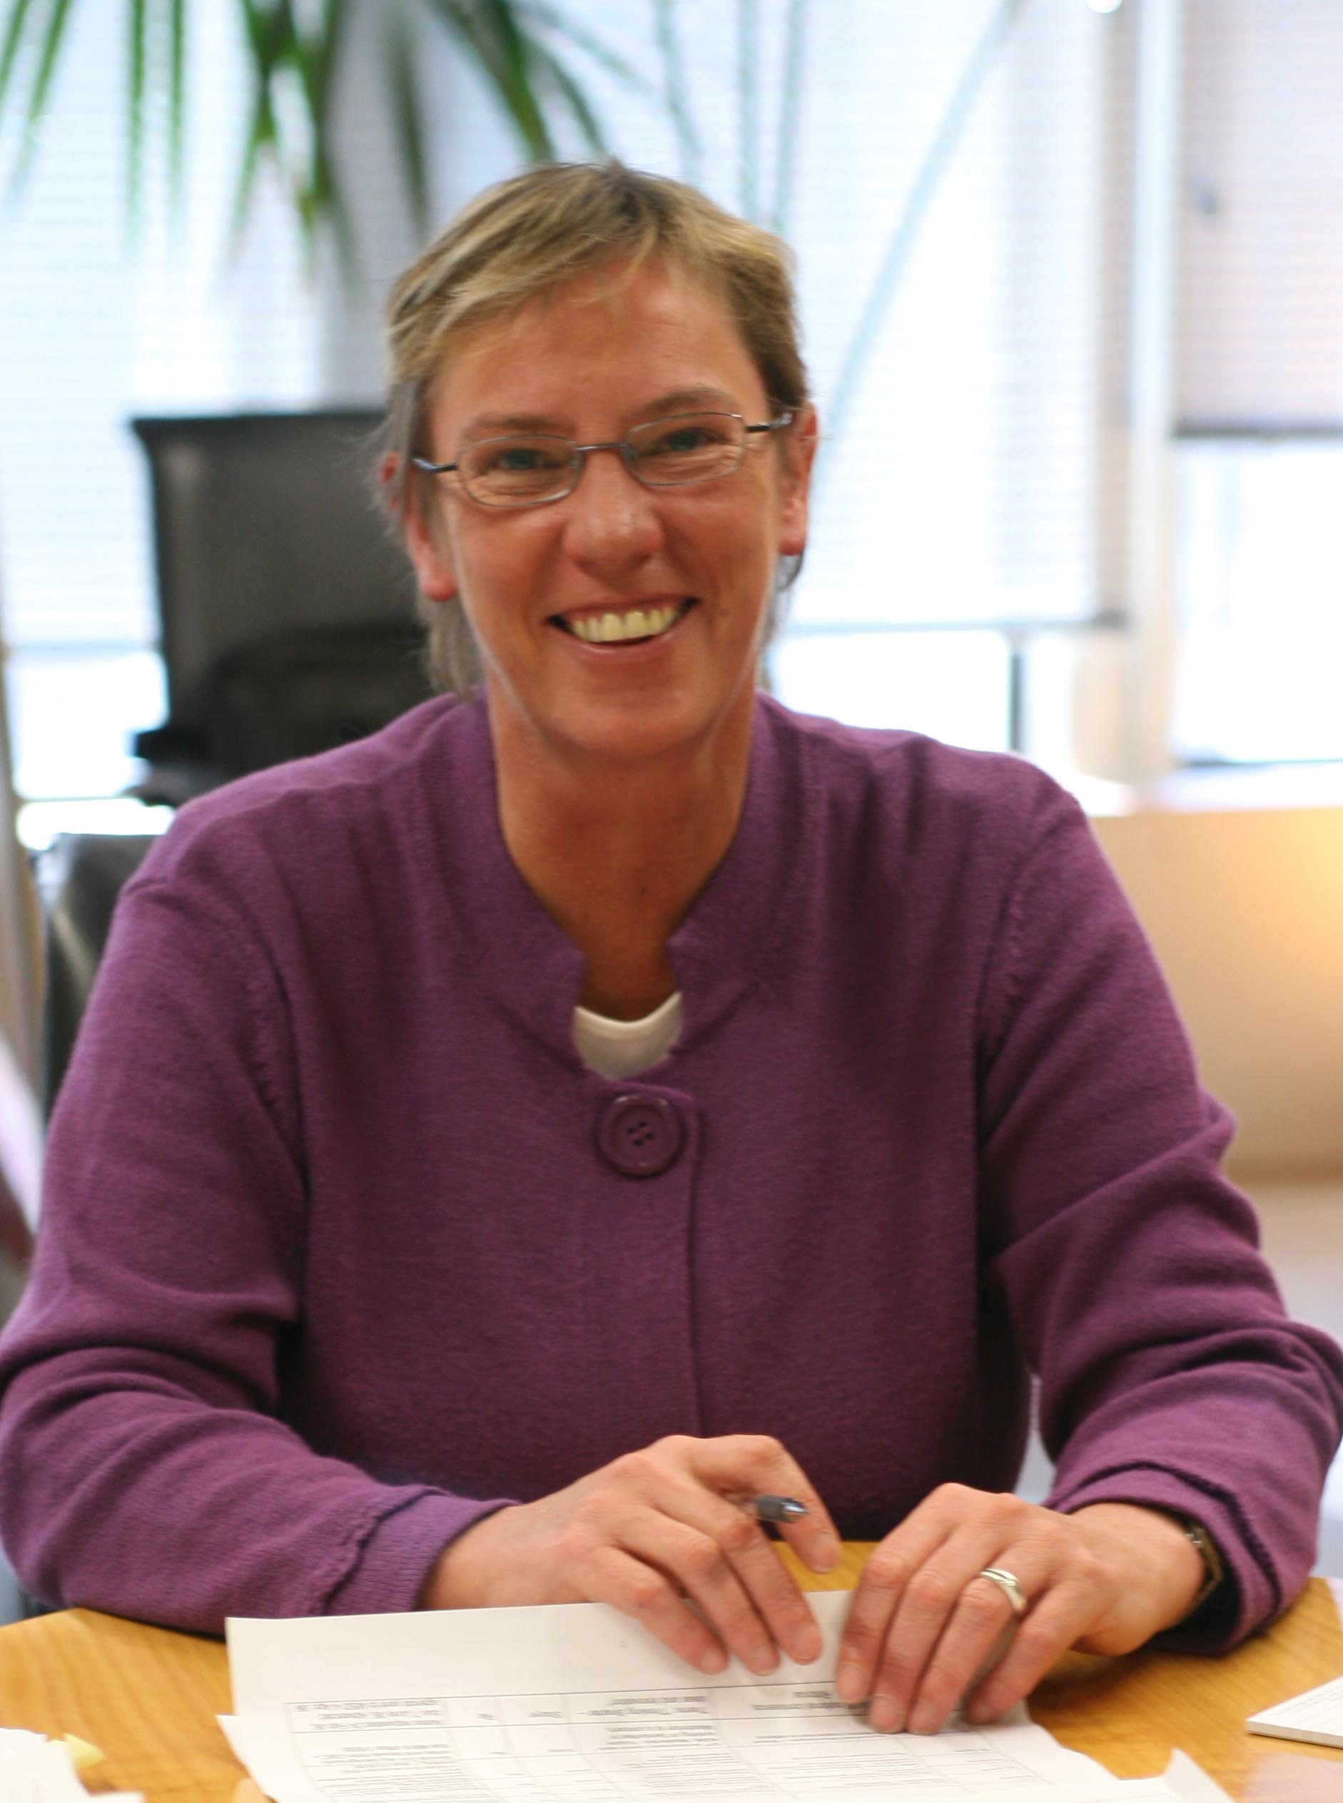
It has been six years since the New Zealand Disability Strategy was launched in 2001 and it is exciting to think about the changes that have happened in New Zealand over this time.

This is a particularly good opportunity for New Zealand to reflect on the progress we have made, and also look to the future and identify opportunities to move forward. Our ultimate goal is an inclusive society, where disabled people are valued and able to participate fully.

We have taken several large steps forward towards this goal, including the signing of the United Nations Convention of the Rights of Persons with Disabilities, the ending of institutions, and repeal of the Disabled Persons Employment Promotion Act.

The many smaller steps are equally important, as combined with the headline changes, they all come together to make a real difference for disabled people and the way they live their lives.

Small but important changes include greater knowledge and understanding of disabled people and disability issues within government agencies, a firm commitment to providing information and services in an accessible way, and a move towards whole-of-life planning.

Increasingly, we see recognition that planning for an inclusive society is of benefit to everyone. This approach signals a fundamental change from disabled people being seen as ‘other’ or special, to simply being part of the rich diversity in our society.

I am excited to see so many government agencies routinely considering the needs of disabled people as part of their work. This type of forward thinking makes good, sound common sense in planning for our futures.

We still have more work to do, but we have come a long way, and can be proud of our achievements so far.

Hon Ruth Dyson
Minister for Disability Issues

Message from the Disabled Persons Assembly
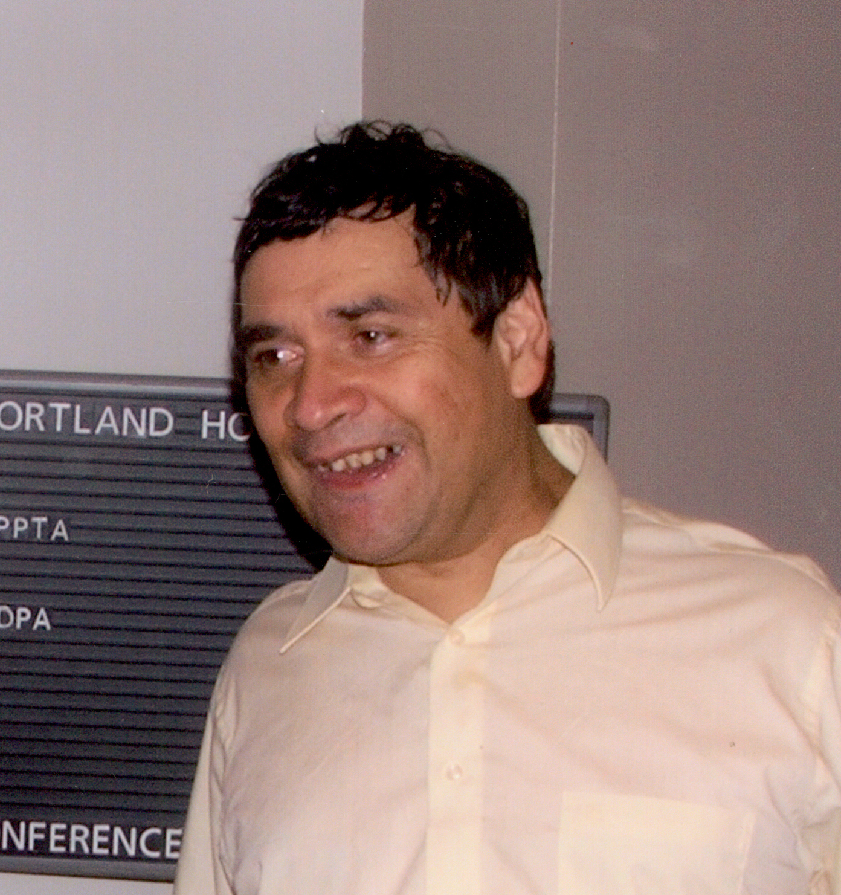
It is my pleasure to write the foreword to the 7th Progress Report of the New Zealand Disability Strategy.

As noted by Minister Dyson, the signing of the United Nations’ International Convention on the Rights of Persons with Disabilities is a big step towards the goal of the Strategy.

Careful analysis reveals how the Convention and the Strategy share a kaupapa of disabled people being included in the ordinariness of our communities. This is no accident: we used the Strategy as a guiding document when working with other countries to develop the Convention.

More importantly though, the success of the Convention process came down to the active partnerships between Governments and disabled people and I look forward to seeing the growth of work to implement the Strategy that is driven by active partnerships domestically.

This Progress Report lists a few achievements including the establishment of the New Zealand Relay Service, the passing of the New Zealand Sign Language Act, the closure of large institutions and the repeal of the Disabled Persons Employment Promotion Act.

These are hard-won gains for disabled people. But for disabled people the practicalities of day-to-day living are the most important things. They continue to include:

- Being able to be alive and to have impairments;
- Using disability support services that support our needs rather than the needs of “the system”;
- Gaining an education that prepares us for a working life that goes beyond work that other people won’t do;
- Getting around our communities and
- Being ourselves

The New Zealand Disability Strategy is meant to do these things and more.

I believe it can but after six years when we note three core Government agencies cannot deliver on their obligation to even report on their progress – “making a world of difference” seems as long, long way off.

Gary Williams
Chief Executive
Disabled Persons Assembly (NZ)

Vision and objectives
Launched in 2001, the New Zealand Disability Strategy presents a long-term vision for changing New Zealand from a disabling to an inclusive society. It was developed in consultation with disabled people and the wider disability sector, and reflects many experiences of disability.
Underpinning the New Zealand Disability Strategy is a vision of a fully inclusive society that highly values disabled people’s lives and continually enhances their full participation.
Achieving this vision will involve ensuring that disabled people have meaningful partnerships with central and local government, communities and support agencies, based on mutual respect and equality.
To advance New Zealand towards a fully inclusive society, the New Zealand Disability Strategy includes fifteen Objectives:
- Encourage and educate for a non-disabling society
- Ensure rights for disabled people
- Provide the best education for disabled people
- Provide opportunities in employment and economic development for disabled people
- Foster leadership by disabled people
- Foster an aware and responsive public service
- Create long-term support systems centred on the individual
- Support quality living in the community for disabled people
- Support lifestyle choices, recreation and culture for disabled people
- Collect and use relevant information about disabled people and disability issues
- Promote participation of disabled Māori
- Promote participation of disabled Pacific peoples
- Enable disabled children and youth to lead full and active lives
- Promote participation of disabled women in order to improve their quality of life
- Value families, whānau and people providing ongoing support.

Highlights
Since the New Zealand Disability Strategy was first published in 2001, there have been many changes in the way disabled people live their lives. We are steadily moving closer to our goal of disabled people enjoying the same opportunities, choices, rights and responsibilities as other people living in New Zealand. Some key achievements include:
- New Zealand signed the United Nations Convention of the Rights of Persons with Disabilities on 30 March 2007. This Convention was agreed over four years. Disabled people were part of New Zealand’s official delegation. New Zealand modelled a partnership approach with disabled people being involved throughout the whole negotiation process.
- Closure of the last institution. In October 2006 the last of the institutions for people with physical and intellectual disabilities was closed. This is a big milestone for New Zealand as disabled people live in the community like other New Zealanders.
- The Disabled Persons Employment Promotion Act was repealed in 2007, giving disabled people access to the same employment conditions, rights and entitlements as other New Zealanders.
- The New Zealand Sign Language Act (the Act) became law in April 2006, and recognises the language and culture of the Deaf community. The Act gives Deaf people a right to use New Zealand Sign Language in legal proceedings. It also sets out principles to guide government departments in consulting the Deaf community on matters relating to New Zealand Sign Language. This gives Deaf people better access to the justice system and other government processes.
- In 2007, New Zealand was presented with the Franklin Delano Roosevelt International Disability Award. This award is presented to a member nation of the United Nations that makes significant progress toward the goal of full participation of disabled people. New Zealand was chosen because of our progress in “raising national and international consciousness about the needs and aspirations of disabled people and enhancing their full acceptance in society”.

Introduction
A change of behaviour by everyone is needed to achieve the vision of the New Zealand Disability Strategy. However, there is an expectation that central and local government have a key role in planning work towards achieving the Objectives of the New Zealand Disability Strategy.
As Minister for Disability Issues, I report to Parliament every year to show progress in implementing the New Zealand Disability Strategy. This report looks in some detail at what has happened over the last year.
This year, 35 agencies have provided reports and they are listed in Appendix One. This progress report is based on the information provided by these agencies, and covers the period July 2006 to June 2007.

Structure of this report
This first part of this report is divided into three sections:
- Leading work that makes a difference – what agencies are doing to change things for disabled people. This is a major part of the reports that agencies give the Office.
- Including a disability perspective – how agencies should be thinking about disabled people in all the work they do and making sure they are included.
- Accessible government – what government agencies are doing to make their information, buildings, and services accessible, and to be good employers of disabled people.
The second part of this report looks at what has been done to implement:
- The New Zealand Sign Language Act – this became law in April 2006 and recognises the language and culture of the Deaf community.
- The “To Have an Ordinary Life” report – this report was released by the National Health Committee in 2003 and looked at how people with intellectual disability are supported to live ordinary lives.

How has reporting changed from last year?
This year, the progress reports for 2006-07 and plans for 2007-08, as provided by agencies, are on the Office for Disability Issues website. Everyone with access to the internet can read them to find out the detail of what is happening in each government agency.

This report provides an overview of what is happening across government in implementing the New Zealand Disability Strategy. It does not list the detail of agencies plans and reports as previous reports have done.

Process for gathering information
Each year, the Office for Disability Issues (the Office) invites government agencies to provide information on what they are doing to implement the New Zealand Disability Strategy.

In 2007, the Office sent agencies a template to complete, asking them to report what they have achieved in the 2006-07 year, and on what they plan to do during 2007-08 in the following areas:
- leading work that makes a difference
- including a disability perspective
- accessible government
- the New Zealand Sign Language Act
- the ‘To Have an Ordinary Life’ report.

Leading work that makes a difference
This section describes work that agencies are leading that makes a difference for disabled people. The work has been organised into 5 areas:
- Citizenship – every person has the right to carry out the normal activities of being a citizen in New Zealand, like voting or being part of groups that make decisions – this area looks at what agencies are doing to make sure disabled people can do these things.
- Government capacity – making sure government agencies have the right knowledge, skills and systems to do their work in a way that removes barriers to disabled people participating in society.
- Disability supports – what agencies are doing to make sure that people have the supports they need to live ordinary lives.
- Participation – for disabled people to participate in society, they need accessible health, education, transport, employment and income, sport, recreation, culture and broadcasting, and buildings. This section looks at what government agencies are doing to improve accessibility in these areas.
- Diversity of need – New Zealand has a mixture of people with different needs and this section looks at what is being done for specific population groups like Maori, Pacific people, women, children, and carers.
These sections are all interdependent, so progress in implementing the New Zealand Disability Strategy in one area may contribute to implementation in other areas as well.

Achievement story

Signing of the United Nations Convention on the Rights of Persons with Disabilities on 30 March 2007

The signing of the Convention was the result of hard work and partnership between government agencies and the disability sector. Representing government was the Ministry of Foreign Affairs and Trade, the Office for Disability Issues, the Human Rights Commission, and the Mental Health Commission. They worked together, and consulted with the disability sector, including the Disabled Persons Assembly, Association of Blind Citizens, IHC Advocacy, New Zealand CCS (now CCS Disability Action), Royal New Zealand Foundation of the Blind, New Zealand representatives of Disabled Persons International and Inclusion International.

Disabled people were included in the official delegations that attended and carried out negotiations for the Convention at the United Nations in New York.

In recognition of the partnership approach, the New Zealand delegation to the Convention signing ceremony included a disability sector representative as well as a government official.

The Convention marks a shift in thinking about the place of disabled people in societies all over the world. Nations that sign up to the Convention are obliged to ensure disabled people experience human rights and opportunities on an equal basis with other people.

Citizenship
Objective 1: Encourage and educate for a non-disabled society.
Objective 2: Ensure rights for disabled people.
Objective 5: Foster leadership by disabled people.
An essential part of full participation is being able to take part in the ordinary activities of being a citizen. This includes things like voting and exercising leadership.

Key gains in this area include the signing of the United Nations Convention on the Rights of Persons with Disabilities, the launch of the Nominations Service at the Office for Disability Issues, and continuation of the Like Minds, Like Mine campaign to reduce stigma and discrimination against people with experience of mental illness.

Disabled people’s lived experience and knowledge of disability is increasingly recognised by agencies that use disability advisory or reference groups to get input into policy. Agencies are either setting up their own disability advisory groups, ensuring disabled people are on current advisory groups, or referring specific issues to established advisory groups.

Other activities that have happened across government include:
- Developing nominations services – e.g. the Ministry of Women’s Affairs’ nominations service adds suitable people to their database from the Office for Disability Issues database, records information when women choose to identify as disabled on the nominations registration form, and provides support, advice and assistance to the convener of the Office for Disability Issues nominations service
- Responding to the Human Rights Action Plan – e.g. the Department of Prime Minister and Cabinet with the Ministry of Justice and other relevant agencies are working on developing options for the government’s response to the New Zealand Action Plan on Human Rights. The principal aim is to increase the understanding of human rights issues (including disability issues) among policy makers. By doing this, issues will be considered fully and at an early stage.
- Reducing discrimination – e.g. the Ministry of Health, Mental Health Commission, Office for Disability Issues, and Human Rights Commission – Reducing discrimination against people with mental illness multi agency plan 2005 – 2007 – a plan to address stigma and discrimination faced by people with experience of mental illness. Key objectives of the plan for 2006-07 included to;
- influence and improve public attitudes through the mainstream media
- develop and enhance the ability of mentally ill people to advocate for their rights and participate in activities to reduce discrimination
- develop and promote education and community activities to reduce discriminatory practices.
- Protecting people’s rights – e.g. Ministry of Social Development’s Office for Senior Citizens is working on the Protection of Personal and Property Rights Amendment Bill. The purpose of this Bill is to strengthen the legislation so that the welfare and rights of vulnerable people are better protected, and to replace the forms and notes with prescribed forms in regulations. This will allow for better guidance in the creation of enduing powers of attorney, clarify the process for activation, tighten provisions relating to gifting, and provide easier access to the courts for anyone with concerns about an attorney’s actions.

Government capacity
Objective 1: Encourage and educate for a non-disabling society.
Objective 6: Foster an aware and responsive public service.
Objective 10: Collect and use relevant information about disabled people and disability issues.
Government agencies need to think about disability in the work they do. This means making sure they have good information about disabled people and disability issues, and sound frameworks for thinking about how changes they propose to make will affect disabled people.

Some examples of how government agencies are making sure they are able to do this include:
- Developing disability awareness – e.g. the Ministry of Transport is planning a new quality assurance tool which will provide consistency across its thinking frameworks (ensuring there is reference to the New Zealand Disability Strategy and the disability perspective in guidelines for policy development).
- Changing long-established policies – e.g. Inland Revenue is reviewing the nominated person’s procedure for disabled people – this is where a disabled person can nominate someone to act on their behalf including appropriate consultation.
- Introducing best practice guidelines – e.g. the State Services Commission is working to ensure the accessibility of government websites – its Web Standards encourage website content that is accessible to all New Zealanders regardless of their impairment, use of the latest technology, and the availability of fast internet connections.
- Gathering data on disability and disabled people – e.g. Statistics New Zealand is compiling results from the 2006 Disability Survey. This is the third time the survey has been run. It collects information on how many people have impairments, the types of impairments they have, the severity and cause of the impairments, current and unmet needs for services and assistance, employment, transport, education, accommodation and special equipment. The information is used by government departments and disability service providers to review the effectiveness of services for people with disability and to help guide the development of new services.
- Doing research into disabled people’s experiences – e.g. the Ministry of Social Development is working on the Costs of Disability Research project. This is designed to improve knowledge about the extra costs associated with disability in New Zealand, and how costs vary because of individual needs and circumstances.
- Doing more research – e.g. the Ministry of Social Development has reported on Living Standards and Disability – this analysed data collected in the 2004 Living Standards Survey. It describes the economic standard of living of people across a spectrum of disability severity for the whole working-age population, and for subgroups defined by family type.

Disability supports
Objective 7: Create long-term support systems centred on the individual.
Access to disability supports is a critical part of being able to participate in society. The New Zealand Disability Strategy envisions supports being available to enable individual disabled people to make their own choices about where they live and who with, and what education, job, leisure, recreational, and public pursuits they will take part in – in other words to live ordinary lives on an equal basis with non-disabled others.

Work being done on individualised supports that are provided or funded by government include:

ACC is working on the following projects:
- Strategic Review of Weekly Compensation – this is designed to reduce the financial burden of injury so people can focus on rehabilitation and recovery. It will make weekly compensation abatement rules easier to understand, ensure eligibility rules are fair for people injured while temporarily between jobs or on unpaid leave, provide reasonable weekly compensation, and ensure a reasonable level of compensation for loss of potential earnings for people who are seriously injured before they enter the workforce.
- Rehabilitation framework – this will improve rehabilitation outcomes for all claimants and improve claimant satisfaction. It involves developing a better claimant profile at an early point, simplifying processes (while still achieving outcomes), developing more sophisticated sets of pathways (or packages of care), and introducing services that focus on claimant outcomes. It has been implemented and there will be ongoing work to develop it further.
- Improving service delivery for people with serious injuries – this work aims to support the participation of disabled people in the community through every day activities such as leisure and employment. Features include supported living services, supported employment services, early intervention intensive rehabilitation programmes, services for children with traumatic brain injury, focus on returning to work, raising employer awareness of, and their confidence in, the benefits of employing workers with an injury or disability.
- Establishing serious injury client reference groups – working in partnership with seriously injured claimants and their families to improve ACC services and processes.
- Communications resources for people with serious injuries – developing information and communication materials for people who have a serious injury (and for their family / whānau). Involves quarterly newsletters (from June 2008) and specific material on the ACC website (by June 2008).
The Ministry of Health is working on:
- the allocation of funding responsibility for people with chronic health conditions who need long-term support services.
- the environmental support services development programme – work that is underway includes to:
- improve the availability of information and the consistency of service provision
- plan for addressing access and eligibility issues for hearing equipment and hearing aids, and for improving assessments and develop an enhanced assessor framework
- undertake initial policy and financial analysis – particularly examining options for extending access and eligibility criteria.
- care and support in the community – focusing on the role of health and disability support services in enabling older people to continue living in the community.
- completing a Guideline for Autism Spectrum Disorder and development of an Autism Spectrum Disorder work programme – to provide information primarily for health, disability, and education professionals, social service providers, and policy makers, using an evidence-based approach. A secondary audience includes parents, people with autism, families / whānau, and caregivers.
- The Ministry of Social Development – Office for Disability Issues is working on a cross-government project to review provision of long-term disability supports. This project will present advice to government on ways to improve the way these supports are provided.

Participation
Disabled people should have the same choices, opportunities, rights and responsibilities as other people. This means they need the same access to health, education, transport, employment and income, sport, recreation, culture and broadcasting, and the built environment as other people.

Agencies have said what they are doing in these areas to improve access and this is outlined below. The information below is not a comprehensive list of all activity across government, but gives an overview of the areas agencies are working on.

Education
Objective 3: Provide the best education for disabled people.
Access to education is a building block for full participation where people establish social networks, learn, make decisions about their future, and start participating in wider society.

It is generally accepted that disabled children achieve better outcomes when they attend mainstream schools and are integrated with their non-disabled peers.

Since the 2001 Disability Survey, the proportion of children participating in mainstream classes has increased significantly. In 2006, 88% of disabled children, aged 5-14 years attended only mainstream classes; 10% attended both mainstream classes and a special unit, which means 2% of children have no mainstream participation. This is a big improvement over 2001, when 74% of disabled children attended only mainstream classes, 16% attended both mainstream classes and a special unit, and 10% of children had no mainstream participation at all.

To enable disabled people to get the best education requires action on many levels, including schools being accessible, teachers being responsive and having the right tools to do their job, and having enough teachers with the right skills.

The following activities by Ministry of Education are contributing to this objective:
- Better Information to Address Barriers to Learning – seeks to help children achieve improved learning outcomes (including social and cultural outcomes) by providing classroom resources to enable teachers to identify and address barriers to learning.
- Resources for parents, carers, and teachers to improve learning for children and young people with Autism Spectrum Disorders (ASD) – this includes an evidence-based Guideline for Autism Spectrum Disorder, emphasis on early interventions, information and education for parents and carers, and ongoing professional development for teachers and other professionals.
- Better Outcomes for Children Action Plan 2006-2011 – to raise achievement and improve services for children eligible for special services through Group Special Education.
- Professional development of the Special Education workforce – to enhance capacity and capability of the workforce, including study awards, workforce planning and contracts to ensure training is accessible.
- Survey of Special Education resourcing – looking at what is available and how individual and school targeted funding is deployed.
- Behaviour Screening Tool – to be implemented, including training initiatives, in early 2008 – this will better identify high risk children for earlier intervention and is intended to be linked to the ‘Incredible Years’ programme for positive parenting.
- Interim Support Fund – provides additional support to schools to better manage the immediate impacts of severe behaviour and to enable better integration into the school of children who have received specialist or off-site support.
- Universal Newborn Hearing Screening Early Intervention Services Development – to enable Group Special Education to have the capacity to deliver early intervention services to children aged 0-3 years diagnosed as deaf or hearing impaired through universal screening.

Transport
Objective 8: Support quality living in the community for disabled people.
A key issue for disabled people is being able to move around in their communities. Having access to the transport system, public and private, and the interconnecting environment is important for disabled people’s participation in society as they need to be able to get to work, school, or sports, and go shopping or visit people, just like non-disabled others.

The 2001 Disability Survey reported that 3% of disabled adults and 2% of disabled children had not made any short trips in the previous 12 months. In the 2006 Disability Survey this had improved and 2% of adults and 1% of children had not made any short trips.

Agencies continue to work to improve access to transport for disabled people, with many local councils now employing disability advisors and consulting disability advisory groups at the outset of planning for changes. When disability issues are considered from the beginning, it increases the likelihood that changes and upgrades to transport and infrastructure will be made accessible and remain so into the future.

Some key pieces of work currently underway include:
- Human Rights Commission’s Accessible Journey report - The Ministry of Transport is working on the recommendations made by the Human Rights Commission Inquiry into Accessible Public Transport. The Ministry is assessing recommendations and working towards a clearer understanding of the issues faced by disabled individuals using public land transport.
- Local and regional transport accessibility - A number of local councils are working on making their public transportation systems more accessible, which includes talking to disabled people about what they need, and considering accessibility from the beginning of development projects. Examples include upgrade work of the transportation network in Auckland, Hamilton and Wellington.

Employment and income
Objective 4: Provide opportunities in employment and economic development for disabled people.
Improvement in the levels of disabled people’s participation in paid work and the incomes they receive for doing it is critical to their well-being and their ability to take part in a wider range of activities in family, community, social, cultural, economic and public life. Government agencies can show leadership in achieving this objective through things like:
- leading by example and being a good employer of disabled people
- developing work programmes that promote and support disabled people into employment and economic independence
- being flexible in the way disability supports are provided.
A significant achievement in this area is the repeal of the Disabled Person’s Employment Promotion Act 1960. Disabled people now have the same employment rights as other New Zealanders. This is critical if disabled people are to achieve the vision in Objective four of the New Zealand Disability Strategy.

In the 2006 Disability Survey, 60% of disabled people aged 15-64 years are in employment compared with 80% of adults without disability. In 2001, 57% of disabled people aged 15-64 years were in employment, compared with 77% of people without disability.

While this is an improvement, with an extra 3% of disabled adults in employment, there has been a similar increase for non-disabled people, and the gap remains the same. In order to start closing this gap, there are several key pieces of work going on across government. These include:
- Mainstream Supported Employment Programme – run by the State Services Commission Mainstream enables the placement of people with significant disability issues into created positions within the State sector. Currently there are 236 people employed on two-year placements across 49 agencies and 57 schools around the country. This programme places 140 new candidates each year.
The Department of Labour:
- has led development on the toolkit Our Youth, Our Future, containing information about young people with disabilities as employees. The toolkit is to help provide Mayors and Council Chief Executive Officers with the information they need to challenge negative assumptions and stereotypes in their communities – this is part of the Mayors Taskforce for Jobs programme
- developed Choices for Living, Caring and Working – a ten year Action Plan, adopted by Cabinet in 2006, to improve the caring and employment choices available to parents and carers of disabled or older people.
The Ministry of Social Development is working with the Department of Labour on Pathways to Inclusion which sets out the Government’s policy for the development of vocational services for disabled people and aims to increase participation of disabled people in employment and in their communities.

The Ministry of Social Development has also developed Work-focussed Support programmes which aim to increase the opportunities for people to participate in the labour market while continuing to provide social and financial support as needed. During 2006 / 2007, the package included:
- employment and training programmes
- establishing specialist disability and health advisors to support enhanced Work and Income case management
- simplified eligibility criteria for Invalid’s Benefit
- extended eligibility for the Domestic Purposes Benefit: Care of Sick or Infirm
- extended provision of Invalid’s Benefit to allow claimants to continue receiving it for up to two years while overseas for vocational or guide dog training.

Sport, recreation, culture and broadcasting
Objective 9: Support lifestyle choices, recreation and culture for disabled people.
Sport and Recreation New Zealand (SPARC) plans to increase participation and strengthen the physical recreation sector, with several initiatives aimed at ensuring disabled people have the same opportunities to participate as other New Zealanders.

SPARC’s key strategy, the No Exceptions policy envisages all people participating in the physical recreation and sport activities of their choice. To help achieve this vision, SPARC is:
- encouraging National Sports Organisations, and National Recreation Organisations to include disability issues within their strategic and operational plans
- developing the No Exceptions training kit to go live on the internet by July 2007, and be delivered to a wide range of environments, including schools, sport and recreation agencies, and local authorities
- introducing the Inclusive Fitness Initiative to New Zealand –SPARC will pilot this in the Auckland region where positive interest has already been expressed by local authorities, the YMCA, the Sport, Fitness and Recreation Industry Training Organisation and the CEO of Fitness New Zealand
- developing the Wellington and Hutt Valley No Exceptions District Initiative – a scoping exercise has been funded.

Buildings (including housing)
Objective 6: Foster an aware and responsive public service.
Objective 8: Support quality living in the community for disabled people.
Accessible buildings and houses are essential to enable disabled people to fully participate. The accessibility of buildings and houses affect every aspect of a disabled person’s life. If a building is not accessible, then it is very difficult to seek employment from a business in that building.

The Department of Building and Housing has:
- issued two new guidance documents Accessible reception and service counters and The international symbols of access
- recommended changes to legislation to require early notification to building developers of access requirements for ‘public use’ buildings, and to provide better information and rights for disabled people living in retirement villages.
Housing New Zealand Corporation has the following activities:
- Community Group Housing programme provides 474 residential homes to community groups who provide residential services to disabled people)
- Housing Innovation Fund provides loans and grants to community-based organisations and local authorities to build capacity to acquire, build or purchase housing to accommodate people with unmet housing including disabled people
- Case Management provides a housing need assessment and agency co-ordination service for state tenants / applicants with complex needs, to ensure sustainability of their accommodation. Over 2006 / 2007 they assisted 1877 customers with complex needs, including many disabled customers
- Suitable Homes Service helps people with physical disabilities access public or privately owned modified housing. In 2006 / 2007 the service assisted 512 people to access suitably modified homes
- Acquisition Programme provides, maintains, and redevelops housing stock to meet needs of customers, including disabled people. The Corporation uses universal design principles in all new builds, and provides purpose built housing for disabled people
- Income Related Rents – disabled people often have lower than average incomes and low-income state tenants are currently charged an income related rent, which means they pay no more than 25% of their income on rent.
Achievement story

Living in the community

Housing New Zealand Corporation led a project to relocate former residents of the Kimberley Centre (Levin) into the community – Kimberley (closed on 20 October 2006) was the last of the 13 institutions for people with intellectual or psychiatric disabilities to have closed in the last two decades.

Seventy-four community houses have been provided in community settings. Of these, 23 new houses were built and another 51 existing houses were extensively modified and customised to better meet the residents’ needs.

The completed houses have been designed to a new quality standard and are future proofed to cater for the diverse needs of a wide range of disabled people over time.

Diversity of need
Objective 11: Promote participation of disabled Māori.
Objective 12: Promote participation of disabled Pacific peoples.
Objective 13: Enable disabled children and youth to lead full and active lives.
Objective 14: Promote participation of disabled women in order to improve their quality of life.
Objective 15: Value families, whānau and people providing ongoing support.
Some groups of disabled people face more barriers to participation than others. The 2006 Disability Survey showed that 60% of working age disabled people are employed, 66% of males and 53% of females. Disabled Māori and Pacific peoples do not fare so well: disabled Māori have a 46% employment rate, while disabled Pacific peoples have a 38% employment rate.

Objectives 11 to 15 recognise that certain groups of disabled people face more barriers than others across all areas of life. Some steps taken by agencies to reduce these barriers include:
- Te Puni Kokiri has funded the translation of the Deaf Association website into Te Reo Māori
- the Ministries of Education, Health, Justice, and Social Development are working on the Early Years Intervention approach – a cross-government approach to achieve a comprehensive early years intervention system for all children aged 0 to 6 years
- the Ministry of Social Development and Ministry of Health received the Best of Care? An Independent Review of Issues at the Interface of Disability Support and Care and Protection in April 2006, and have developed a joint work programme to achieve better outcomes for those children and young disabled people
- the Ministry of Social Development is working on:
- Supporting Parents with disability - developing a pilot service to support parents with intellectual impairments or mental health issues, to continue to meet the needs of their children and to retain or resume the care of their children, where possible. Where children have come into care, the service is to support parents to have meaningful involvement with their children
- improving access to Out of School Services for disabled children. This involves developing a five-year action plan for Out of School Services – to ensure these services are reliable, at convenient locations and are accessible to children with a disability or other special educational needs
- a national Carers Strategy to improve information and support for carers. The strategy will be launched in 2008.

Including a disability perspective
Effective implementation of the New Zealand Disability Strategy will happen only when agencies routinely consider the impact of their work on disabled people.

To implement the Disability Strategy objectives, agencies need to think about disability and disability issues at the outset of all policy work so it is an integral part of the design of any proposals. It requires considering how the policy debate can be lead by disabled people thereby creating increased capacity and capability within government agencies to understand the barriers disabled people face. It also requires the gathering of evidence of the lived experience of disability to better inform policy development and any changes to policies and procedures.

Disability Perspective Toolkit
In 2005, the Office for Disability Issues developed a guide for policy makers called Including a disability perspective: A toolkit for policy makers. In 2007, 40% of agencies reported having incorporated this into their policy development and quality assurance frameworks, and 50% of government agencies reported that “new policy and service development specifies the impact on disabled people”.

Disability advisory / reference groups
A key development for agencies to ensure they include a disability perspective is in the use of disability advisory or reference groups, made up of disabled people, their family or whanau, and carers. This gives life to a vision of the New Zealand Disability Strategy, ‘Nothing about us, without us!’

Agencies find that advisory and reference groups provide practical and useful advice on policy issues, and several changes have been made as a result of consultation with them.

Other areas where agencies are including a disability perspective include:
- Te Puni Kokiri has developed a programme to implement a cultural needs assessment for kaumatua and kuia within the Tamaki and Makarau region. This will give them training in how to integrate a disability perspective into the cultural advice and support that is offered to clients.

- SPARC has developed a collaborative framework agreement with the Halberg Trust, Paralympics New Zealand, and Special Olympics which provides input to policy.
Achievement story

Government gets insight into experience of disability

In 2005, the Disability Advisory Council held its first meeting. The Council was set up to provide advice to the Office for Disability Issues on implementation of the New Zealand Disability Strategy and provide feedback on emerging issues affecting disabled people.

In 2007, the Office reviewed the activity of the Council. As part of this process, other agencies who had consulted the Council were asked for feedback. Agencies reported that their consultation with the Council was helpful. Some feedback comments included:

- “…very useful and very insightful both from providing a disability perspective and their knowledge of government policy and procedures.”

- “When we came to the Council we were in the initial stages of consultation - we are still now developing our response to that consultation, however the Council's views were both taken into account as a voice in the consultation and helped us to shape our thinking at more of a 'global' level around the main issues. The views are therefore influencing the work”.
- the Ministry of Women’s Affairs commissioned a review of available information on the trends and issues for disabled people, particularly disabled women. The review paper includes key statistics and trends, information about recent and current policy initiatives, and suggestions for further work. This will inform policy development and identify particular barriers for disabled women.
- the Ministry of Justice (Chief Electoral Office), the Electoral Commission and the Electoral Enrolment Centre consulted widely across the disability sector, government and the community as part of planning to improve accessibility for the 2008 General Election. This resulted in an accessibility plan for the 2008 General Election to be implemented during 2007 / 2008.
- The Ministry of Health has:
- supported Ngāti Kāpo o Aotearoa with a grant to develop a strategic plan. Health also provided a grant in 2004 / 2005 for Ngāti Kāpo to develop a website which was launched in April 2007.
- enrolled its Consumer Consortium into a number of project groups looking at service development, including Home Based Support Services service specifications, the Antenatal Down Syndrome Advisory Group, and the National Screening Advisory Committee.
Achievement story

Learning about including a disability perspective

The Ministry of Education has been fostering a disability perspective through several methods including a ministry-wide seminar entitled “Nothing about us without us”, and by organising a series of three conferences addressing the issue of inclusive learning environments:
- the first event, in July 2006, focused on “Rethinking learning environments”
- the second event, in June 2007 was “21st century learning environments for all learners”
- the third event is planned for March 2008 and the theme is “Inclusion and integration through innovation”.

Accessible government
The New Zealand Disability Strategy has several objectives which highlight the importance of accessible government.
Objective 1: Encourage and educate for a non-disabling society.
Objective 2: Ensure rights for disabled people.
Objective 4: Provide opportunities in employment and economic development for disabled people.
Objective 6: Foster an aware and responsive public service.
Objective 10: Collect and use relevant information about disabled people and disability issues.
Consistent with the New Zealand Disability Strategy, government agencies are expected to take a lead in making their information, services and workplaces responsive to disabled peoples’ needs and expectations. For this report, agencies have been asked to say what they are doing in the following four key areas:
- accessible information
- accessible services
- being a good employer
- accessible buildings.
- If disabled people can get information, use services, be employed on an equal basis and get in and around buildings easily, then government is considered to be accessible.

Issues with data reported in this section
All of the information reported in this section has been drawn from responses by agencies to questions asked by the Office for Disability Issues.

The template used for recording agency responses changes from year to year as new questions are added or the way questions are framed is altered to elicit better data.

The data is organised with a textual description of data and comparison with data from the previous year, 2006. Following that is a graphical representation of the data to give a picture of change occurring over the year from 2006 to 2007.

Where the graphs display no data for one year (normally 2006), this means the questions have been changed to collect more detailed information.

The number of agencies that provide plans also changes each year, so results record the percentage of agencies that report activity that has been achieved in a particular activity area. This means the results from different years can be compared, albeit roughly.

Where questions do not have a clear ‘yes’ or ‘no’ answer, the result is considered to be achieved if agencies have made substantial progress in achieving the target (for example, most of the building sites are accessible and plan to continue working on this), or would be able to do it on request.

In some cases, a judgment call has been made as to whether an agency is considered to have achieved a particular target, based on the information provided.

While every effort has been made to produce quality and reliable data in the graphs, for full information on what an agency has reported, you should refer to the Office for Disability Issues website where agency plans / reports have been made available for public viewing.

Accessible information
Information is essential for making what government does accessible to everyone. Information can make a difference to people being able to:
- take part in decision making about themselves
- take part in decision making about rules and systems
- find out how to contact an agency
- find out what an agency does.

If people are able to do all these things, then government is accessible.

Government agencies were asked what they do to make information more accessible. Their responses are summarised in graph one (below) and are compared with the results from last year.
Achievement story

Online government sets a standard for accessibility

The State Services Commission has shown leadership and partnership in developing the New Zealand Government Web Standards and Recommendations Version 1.0.

The Commission formed working and advisory groups made up from numerous government and disability sector representatives, and the new standards reflect their diverse input. The new standards set a high standard in usability and accessibility for government websites.

Agencies report they have taken the following steps to improve accessibility:
- most agencies are reviewing their communication materials, communication strategies and websites for accessibility. Key areas where changes are being made include converting download files to HTML format wherever possible, ensuring documents are written in plain English, and requiring any contracts for IT changes to include accessibility
- there is a general move towards using plain English in all documents, whether intended for publication or not. This is accepted as best practice and many agencies are training their staff and updating their templates to encourage it.
Achievement story

Measuring progress of accessible government websites

In 2005 / 2006 the Office for Disability Issues, in partnership with the State Services Commission, got AccEase Ltd to survey some government websites for accessibility for disabled people.

The survey found there was an overall improvement in compliance with Web Guidelines, although there is still work to be done in this area. The results of this survey are available on the Office website:
http://www.odi.govt.nz/publications/going-beyond-compliance/index.html

Online information (see graph one)
- In 2007, agencies who met the Web Guidelines Version 2.1 increased from 50% to 66%. From January 2008, there will be new standards (New Zealand Government Web Standards and Recommendations Version 1.0), and 24% of agencies reported having achieved these new standards. Agencies have until January 2008 to comply with these standards or apply to the State Services Commission for a temporary exemption.
- Fifty eight percent of agencies have had their sites tested for usability, an increase from 40% in 2006, and 55% of agencies have made changes to improve accessibility, an increase of 10% from 2006.
- In 2007, 58% of sites have their information available for download in the HTML format. This format is accessible for people using software that reads documents out to them. This is a small increase from 55% in 2006.
- In 2007, agencies were asked about providing information in other formats. 68% said they provide information in plain English, and 5% in New Zealand Sign Language.

Graph one – Accessible information – online information

Hardcopy information (see graph two)
- Seventy one percent of agencies reported that they provide hardcopy information in plain English.
- In 2006, agencies were asked if they provided information in other formats if requested and 35% of them did. In 2007, they were asked about specific formats. Responses show that 3% can provide it in New Zealand Sign Language, 8% in Braille, and 10% in audio format.

Audio-visual and other information (see graph two)
- New questions were asked about whether agencies provided captions or New Zealand Sign Language formats for audio-visual information. Thirteen percent of television advertising done by responding agencies use either captions or New Zealand Sign Language, and 16% of DVDs or videos use captions or New Zealand Sign Language.
- The last question in this section was whether agencies inform people about the different ways that the agencies could be contacted (i.e. through the telephone, fax, email, etc). In 2006, 70% did this, and in 2007, this has increased to 82%, an increase of 12% overall.

Graph two – accessible information – audio visual and other information

Accessible services
Accessible services are another key part of making government accessible.
Achievement story

Improving access to information about health services

The Ministry of Health has improved its communications and accessible information by:
- revamping the web pages to ensure disabled people can find out about services funded by the Ministry of Health
- developing a series of fact sheets about funded services, available in plain English and different formats, like Braille
- holding consumer forums, hui and fono with disabled people to discuss issues and ideas for future planning – these meetings always have New Zealand Sign Language interpreters, hearing loops or other hearing assistance, and materials available in accessible formats.
Key measurements for this area include that:
- collected data can be split by types of impairment
- services are responsive to disabled people’s needs
- agencies have a written policy on use of New Zealand Sign Language and / or the New Zealand Relay Service
- staff are trained in how to be responsive to disabled people’s needs.
Government agencies were asked what they do to make services more accessible. Their responses are summarised in graph three (below) and are compared with the results from last year.

Data on accessible services (see graph three)
- In 2006, data collected by 20% of responding agencies could be analysed by disability, but in 2007, only 8% of responding agencies could analyse their data this way.
- In 2006, 30% of responding agencies considered their services were responsive to the needs of disabled people. In 2007, this had increased to 42%.
- A new question for 2007 relates to whether agencies have a written policy on use of New Zealand Sign Language Interpreters. Sixteen percent of responding agencies have achieved this.
- There has been a significant increase in agencies who provide their staff with training to understand and be responsive to disabled people’s needs. In 2006, 15% of agencies had achieved this, but in 2007 this had increased to 45%.
- The final question in this section relates to the New Zealand Relay Service and whether staff know about, and can use, this service. This is a new question and 50% of responding agencies advise they have achieved this.
Achievement story

Improving access to voting places

The Ministry of Justice (Chief Electoral Office), the Electoral Commission and the Electoral Enrolment Centre have consulted widely across the disability sector, government and the community as part of planning to improve accessibility for the 2008 General Election.

As a result of this, they have an Implementation Plan which includes initiatives to:
- improve accessibility of information about elections by use of plain English, pictorial resources, etc
- improve the way information is distributed to disabled people
- improve physical access and assistance, for example, by using temporary aids like ramps to improve access to polling places.

Graph three – Accessible services
Percentage of responding agencies
0.00
10.00
20.00
30.00
40.00
50.00
60.00
Data available
on disabled
service users
Services are
responsive
Written policy
on NZ Sign
Language
interpreters
Staff trained to
understand and
be responsive
Staff know
about, and can
use, the NZ
Relay service
Achieved 2006
Achieved 2007

Being a good employer
This is another critical area for accessible government. It is essential that government lead by example in employing disabled people on an equal basis with others. Agencies were asked what they were doing to recruit, retain or promote employment of disabled people, on the same basis as non-disabled people.
- Several agencies reported providing supports for staff as needed (like JAWS software, a scanner, large monitors etc. They have also provided other accommodations like car parking, extra domestic leave, remote computer access to support staff who are disabled or caring for a disabled person, adjusted terms and conditions of employment.

Data on being a good employer (see graph four)
- There has been a small increase in the proportion of agencies that consider their HR EEO policies do not discriminate against disabled people. This rose from 65% in 2006 to 68% in 2007.
- In 2007, 81% of responding agencies consider their recruitment processes are accessible and responsive. This is compared with 85% in 2006.
- There has been a significant increase in agencies who advise their human resources staff are familiar with EEO issues for disabled people. This has gone up from 55% in 2006 to 82% in 2007.
- A new question in 2007 asked whether agencies’ induction training includes disability awareness. Twenty nine percent of responding agencies advise they have achieved this.
- There has been an increase in the proportion of agencies who use their internal communications to promote the visibility of disabled staff. This rose from 25% in 2006 to 32% in 2007.
- Fewer agencies are collecting information on the number of disabled people they employ. In 2006, 70% of responding agencies did this compared with 58% in 2007.
- There is an increase in the proportion of agencies that currently employ someone through the Mainstream programme. In 2006, 60% of responding agencies had employees through this programme, and in 2007 this has increased to 63%.
- In 2007, agencies were asked if they employ staff who were previously employed through the Mainstream programme. Fifty eight percent of agencies reported doing so.

Graph four – Being a good employer

Accessible buildings
- This section reports on how agencies have made their buildings accessible and safe for disabled people.

Key achievements in having accessible buildings (see graph five)
- Several agencies have moved buildings, and have ensured their new premises are accessible.
- Several agencies who lease buildings have presented their concerns to the building owners regarding accessible features like talking lifts, Braille signage in lifts, accessible entrances / toilets etc.
- Some agencies who own their own buildings have had them audited for accessibility and are working through the audit recommendations.
- In 2006, 70% of responding agencies met the regulatory access requirements including compliance with NZS 4121:2001. This has increased to 74% in 2007.
- There was a substantial increase in the number of agencies confirming their offices have Building Code compliance – this rose from 70% in 2006 to 87% in 2007.
- There was a substantial increase in the proportion of agencies who reported they had passed accessibility audits – from 15% in 2006 to 42% in 2007.
- In 2007, new questions were asked on whether agencies had clear walk paths through floors (76% of responding agencies replied they did), whether there are assistive listening devices available (21% of agencies replied yes), whether they had talking elevators (11% did), and whether they had Braille labels in elevators (39% of agencies advised they had these).
- Another area where good gains were made was in having accessible reception areas. This increased from 75% in 2006 to 84% in 2007.
- In 2006, 50% of agencies reported they had lowered public counters for people in wheelchairs or with height and reach limitations. This increased to 68% in 2007.
- Disability responsiveness training was completed by only 30% of responding agencies in 2006, but in 2007 this has doubled to 60% of responding agencies.
- A similar increase was recorded of staff being familiar with the New Zealand Relay Service. This increased from 35% of agencies in 2006 to 58% in 2007.
- In 2007, 71% of agencies reported having clear and visible signage, and 53% had accessible car parking nearby.
- There was an increase in the percentage of agencies that have included accessibility as a requirement in their IT procurement contracts. In 2006, 40% of agencies did this, and in 2007, this rose to 47%.
- The final two questions in this section are new. Agencies were asked if they have safety and evacuation procedures that specify the needs of disabled people (staff and visitors) and 71% of agencies said they did. In addition, 18% of agencies reported they have fire alarms with flashing lights to alert hearing impaired / Deaf people in emergencies.

Graph five - Accessible buildings

Implementation of the New Zealand Sign Language Act 2006
The New Zealand Sign Language Act (the Act) became law in April 2006. The Act is an important step forward as it recognises the language and culture of the Deaf community.

The Act gives Deaf people a right to use New Zealand Sign Language in legal proceedings. It also sets out principles to guide government departments in consulting the Deaf community on matters relating to New Zealand Sign Language and its use by government agencies.

The Act provides that reporting on progress in implementing this Act be included in the progress reports for the New Zealand Disability Strategy. Therefore, as part of the annual reporting progress, departments are asked to say what they are doing to implement the Act. Agencies have reported the following:
- ACC produced a DVD which uses New Zealand Sign Language and captioning to provide information about the ACC Scheme and how to access it. The DVD was made with the assistance of Deaf claimants who shared their stories about how ACC has supported them.
- in 2007/2008, ACC is developing a Memorandum of Understanding with the Deaf Association of New Zealand to improve access to New Zealand Sign Language interpreters and other relevant services where required for Deaf and hearing impaired people.
- all ACC television adverts are now captioned. ACC also operates two specialised units, with dedicated email and fax, to cater for people with hearing impairments, and has introduced a training module to empower staff to better connect with Deaf claimants.
- Housing New Zealand Corporation is planning a detailed review of its Communications Strategy during 2007/2008 – this will fully consider the requirements of the Act.
- the New Zealand Customs Service has developed operational policy procedures covering access to, and use of, New Zealand Sign Language interpreters – there is also a national register of interpreters available to staff via a hyperlink in the procedures.
- the Ministry for Culture and Heritage has formally invited New Zealand On Air and Television New Zealand to develop plans for improving Deaf people’s access to public broadcasting services including consultation with the Deaf community. The Ministry has consulted with both agencies on how to improve access for Deaf people to the broadcast media services funded by the government.
- the Ministry for Culture and Heritage has formally invited government departments to consider whether there is scope for providing Deaf people with access to information they make available via broadcast media. Both New Zealand On Air and Television New Zealand are planning to consult with minority groups, including disabled people, to ensure they meet their broadcasting needs.
- the Treasury is developing an “Access to New Zealand Sign Language Interpreters” policy. This will increase staff awareness, and provide advice on how to best meet needs for a New Zealand Sign Language interpreter.
- Statistics New Zealand – celebrated New Zealand Sign Language week with events and activities to raise awareness and visibility of New Zealand Sign Language within the organisation. This included a presentation to staff about Deaf language and culture, a taster class in New Zealand Sign Language, posters, distribution of finger-spelling cards, posting of basic signs in resource areas, showing of Deaf short films and holding of a ‘signing space” where New Zealand Sign Language users and students could gather and korero in New Zealand Sign Language.
- Statistics New Zealand is currently developing a New Zealand Sign Language Policy to cover the use of New Zealand Sign Language within Statistics New Zealand and the services that the department provides. This will enable Deaf people to participate in surveys more easily, create a Deaf-friendly work environment, and make information provided by Statistics New Zealand more accessible to the Deaf community.
- National Library of New Zealand – New Zealand Relay Service – Development of Policy for New Zealand Sign Language.
- the Ministry of Health has the following initiatives:
- sign language interpreters were available at recent consumer forums, hui and fono throughout New Zealand
- the Disability Services Directorate Consumer Consortium has 18 people representing disability organisations – one member regularly communicated in New Zealand Sign Language, at both the meetings and when representing the Consortium at consumer forums
- Disability Services Directorate is producing a DVD on how to get information and access to disability support services funding by the Ministry of Health – the DVD uses New Zealand Sign Language, captioning to make it accessible for Deaf and hearing-impaired people.
- Inland Revenue is planning to consult with the Deaf community about their preferences regarding:
- New Zealand Sign Language and its use in the promotion of IRD services and information
- the provision of information and service delivery
- current services and their usage.
- The Department of Labour is developing a report on Labour Market Information Needs for Sign Language interpreters. This will outline the availability of labour market information about interpreters –focussing on interpreters and users in terms of what information is currently available, could be available and not available.
- The Office for Disability Issues is working with the Office for Ethnic Affairs on a proposal for a nationally consistent approach to standards, funding and provision of interpreters and translators.
- Work and Income will liaise with representatives of the Deaf community to develop a plan for appropriate use of New Zealand Sign Language.
- The Ministry of Education has developed New Zealand Sign Language in the New Zealand Curriculum which creates an opportunity for all students to learn the third official language of New Zealand. The Ministry is also developing The Learning Languages Series, which provides teachers with a multimedia resource specific to each language taught in schools – this emphasises the importance of learning both the language and the culture of those who use it.
- The Ministry of Education has developed a five-year plan on how it will implement the Act. This has four key parts:
- communication and awareness, includes New Zealand Sign Language beginners courses in the Ministry, scoping of communications needs, stakeholder relationships, and a protocol for communicating with Deaf people
- workforce development, includes human resources, fostering an increase in tri-lingual interpreters, teachers of the deaf, increasing fluency and cultural awareness for specialist workforce, internal and external liaison, consideration of Deaf mentors
- access to learning through New Zealand Sign Language, including accessibility of tertiary sector, awareness of the Act within Crown entities, property advice, access to transition services, curriculum, multi-media package, and a mathematics lexicon
- other issues related to the principles of the Act such as improved website functionality and accessibility, strategic information and resourcing, and legal advice.

To Have an ‘Ordinary’ Life
The National Health Committee published a report in 2003 called To Have an ‘Ordinary’ Life, Kia Whai Oranga 'Noa'. This report looked at community membership for adults with an intellectual disability, and it found that they were not being well supported to live ordinary lives, the way other New Zealanders could.

In order to change this, government agencies were asked what they are doing specifically to help people with intellectual disability.

The following responses were received:
- ACC advised it:
- ensures people know who ACC is and that they have confidence ACC will be able to help them in the event of an injury
- focuses services on the needs of people who receive the service, that support the achievement of good outcomes
- ensures a person can access the Scheme, no matter who they are or where they live
- focuses on injury prevention
- employs good staff, positive and supportive work environment
- provides tailored, personal rehabilitation and support.
- SPARC increased its investment in Special Olympics with the overall aim of doubling the number of disabled participants in sporting activity.
- Statistics New Zealand carried out the 2006 Disability Survey, which collected detailed information on people who identify as disabled – this information will become increasingly available to inform policy development, and provide some measure on how much real progress has been made in achieving objectives of the New Zealand Disability Strategy.
- The Ministry of Health is implementing outcomes-based evaluations for most services, and in 2007 is concentrating on intellectual disability residential services. The Personal Outcome Measure focused evaluation tool has been trialled in community homes and feedback to date has been positive.
- The Department of Labour worked on the repeal of the Disability Persons Employment Promotion Act. This gives disabled people the same employment conditions, rights and entitlements as other New Zealanders.
- The Ministry of Social Development made changes to the policy on payment of the Disability Allowance for people getting assistance through the Residential Support Subsidy. This group can now also receive the Disability Allowance which gives extra financial support.
- Child, Youth and Family is developing a pilot service to support parents with specific intellectual disabilities to continue to live with and parent their children, and to retain or resume the care of their children, wherever possible.

Review of New Zealand Disability Strategy implementation
Through May to August 2007, the Office for Disability Issues contracted Litmus Ltd (a specialist research and evaluation company) to interview a mixture of disabled people, disability sector representatives, and government officials to talk about how they felt the New Zealand Disability Strategy implementation was going.

Initial results from this review show that:
- there is a lot of positive feeling and good will towards the New Zealand Disability Strategy
- there have been many achievements since 2001, and that real progress is being made to reduce barriers for disabled people so they can better participate in society
- non-government people (disabled people, disability sector organisations and service providers) felt there should be more and faster activity happening by government
- government people felt they would be helped by having more practical support on aspects of the New Zealand Disability Strategy and how they can go about implementing it.

It was also generally felt that there is much more work needed to achieve the New Zealand Disability Strategy’s vision of a fully inclusive society.

Officials will be considering how to ensure that sufficient information is collected over the next four years so that the ten-year evaluation of the New Zealand Disability Strategy implementation will have a strong evidence base.

More information will be available early in 2008 on this review of the implementation of the New Zealand Disability Strategy.

Appendix one – Agencies that have provided plans and reports
The following government agencies have provided final reports for 2006-07 and plans for 2007-08 to the Office for Disability Issues:
- Accident Compensation Corporation
- Archives New Zealand
- Crown Law
- Department of Building and Housing
- Department of Conservation
- Department of Corrections
- Department of Internal Affairs
- Department of Labour
- Department of Prime Minister and Cabinet
- Education Review Office
- Housing New Zealand Corporation
- Inland Revenue
- Land Information New Zealand
- Ministry for Culture and Heritage
- Ministry for the Environment
- Ministry of Agriculture and Fisheries
- Ministry of Economic Development
- Ministry of Education
- Ministry of Foreign Affairs and Trade
- Ministry of Health
- Ministry of Justice
- Ministry of Research, Science and Technology
- Ministry of Social Development
- Ministry of Transport
- Ministry of Women’s Affairs
- National Library of New Zealand
- New Zealand Customs Service
- New Zealand Police
- Sport and Recreation New Zealand
- State Services Commission
- Statistics New Zealand
- Te Puni Kokiri
- The Treasury.

The following agencies provided interim draft reports for 2006-07 and plans for 2007-08 to the Office for Disability Issues:
- Government Communications Security Bureau
- Ministry of Fisheries.

The following agencies did not provide a report for 2006-07 or plan for 2007-08 to the Office for Disability Issues:
- Ministry of Defence
- Ministry of Pacific Island Affairs
- Serious Fraud Office.

The following agencies informed the Office for Disability Issues that they considered it was no longer appropriate nor practicable for them to provide reports and plans on New Zealand Disability Strategy implementation:
- Human Rights Commission
- Office of the Health and Disability Commissioner.

The individual government agencies’ plans and reports can be viewed at: http://www.odi.govt.nz/nzds/
2006 Disability Survey, Statistics New Zealand
2001 Disability Survey, Statistics New Zealand
2006 Disability Survey, and 2001 Disability Survey, Statistics New Zealand
2006 Disability Survey, Statistics New Zealand
2001 Disability Survey, Statistics New Zealand
2006 Disability Survey, Statistics New Zealand
These guidelines can be downloaded from: http://www.e.govt.nz/standards/web-guidelines/web-guidelines-v-2-1/
These standards can be downloaded from: http://www.e.govt.nz/archive/standards/web-guidelines/web-standards-v1.0
This report is available at: http://www.nhc.health.govt.nz/moh.nsf/indexcm/nhc-ordinary-life?Open

