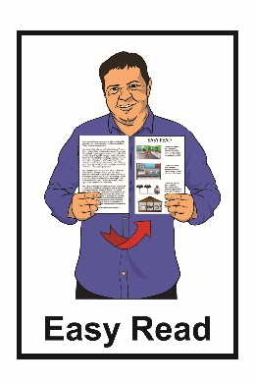
Report:
How the Government
is getting on with the
Disability Action Plan

6-monthly report:
January 2020 to June 2020
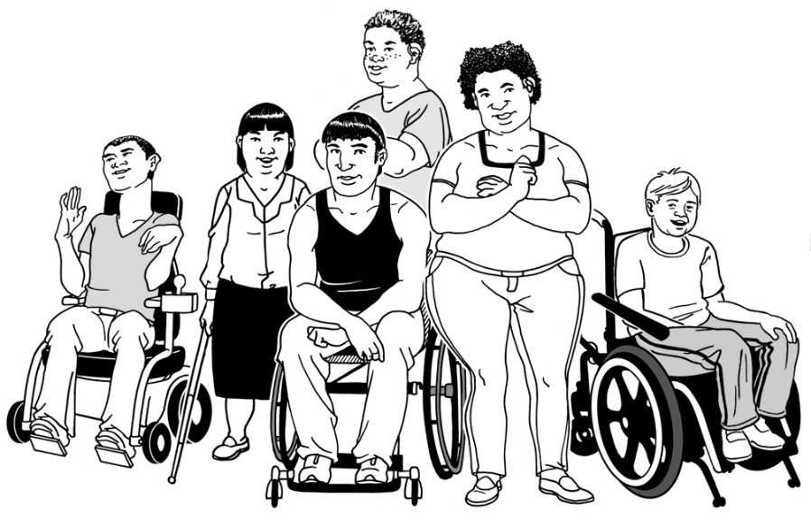

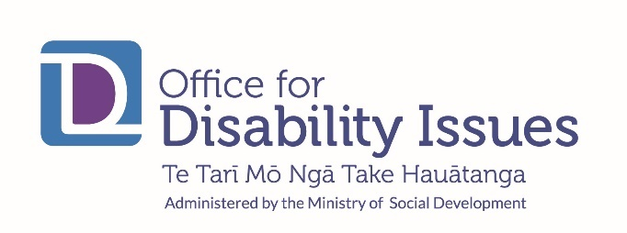
What you will find in this report

Page number:
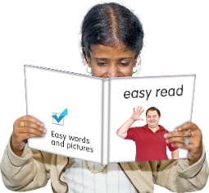

What is this report about?....................................3

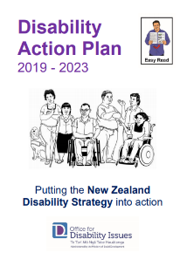

What is the Disability Action Plan?......................5

COVID-19………………………………………..….9

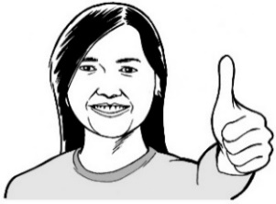

What has happened so far?....……………….....10

What the Department of Corrections
have done………………..……………………..…12

Page number:

What the Ministry of Health
have done………………………..………………..14

What the Ministry of Social Development
have done…………………………..……………..16

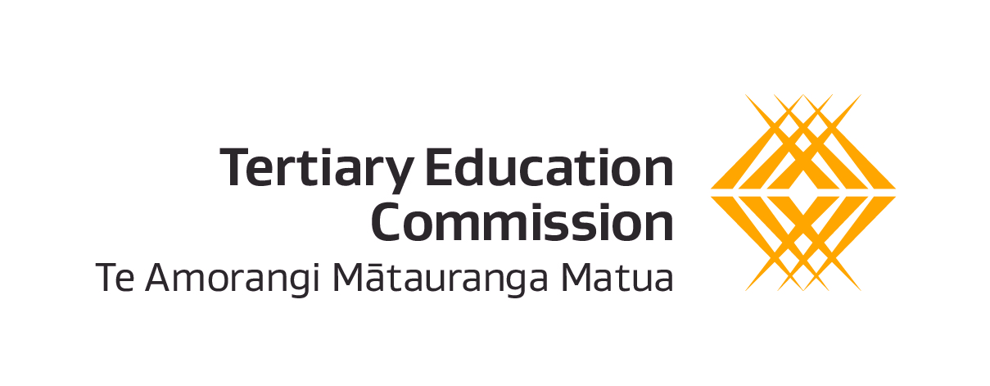
What the Tertiary Education Commission
have done……………………………..…………..19

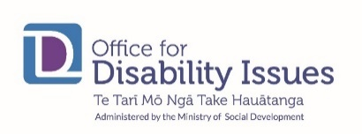
Where to find more information……………….…21

What is this report about?

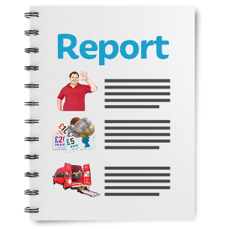
This Easy Read document is a report about how well the Disability Action Plan is working.

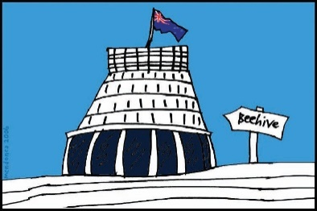
The Disability Action Plan is how the Government will make the New Zealand Disability Strategy happen.

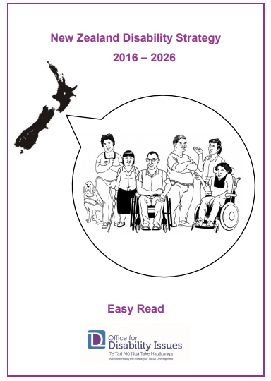
New Zealand Disability Strategy works to make sure disabled people:

- are treated fairly

- get what they need to have a good life

- are part of the community

- can make their own decisions.

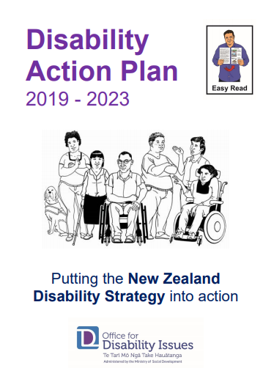
There are Easy Read translations about the:

- New Zealand Disability Strategy

- Disability Action Plan

You can find these Easy Read translations on the Office for Disability Issues website:

https://www.odi.govt.nz/

What is the Disability Action Plan?

The Disability Action Plan started in November 2019.

The Disability Action Plan works to improve the wellbeing of disabled people by working on main 8 main outcomes.

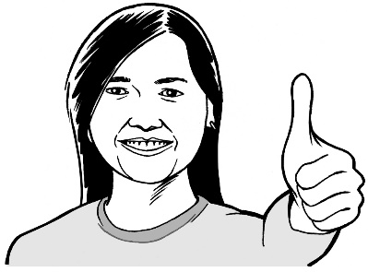
Wellbeing means how people feel about their lives.

Wellbeing can be things like:
- how you feel about your life
- health
- money
- housing.
Outcomes are the things we want to happen from the Disability Action Plan.

These outcomes are:

- Education

- Jobs and money

- Health and wellbeing

- Accessibility

- Disabled people as leaders.

- Disabled people having choices and control over their own lives

- Protecting the rights of disabled people

- Attitudes towards disability.

You can find more information about the things being worked on in each of these outcomes in the Disability Action Plan.

You can find this Easy Read translation on the Office for Disability Issues website:

https://www.odi.govt.nz/

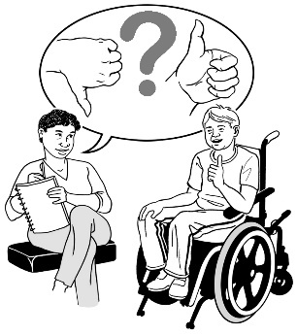
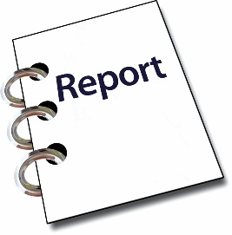
Every 6 months the Office for Disability Issues puts out a report about what the different parts of government are doing from the Disability Action Plan.

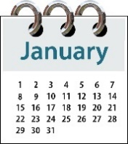
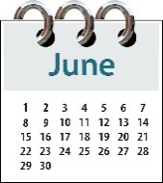
This report looks at what the different parts of government did from January 2020 to June 2020.
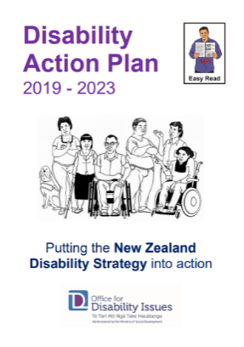

These reports are the one of the ways to see how well the Disability Action Plan is working.

1
This report is the first report they have done.
COVID-19

COVID-19 has changed how the Disability Action Plan is being done.

COVID-19 is a virus that can make people very sick.

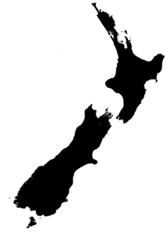
Everyone in New Zealand had to make changes to stop people getting COVID-19.

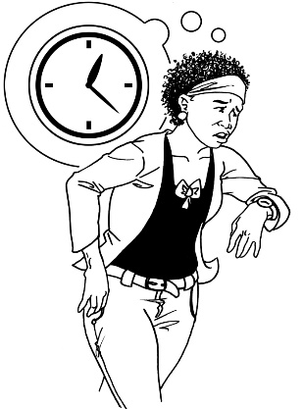
Some work programmes:
- have started late
- have not started yet but will start later
- had to change what they were doing.

What has happened so far?

29
The Disability Action Plan has 29 work programs.

The people working on 9 of these programs reported they have not done as much as the plan said.
9

The people working on these programs said they think they will still finish their work on time.

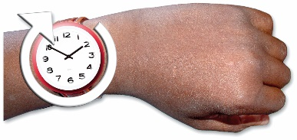
The Disabled Persons Coalition said that 2 of these programmes have had problems doing their work on time.

No work programmes reported problems that would stop them completing their work.
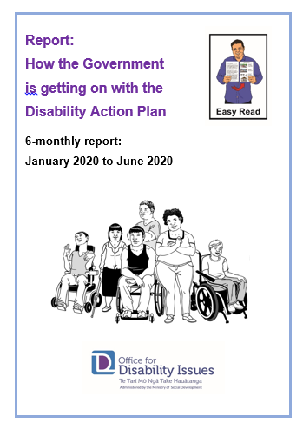
Some important things have been done by different government departments.

In this Easy Read report we look at some examples of good work that has been done by:
- Department of Corrections

- Ministry of Health
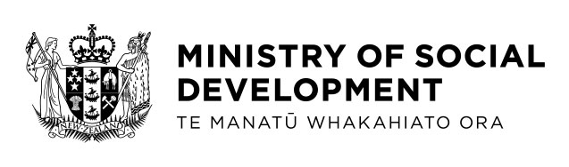
- Ministry of Social Development

- Tertiary Education Commission

What the Department of Corrections
have done

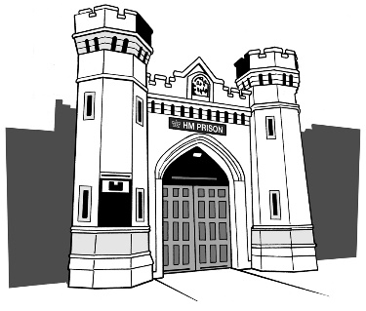
The Department of Corrections looks after places like prisons in New Zealand.

The Department of Corrections has stopped using tie down beds in prisons.

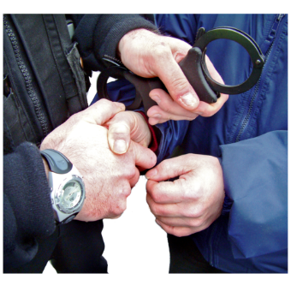
Tie-down beds are beds that have cuffs for:

- hands
- feet
- waists.

These beds are used to tie people down so they cannot move.

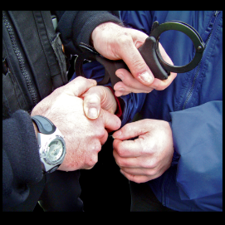
Taking away tie down beds is part of their program to:
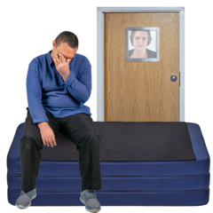
- use forms of restraint less
- reduce segregation.

Restraint is when someone is stopped from doing something.

Restraints can be things like:

- someone being tied to a bed or chair
- given medicine to stop someone doing something.

Segregation in New Zealand prisons is when someone is put in a place on their own.

What the Ministry of Health have done

In September 2020 the government took away Part 4A of the Health and Disability Act 2000 was started.

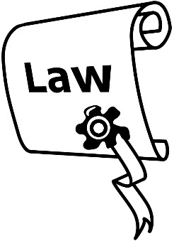
The Health and Disability Act 2000 is part of New Zealand law.

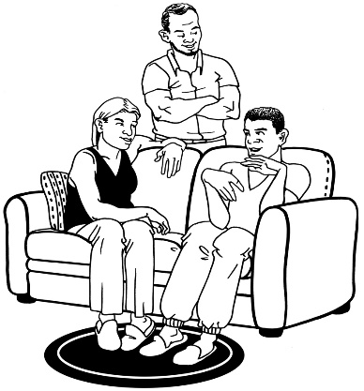
Part 4A of the Health and Disability Act 2000 was about:
- not allowing family of people with disabilities to be paid as carers
- what family care policies would allow family members to be paid as carers.

By taking away Part 4A some laws have changed.

These laws are about:
- Ministry of Health paid family care policies
- District Health Board paid family care policies.

The changes are:
- more pay for family / whānau carers
- having choices about how having a paid carer would work
18
16
- changing the youngest a carer can be from 18 years old to 16 year old
- making it so some partners and spouses will be paid for being a carer.
What the Ministry of Social Development
have done

The Ministry of Social Development worked hard at putting in place the Accessibility Charter.
Agreement
The Accessibility Charter is written by the Ministry of Social Development

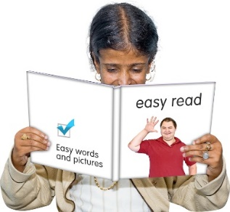
The Accessibility Charter is an agreement about:
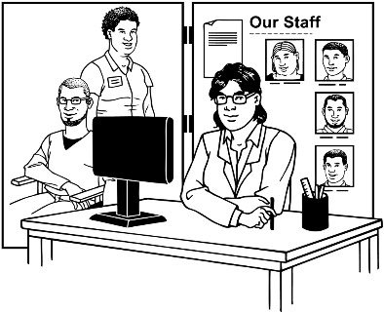
- having government information in ways that everyone can understand

- making government services in ways that work for everyone.

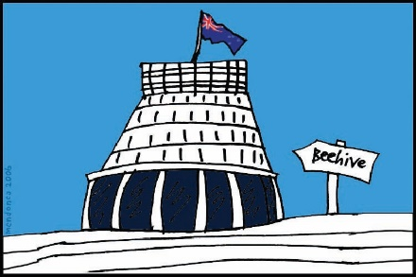
All of the government agencies have signed up to follow the Accessibility charter.

This means that:
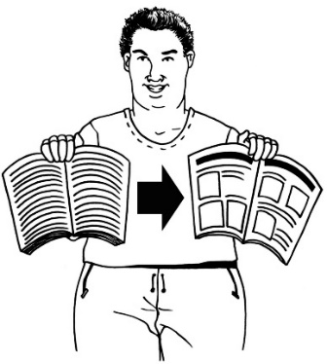
- all government agencies have agreed to make their important information accessible formats such as:

- Easy Read
- New Zealand Sign Language

- Braille

- Large Print

- Audio.
- all government agencies have agreed to make their services easy to use.

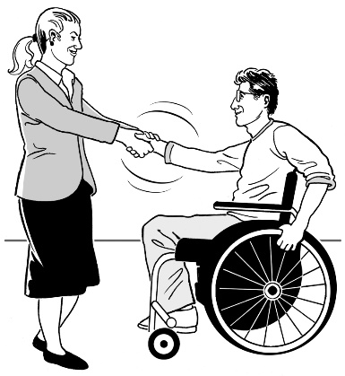
The Ministry of Social Development also updated the Lead Toolkit.

The Lead Toolkit is information to support businesses in having disabled people work for them.

What the Tertiary Education Commission
have done

The Tertiary Education Commission has been working on making it better for disabled learners in tertiary education.

Tertiary education is the learning that people do after high school / college.

You can do tertiary education at:
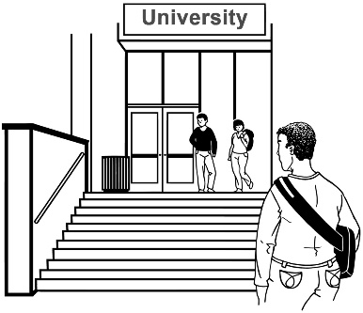
- universities

- polytechnics

- other tertiary education places.

The Tertiary Education Commission:
- put in place Disability Action Plans which is a list of things they want to work on
- got data from tertiary places such as universities.

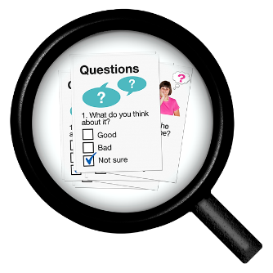
Data means collecting information about things.

The data can be used to look at things like:
- knowing how many people have disabilities
- knowing if an action plan is working
- learning how well students with disabilities finding their time at tertiary education.
Where to find more information

You can more information about what other government agencies have done in the full report called:

Office for Disability Issues:
Bi-annual Progress Report –
January to June 2020

You can find this report on their website:

https://www.odi.govt.nz/

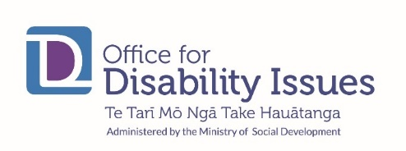
You can contact the Office for Disability Issues:
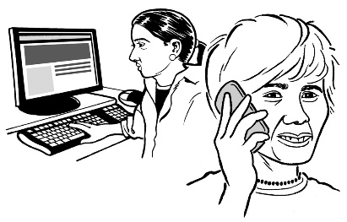
Phone: 04 916 3300

Email: odi@msd.govt.nz

This information has been written by the Office for Disability Issues.

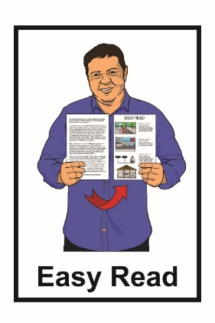
It has been translated into Easy Read by the Make It Easy service of People First New Zealand Inc. Ngā Tāngata Tuatahi.

The ideas in this document are not the ideas of People First New Zealand Ngā Tāngata Tuatahi.
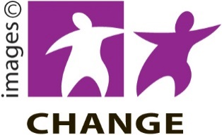
Make It Easy uses images from:

- Changepeople.org

- Photosymbols.com

- Sam Corliss

All images used in this Easy Read document are subject to copyright rules and cannot be used without permission.

