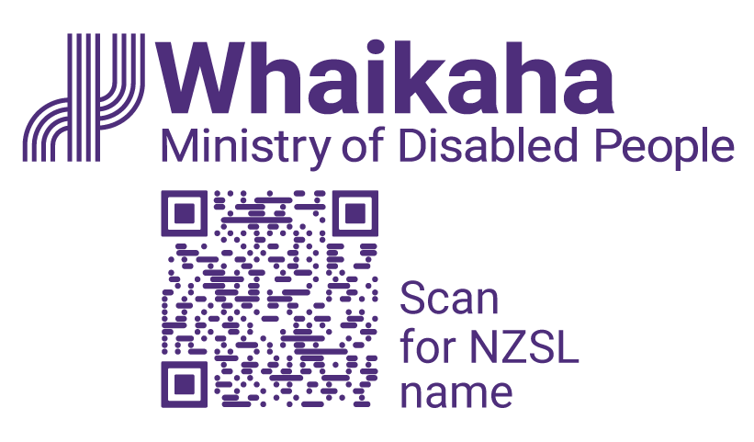
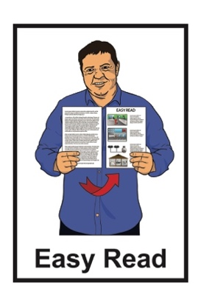

Starting the

Growing Voice and Safety

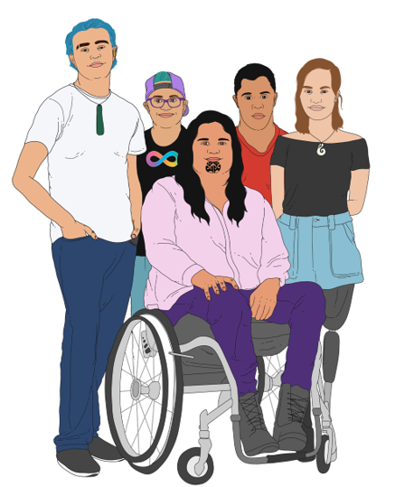
services

Published: November 2023

What you will find in this document

Page number:

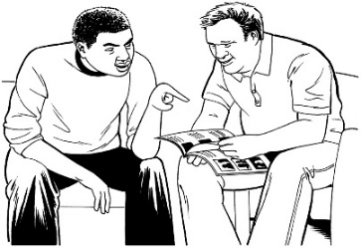
Before you start 3

What is this document about? 5

What is Growing Voice and
Safety? 6

What will Growing Voice and
Safety do? 11

What is People for Us? 19

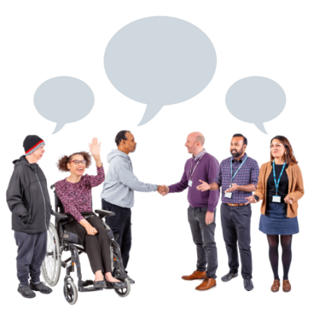
What is Assisting Change? 23

What is the procurement
process? 26

How to contact Whaikaha 30

Before you start
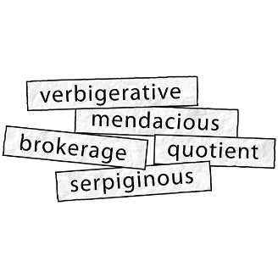

This document has some hard words in it.

These hard words are explained.

You may want to ask someone to support you while reading this document to understand some of these hard words.

This document also talks about abuse.

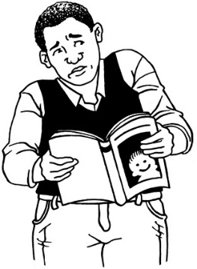
This information may upset some people when they are reading it.

This information is not meant to scare anyone.
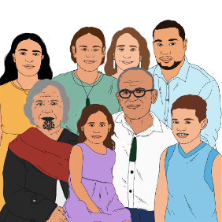
If you are upset after reading this document you can talk to your:
whānau / family
friends.

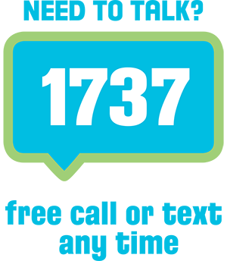
You can also contact Need to Talk by:
calling 1737
texting 1737.

It does not cost any money to call / text 1737.

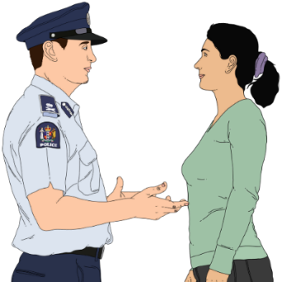
If you do not feel safe call the police on 111.

What is this document about?

This Easy Read document is about
2 new services from Whaikaha – the Ministry of Disabled People.

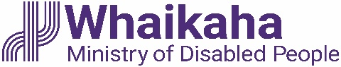
In this document Whaikaha –
the Ministry of Disabled People will be called Whaikaha.

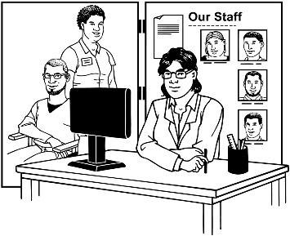
This document will also talk about the procurement process for the 2 new services.

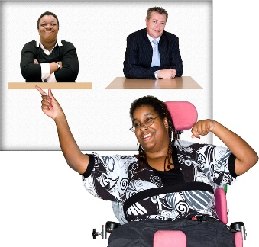
A procurement process is choosing the right organisations to do services at a good price.

What is Growing Voice and Safety?

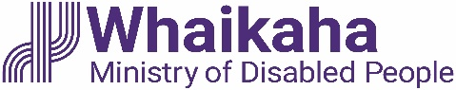
Growing Voice and Safety is the name of 2 new quality improvement services from Whaikaha.

Quality improvement means putting in place ways of doing things that work better for everyone.

You can find more information about Growing Voice and Safety on this website:

tinyurl.com/3tcze86w

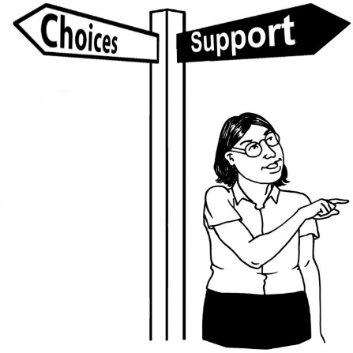
The 2 new services are called:
- People for Us
- Assisting Change.

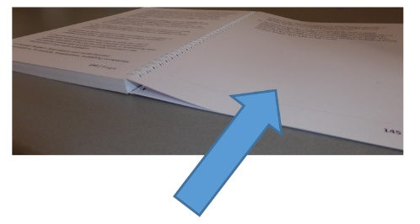
You can find information about People for Us on pages 19 to 22.

You can find information about Assisting Change on
pages 23 to 25.
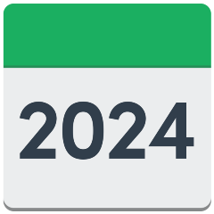

These 2 new services will start in the middle of 2024.

Whaikaha will be giving funding to the 2 new services.

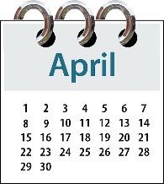
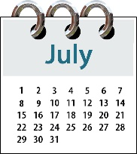
Growing Voice and Safety was designed / put together from April to July 2023.

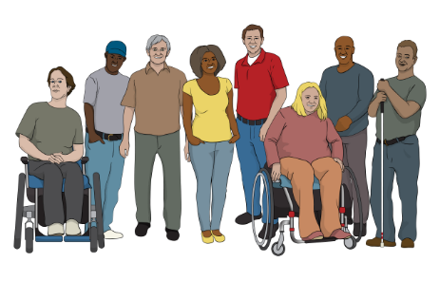
Growing Voice and Safety was designed with support from:
the disability community
support providers.

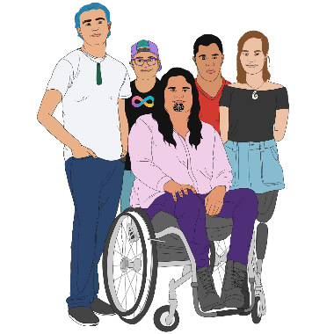
Growing Voice and Safety is for:
disabled people
tāngata whaikaha Māori / Māori disabled people.

Growing Voice and Safety will be used to make sure these people have:
safety
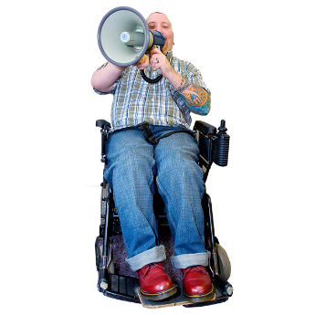
ways to be listened to
good lives
human rights.

In services Whaikaha pays for
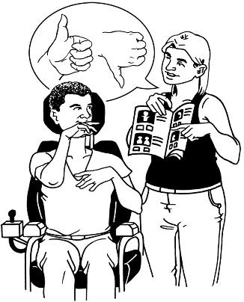
Growing Voice and Safety will also make there be less:
neglect
abuse.

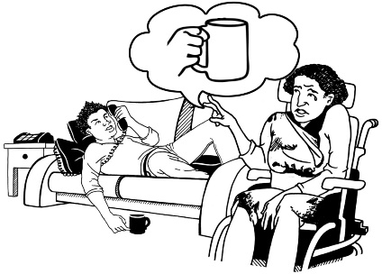
Neglect is when someone does not give you the things you need to live a good life.

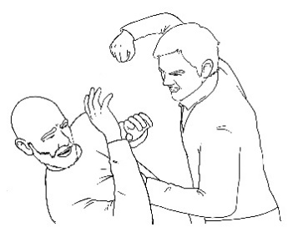
Abuse can be:
hitting
kicking
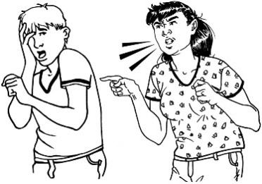
yelling
saying things that are not nice.

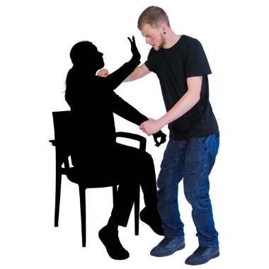
Abuse can also be doing sexual things to you that you do not want like:
kissing
touching
making you have sex.

What will Growing Voice and Safety do?

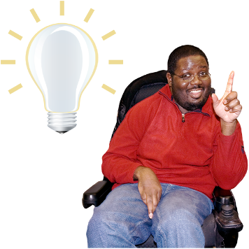
The Insights Alliance worked with people at Whaikaha to come up with ideas to make the 2 new services work well.

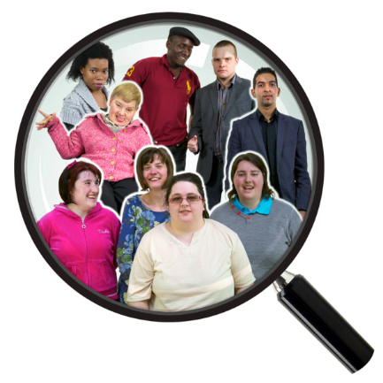
The Insights Alliance is a group of people who look at the changes happening in:
disability support organisations
Whaikaha.

People in the Insights Alliance are:
tāngata whaikaha Māori / Māori disabled people
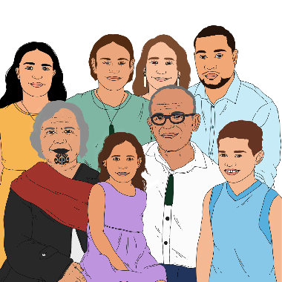
disabled people
whānau / families of disabled people
Whaikaha staff.

The ideas they came up with became part of the 7 outcomes the new services will make happen.
7

An outcome is a result someone would like to get from a:
service
person
group.

Outcome 1

The people using Whaikaha funded services will experience:
safer lives
better wellbeing.

Wellbeing means things like:
how we feel about ourselves
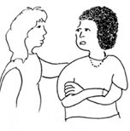
looking after our bodies with good food and exercise
getting support when we are feeling sad or worried.

Outcome 2

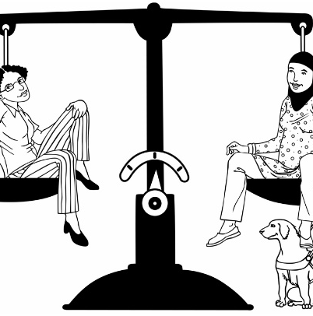
Getting equity is important in everything the services do.

Equity means everyone gets what they need to live a good life.

Equity is important for:
tāngata whaikaha Māori / disabled Māori
the whānau / families of disabled Māori.

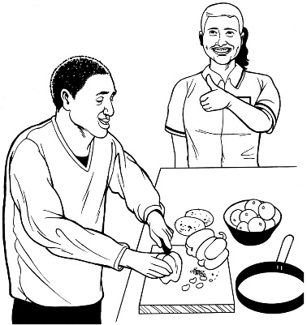
Outcome 3

People for Us workers have what they need to be good at their job.

Outcome 4

The organisations delivering the People for Us services are led by:
tāngata whaikaha Māori / Māori disabled people
disabled people.

They must include what whānau / families of disabled people think.

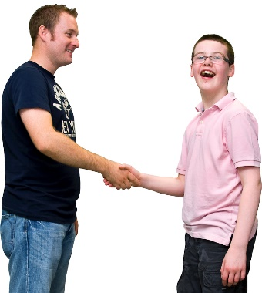
The organisations must be:
independent which means they make their own decisions
trusted
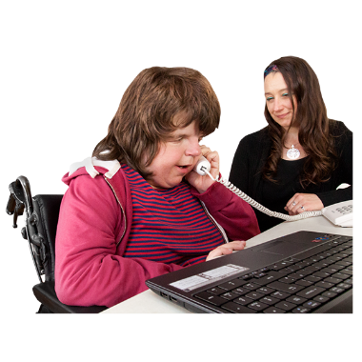
connected to the disability community
good at what they do.

Outcome 5

The organisations delivering the Assisting Change services are led by:
tāngata whaikaha Māori / Māori disabled people
disabled people.

They must include what whānau / families of disabled people think.

The organisations must be:
independent
trusted
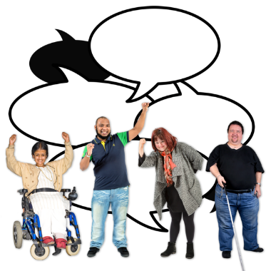
connected to the disability community
good at what they do.

Outcome 6

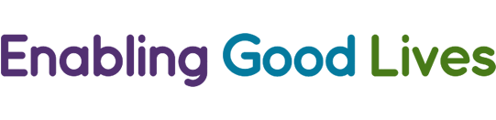
Disability support providers are supported to give safer services that use Enabling Good Lives:
vision
principles.

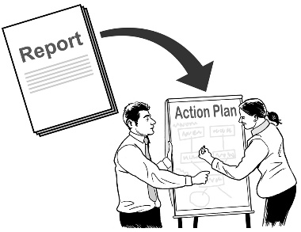
Here vision means ideas of what things should be like.

Here principles are ideas that guide an organisation to reach its goals.

Outcome 7

Whaikaha gets good information about the services it makes happen to make sure they are:
safe
very good.

What is People for Us?

People for Us will:
make other ways for disabled people to be listened to
work outside of Whaikaha
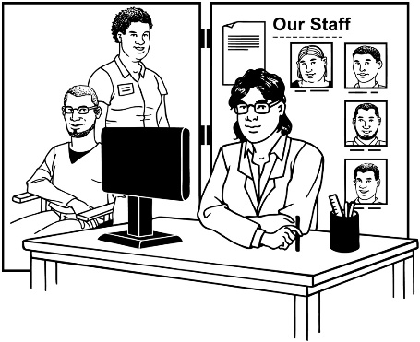
be separate from other service providers.

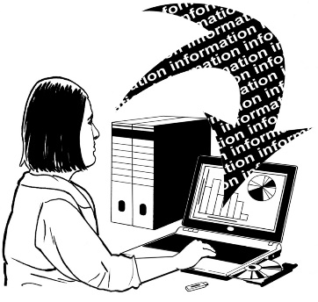
People for Us will collect information disabled people have about:
their concerns
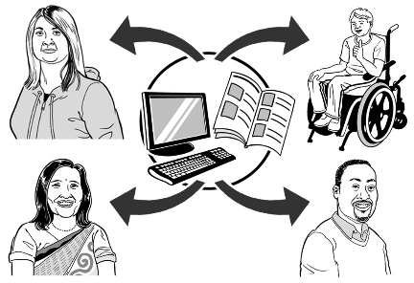
things that are important to them
things that keep happening.

This information will be shared with Whaikaha to make things better for:
services
the disability community.

People for Us used to be called disabled person led peer monitoring.

The people working for People for Us will be:
tāngata whaikaha Māori / Māori disabled people
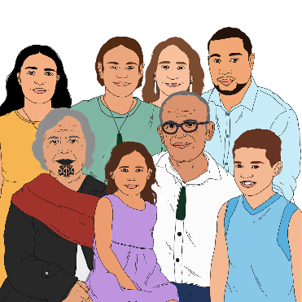
disabled people
whānau / family of disabled people.

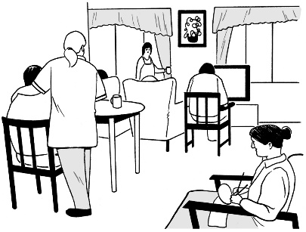
This first thing People for Us will do is work with disabled adults who live in residential services.

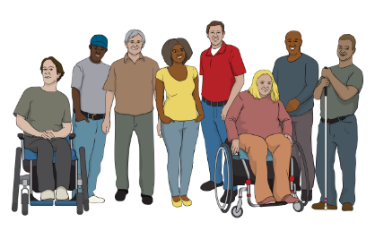
They will then add in other disabled people to their work.

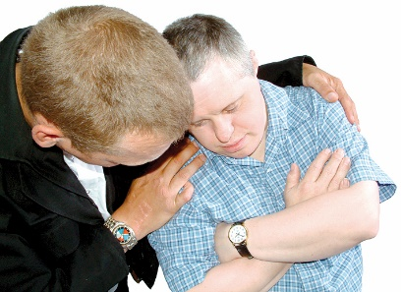
People for Us will have ways to support disabled people who are:
unsafe
unhappy.

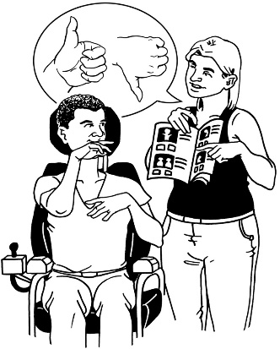
They will support disabled people to use the right service or services to work on their problem.

These services might be:
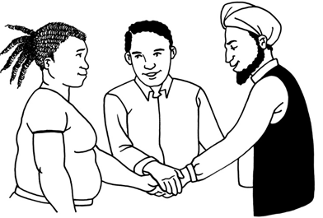
the Disability Abuse Prevention and Response team
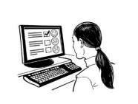
My Home My Choice
independent advocates
a complaints process
kaitūhono / connectors at Enabling Good Lives
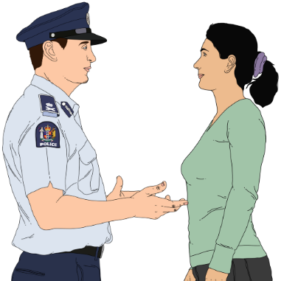
Needs Assessment Service Coordination
the Police.

What is Assisting Change?

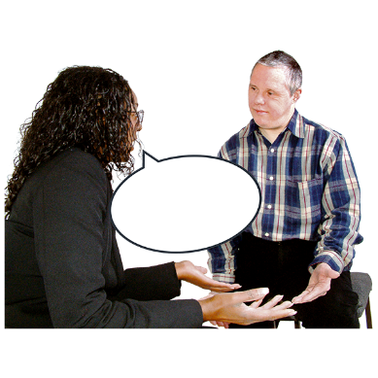
Assisting Change is an advice service.

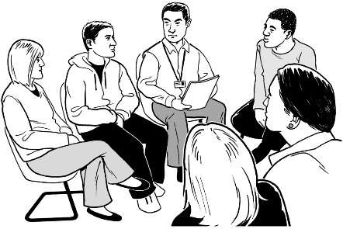
It will give lots of support to providers who are having trouble fixing their problems.

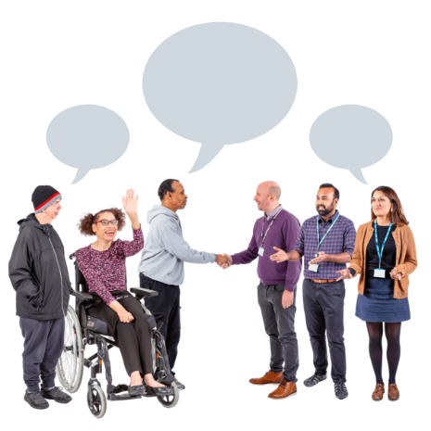
Whaikaha will hire a brokerage service.

A brokerage service is a group that connects the right people to a job that needs to be done.

The brokerage service will create a team of people with the right:
skills
experience.

Each of the people in the team will become an advisor.

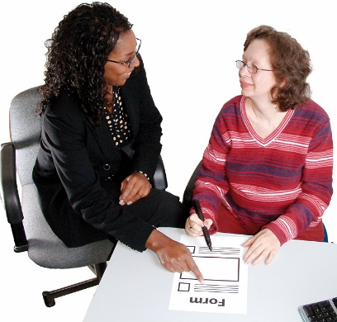
An advisor is someone who can support another person to:
understand something
do something.

The service will match an advisor with the support provider having problems for a short time.

The advisor will assist the support provider to fix their problems.

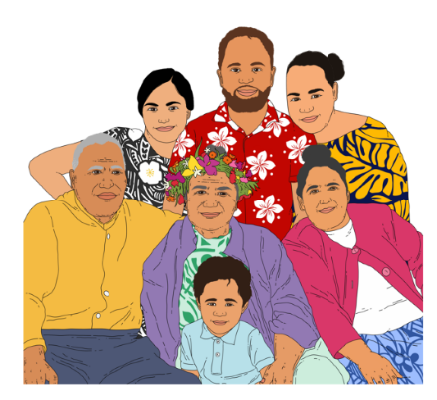
The service will also make sure they find teams who are the right fit for:
kaupapa Māori providers
Pacific support providers.

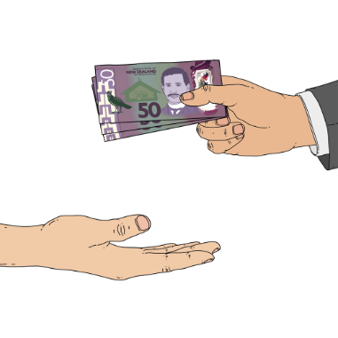
Whaikaha will also give some money to the work being done by each team.

What is the procurement process?

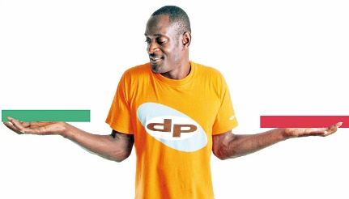
Whaikaha will decide how to make the Growing Voice and Safety services happen.

The first thing that might happen is a Registration of Interest from organisations who want to work for Growing Voice and Safety.

A Registration of Interest is a document an organisation makes to set out how they will do a job.

A Registration of Interest in working for Growing Voice and Safety must talk about how the organisation will make the 7 outcomes happen.
7

The organisation must also talk about how they match up with the things Whaikaha thinks are important to do.

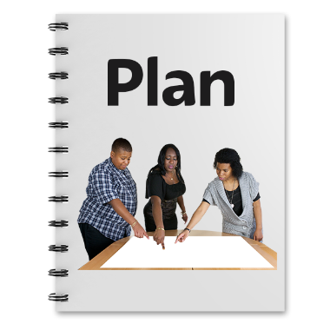
If Whaikaha thinks the organisation might do a good job they will ask them to do a Request for Proposal.

A Request for Proposal is a document that gives much more information about how the organisation will do the job.

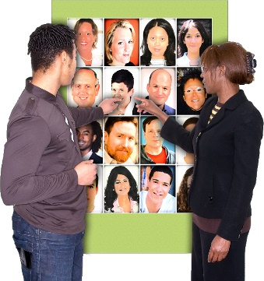
This might be things like:
who the workers will be
what skills they have
how much it will cost.

The procurement process for Growing Voice and Safety will be put on the Whaikaha website.

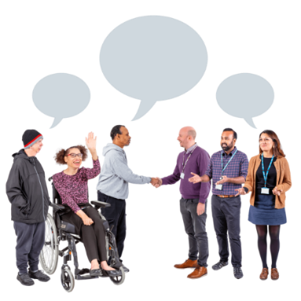
Whaikaha would like all organisations to think about taking part.

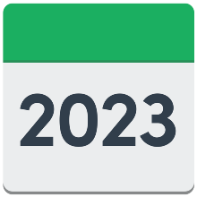
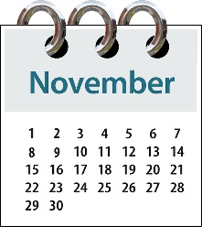
Whaikaha would like to start looking for people to work for Growing Voice and Safety at the end of
November 2023.

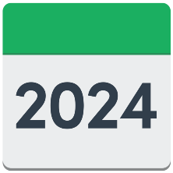
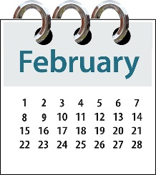
They think it will take organisations until February 2024 to get their documents ready.

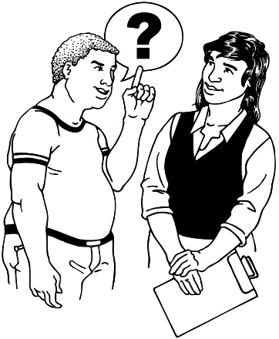
Whaikaha will make ways to answer questions about:
Growing Voice and Safety
the procurement process.

How to contact Whaikaha

You can contact Whaikaha about Growing Voice and Safety by:
email at:
quality@whaikaha.govt.nz

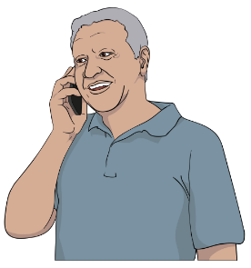
phone on:
0800 566 601

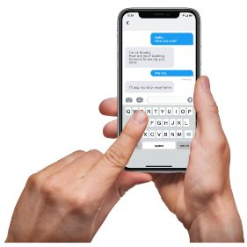
text on:
4206

If you find it hard to use the phone the New Zealand Relay service is for people who are:

- Deaf / hard of hearing
- deafblind

- speech impaired / find it hard to talk.

You can find out more about the New Zealand Relay service at:

www.nzrelay.co.nz

You can find more about how to contact Whaikaha on their website at:

www.whaikaha.govt.nz/contact-us
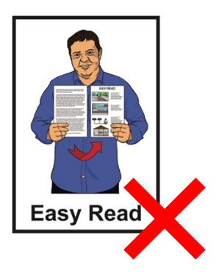

This website is not in Easy Read.

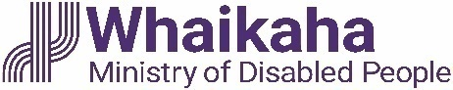
This information has been written by Whaikaha – Ministry of Disabled People.

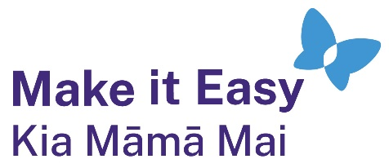
It has been translated into Easy Read by the Make it Easy Kia Māmā Mai service of People First New Zealand Ngā Tāngata Tuatahi.
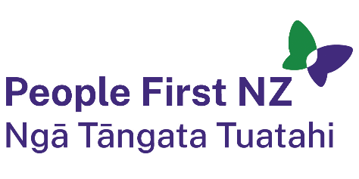
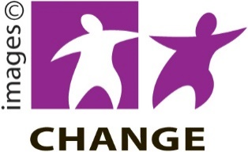
The ideas in this document are not the ideas of People First New Zealand Ngā Tāngata Tuatahi.

Make it Easy uses images from:

- Changepeople.org

            - Photosymbols.com

- SGC Image Works
- Huriana Kopeke-Te Aho
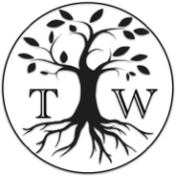
- T. Wood.
All images used in this Easy Read document are subject to copyright rules and cannot be used without permission.

