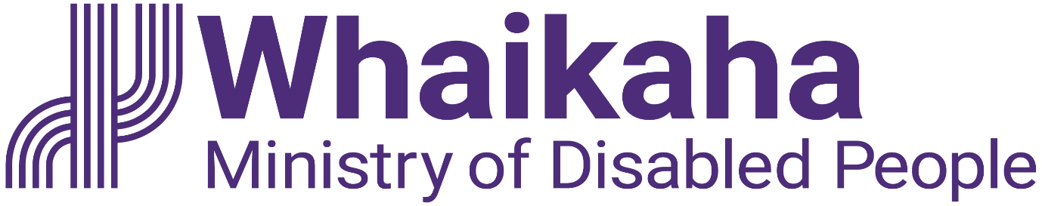
Growing Voice and Safety Goes Ahead

Adapted in 2023 by Accessible Formats Service, Blind Low Vision NZ, Auckland

TN: Logo at the top of the page is: Whaikaha Ministry of Disabled People.

Growing Voice and Safety Goes Ahead

Growing Voice and Safety
Growing Voice and Safety is the name of two new quality improvement services starting in mid-2024.
The disability community and service providers supported the design of these two services during April-July 2023, by contributing to the engagement process. We thank all of those people who contributed their thoughts and ideas for these services. Both services were approved and will go ahead.
The purpose of the services is to increase the focus on the safety, voice, good lives and human rights of disabled people and tāngata whaikaha Māori. While also reducing the risks and occurrences of neglect and abuse in services funded by Whaikaha.
The first service is called Growing Voice and Safety—People for Us, previously known as disabled person led peer monitoring.
The second service is Growing Voice and Safety—Assisting Change, focused on supporting providers who are experiencing quality issues to improve.
With the guidance of the Insights Alliance working group, the feedback collected during the engagement process was used to develop a number of themes. They became the basis for the following outcomes. These seven key outcomes will be delivered by the new services. They are:
1. Disabled people, tāngata whaikaha Māori, whānau and families will experience safer lives and increased wellbeing in Whaikaha funded services.
2. The access, experience and outcomes achieved are equitable across a range of dimensions, particularly for tāngata whaikaha Māori and their whānau.
3. Disabled people, tāngata whaikaha Māori, and family and whānau members have what they need to be effective People for Us workers.
4. The organisation(s) delivering People for Us is led by disabled people, tāngata whaikaha Māori and includes whānau and family perspectives, is independent, well-connected, effective and achieves equitable outcomes.
5. The organisation(s) delivering Assisting Change is led by disabled people, tāngata whaikaha Māori and includes whānau and family perspectives, is independent, credible, well-connected, and effective.
6. Disability support providers are supported to deliver safer services that are aligned with the EGL vision and principles.
7. Whaikaha has more evidence that the services it commissions are safe and are of high quality.
These seven key outcomes will be delivered by the two services across Aotearoa New Zealand. Whaikaha has committed funding to implement both services.

The procurement process we are undertaking
The procurement process is the way Whaikaha decides who will deliver the services. It will likely start with a Registration Of Interest (ROI) that will require organisation(s) to briefly outline how they will deliver the seven key outcomes and meet specific criteria. Those organisation(s) who meet the criteria of the ROI process will likely be invited to then submit a Request For Proposal (RFP) document.
This procurement process will be advertised on the Whaikaha website and linked to the Government Electronic Tenders Service (GETS) website. We encourage all organisations to consider becoming involved in the process. We are aiming to start in late November 2023 and then organisations will likely have until February 2024 to prepare their documents. Opportunities to ask questions and seek clarification will be provided.

The two services we are funding

Growing Voice and Safety—People for Us:
Workers will be disabled people, tāngata whaikaha Māori and whānau or family members. They will start working with disabled adults who live in residential services and over time the service will extend from these potentially at-risk people to include others. For those who are found to be unsafe or unhappy the workers will assist the disabled person or tāngata whaikaha Māori to follow the relevant pathway to resolve their concern e.g. the Disability Abuse Prevention and Response (DAPAR) Team, My Home My Choice, independent advocates, complaint process, EGL connectors/kaitūhono, NASC or the Police.
People for Us will sit externally from Whaikaha and be independent from direct service providers. People for Us will provide another mechanism to listen to the voices of disabled people and build a picture of concerns, issues and trends, that will be fed into the Whaikaha quality system and the disability community.

Growing Voice and Safety—Assisting Change:
Assisting Change is an intensive advisory service for providers who have quality issues and who do not have the capability and capacity to make improvements. Whaikaha will contract a brokerage service, linked to the Whaikaha audit/developmental evaluation programme. They will source a pool of specialist advisors with a diverse range of skill sets and experience. Then match the advisor to work alongside the provider for a short time to assist them to change their specific quality issues. This will include culturally appropriate matches for Kaupapa Māori and Pacific providers. Whaikaha will also fund a contribution to the intensive advice.

Get in touch with us
If you have any questions or comments about these services, you can email quality@whaikaha.govt.nz.
This information can be found on our website under Engagement forums Growing voice and safety (https://www.whaikaha.govt.nz/engagement-forums-growing-voice-and-safety-2/, or at https://tinyurl.com/3tcze86w)
Please visit our Contact us webpage for all our contact information: https://www.whaikaha.govt.nz/contact-us/

You can also contact us on:
Phone: 0800 566 601
Mon, Tue, Thur, Fri: 8am-5pm.
Wed: 9:30am-5pm
Text: 4206
If you are Deaf, hard of hearing, deafblind, speech impaired or find it hard to talk, you can use the New Zealand Relay Service. https://www.nzrelay.co.nz
End of Growing Voice and Safety Goes Ahead

