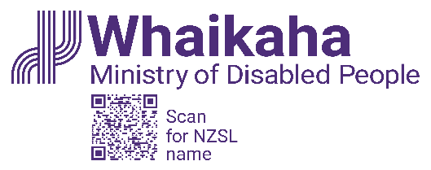
Outcomes framework
Published July 2023
Disabled people and their whānau are placed in the top row to reflect the deliberate
and explicit shift in power by the system transformation.
 | Rights and Protection | Wellbeing | Authority | Equipped | Developing and achieving | Connections | Belonging
 | We are safe and our rights are upheld | We are happy and healthy, both emotionally and physically. | We have choice and control over the service provision to suit our needs. | We have the support and resources we need. | We have agency and are living our good life. | We are connected in positive ways to whānau, society and networks. | We belong, contribute to and are valued by our community.
Disabled people and whānau | We live in a safe environment.  We know how to access support if we feel unsafe.  We can access places, services and information with ease. | Our health and mental wellbeing needs are met.  We have positive self-esteem. | We have control of our funding and where we spend it.  We are living a life consistent with our aspirations and goals. | We have resources to enable material wellbeing.  We direct the support and services to lead Good Lives.  We have knowledge, resources and skills to lead Good Lives. | We are building confidence and developing skills.  We are making progress towards our Good Life. | We have constructive whānau relationships.  Our personal relationships are acknowledged and respected.  We have affirming social networks beyond family. | We are valued contributors to society.  We are connected to culture, family and community.
Services | Support accessed is in keeping with the EGL principles.  Kaupapa Māori approaches are valued and available. | Providers know how to support achieving Good Lives.  Designing systems, supports and services is done in partnership. | Funding is allocated on an individual basis.  Capable tūhono facilitate planning for Good Lives. | Service provision matches requirements.  Community options are used first before specialist services | Education, training and employment opportunities are provided. | There are networks of support in the community.  Culturally suited independent allies are available. | Public services are available for use by all.  Communities are informed and responsive.
System | Whakahaumaru safeguarding systems enable people to make choices with agency. | There are mechanisms for alignment of support across government agencies. | Authority shifts to disabled people and whānau.  Commissioning enables our authority. | Resource provision through work across agencies. | Policy settings across government align with Enabling Good Lives principles. | Investment builds community support networks. | Central government enables community leadership.

Enabling Good Lives (EGL) principles
underpin the outcomes
EGL principles: Self-determination, beginning early, person centred, ordinary life outcomes,
mainstream first, easy to use, relationship, mana enhancing

Partnership
Working in partnership with disabled people and whānau, including a particular focus on partnership with Māori is evident when there is:
- Partnering in the governance, design, delivery and monitoring of health and disability services.
- A strong focus on shared decision making, co-design, leadership and governance.
Equity
Increased wellbeing for all disabled people and whānau with equity of outcomes for Māori and Pacific peoples involves:
- Kaupapa and Pacific approaches to support.
- Choice and control of decision making for all.
- Evolving the capability of disabled people to be leaders in their own lives and communities.
Stewardship
A sustainable, values driven sector working for disabled people and whānau includes:
- A policy agenda to better understand and adapt to changing nature of disability.
- A system level performance model that drives system improvement and better outcomes.
Value for money
Disability services are adequately funded to effect system transformation and improved outcomes for disabled people and whānau. This means
- Strategic investment for support funding that drives value and better outcomes.

