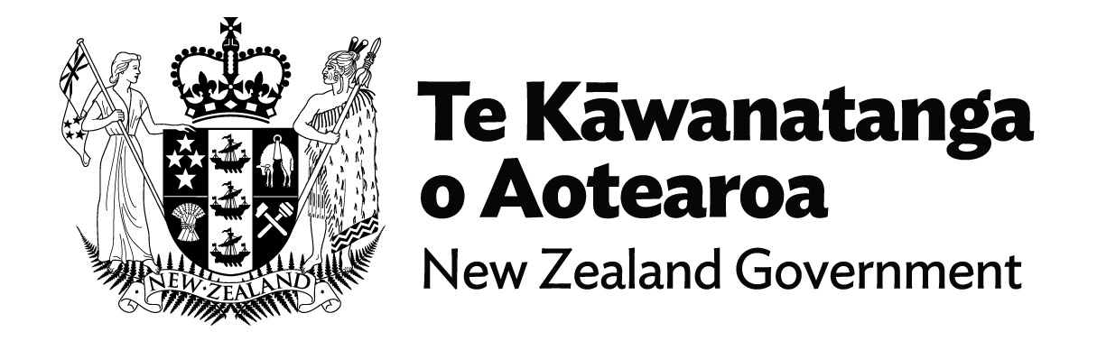

Fact Sheet - Item Two: New Ministry for Disabled People
The recent reforms of the Health system and evolving government priorities have provided an opportunity to review the current arrangements for working with, and supporting, the one in four New Zealanders that identify as disabled.
The current cross-government disability system presents barriers for many disabled people and whānau in achieving ordinary life outcomes. Supports can be fragmented and difficult to navigate, and multiple eligibility criteria for different services makes it difficult for disabled people to know what support services they are entitled to.
That’s why the Government is introducing a Ministry for Disabled People – to lead the realisation of a true partnership between the disability community and government, and to help drive ongoing transformation of the disability system in line with the Enabling Good Lives (EGL) approach.
The new Ministry will take on most functions currently delivered by the Disability Directorate (DSD) in the Ministry of Health (MoH), as well as taking on new responsibilities.
The ambition for the new Ministry is aspirational. To truly transform the way government serves disabled people, tāngata whaikaha Māori, families and whānau, the Government decided to look beyond disability supports to examine and strengthen the cross-government disability system.
The new Ministry will have a range of functions that will expand in the future as Disability System Transformation progresses.
All government agencies will continue to have responsibility to disabled people, for example the health system continues to have responsibility for the health outcomes of disabled people.

This will mean:
- ensuring the Enabling Good Lives vision and principles as the basis on which government supports disabled people across their lives,
- working in partnership with disabled people and ensuring a high level of trust and transparency,
- lifting the profile and visibility of disability across government.

Ensuring the system:
- gives full effect to the voice of disabled people, families, and whānau, and to Te Tiriti o Waitangi,
- is consistent with the United Nations Convention on the Rights of Persons with Disabilities and the United Nations Declaration on the Rights of Indigenous Peoples,
- aligns with the principles and approaches of Whānau Ora,
- strengthening disability rights approaches across government strategies, including the Child and Youth Wellbeing Strategy, Better Later Life – He Oranga Kaumātua, the New Zealand Disability Strategy, and Mahi Aroha – the New Zealand Carers’ Strategy,
- improving cross-government disability data and information
- developing a disability-focused research and evaluation strategy.

The new Ministry for Disabled People will also:
- Lead the Disability System Transformation work.
- Operate as a Ministry, including providing policy and budget advice to the Minister of Disability Issues.
- Manage relevant legislation.
- Fully implement, from an initial pilot, the Enabling Good Lives approach (including funding).
- Continue to work with MoH on broader health and statutory requirements.
- Continue to work with MoH on payment processes (until transition).
- Operate the needs assessment system.
- Provide for long term home based and community support for 43,000 people.
- Provide equipment and modification services to 83,000 people.
- Provide 22,000 people access to hearing aid and subsidy schemes.
- Process 90,000 to 100,000 claims.
- Manage bulk funded providers.
- Manage 1,500 contracts and 975 service providers.
- Manage appropriation of $1.8b.

Next Steps:
Cabinet has tasked the Ministry of Social Development (MSD) with establishing and hosting the new agency, which will have its own Chief Executive.
The new agency will ultimately be functionally and operationally autonomous from MSD, once it has established itself and is in a good position to carry out its functions and mandate.
Given the scale and scope of the new agency, MSD is setting up a dedicated Transition and Establishment Team to support its establishment, and the transition of MoH functions.
The Transition and Establishment Team will be in place in the very near future, with the new Ministry being established from 1 July 2022.
The Team will build on insights from the establishment of new Ministries, such as Oranga Tamariki and the Ministry of Housing and Urban Development. A key focus will be ensuring disabled people continue to receive support over the transition.
The Team will work closely with the disabled community and their families/whānau to understand their dreams and aspirations for the new agency, to ensure the community’s vision is built into the DNA of the new agency.
There will be continuity of disability support services during the transition period.
Please check back in the coming weeks and months for updates on our progress and for information of how you can be involved.
You can access the Minister’s announcement here.
You can access the Cabinet paper here.

End of Fact Sheet - New Ministry for Disabled People

