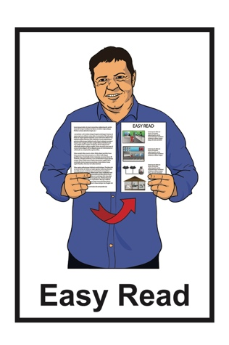
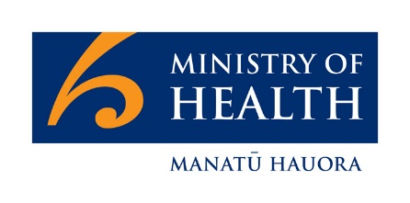

Letter to people getting

Disability Support Services from the Ministry of Health

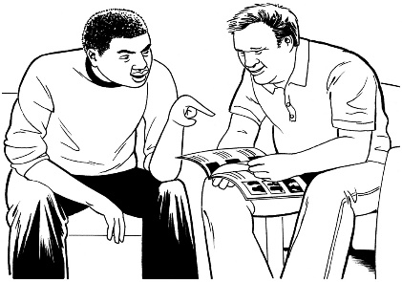

June 2022

What is this letter about?

This letter is from Amanda Bleckmann.

Amanda is the Group Manager of the Disability Directorate at the Ministry of Health.

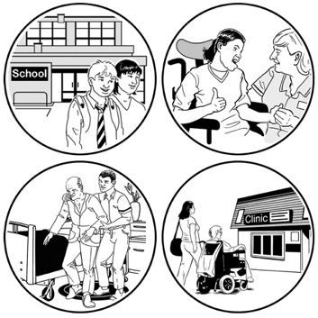
This letter:

- is for people who get disability support services funded by the Ministry of Health

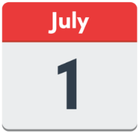
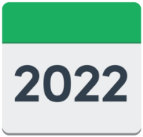
- tells you what will happen to your disability support services when the new Ministry for Disabled People starts on 1 July 2022.

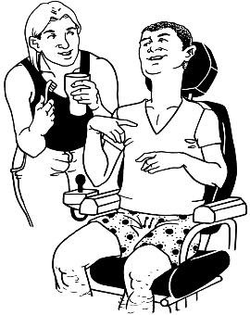
Some examples of disability support services funded by the Ministry of Health are:

- supported living
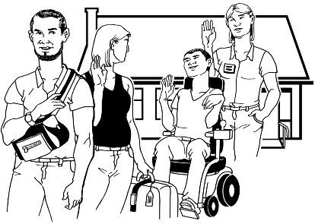
- respite services
- home support
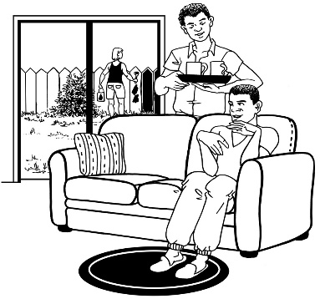
- community residential support
- individualised funding
- carer support.

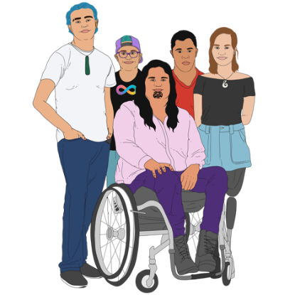
The Ministry for Disabled People is a new part of the government that over time will:

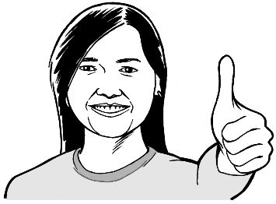
- make disability support services better for disabled people and their families / whānau

- use an Enabling Good Lives way of doing things

- work with other government agencies to better support disabled people.

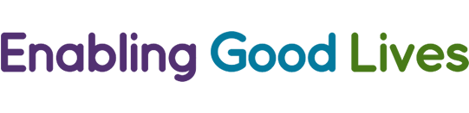
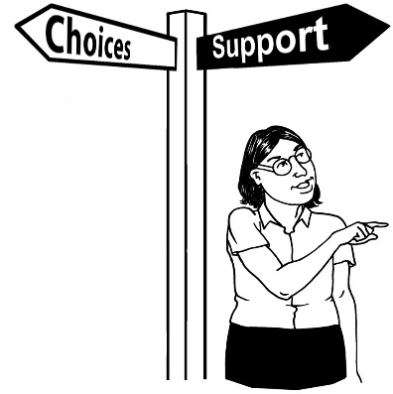
Enabling Good Lives is a way of doing disability support that gives you:
- choice and control in your life
- the support you need and want.

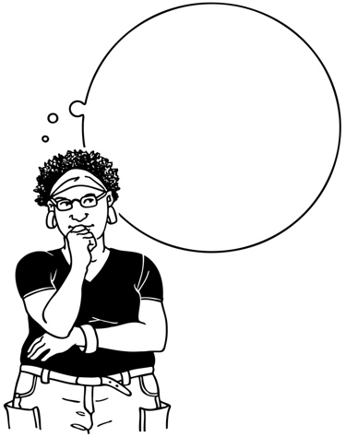
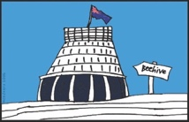
The name for the new Ministry for Disabled People has not yet been decided.

In this document we will call it the new Ministry.

What will happen to your

disability support services?

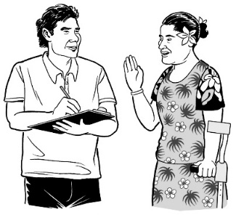
The new Ministry will take over the running of Disability Support Services from 1 July 2022.
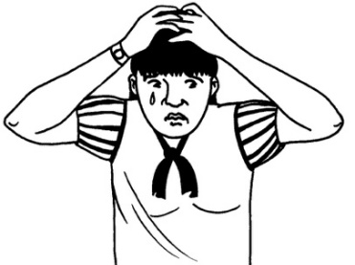

You do not need to worry about this change.

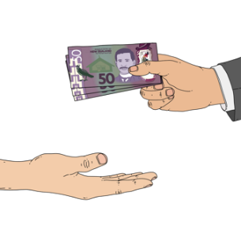
The disability support funding / services that you already get will not change.

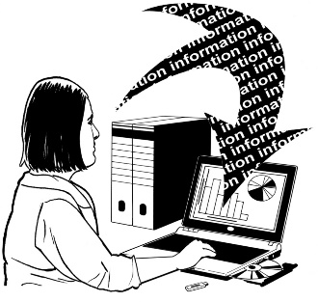
The information about your disability support services will be moved from the Ministry of Health to the new Ministry.

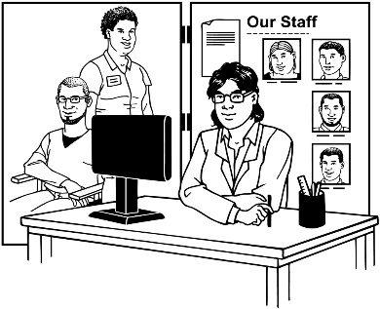
The service providers / organisations that you get your services from will not change.

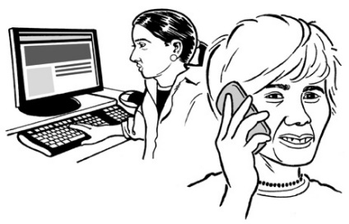
If you have 1 you will still be able to talk to your:

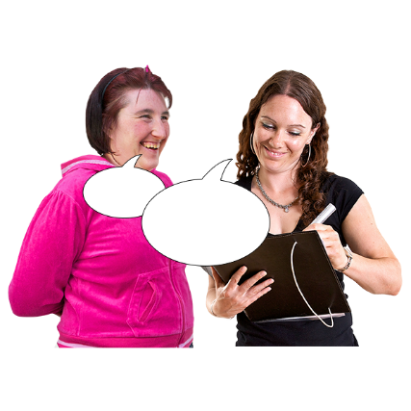
- Enabling Good Lives Kaitūhono / Connector

- Needs Assessment Service Coordinator also called a NASC.
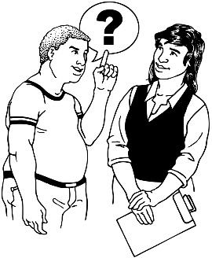

They will still be able to answer any questions you have.

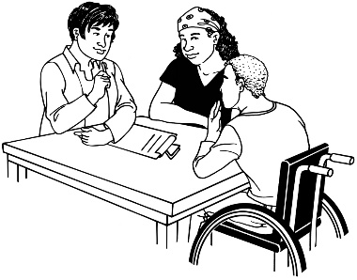
There will still be reviews / reassessments of your disability support services.

A review / reassessment means looking at how well your disability support services are working for you.

This may mean changes to your disability support services.
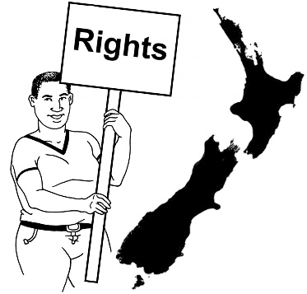

Your rights as a service user will not change.

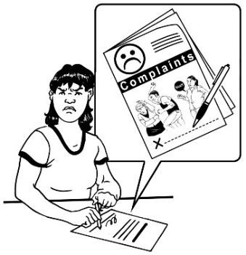
This means you will still be able to:
- make complaints to the new Ministry about your disability support services
- tell the new Ministry what is working well for you.

1 important change to know about

There is 1 change that is important for you to know about.

From 1 July 2022 the information that the new Ministry has about your disability support services will be shared with Health New Zealand.

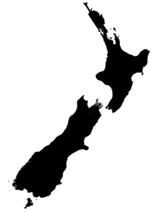
Health New Zealand is the new health system that also starts from 1 July 2022.

Health New Zealand will mean everyone in New Zealand will get good health care wherever they live.

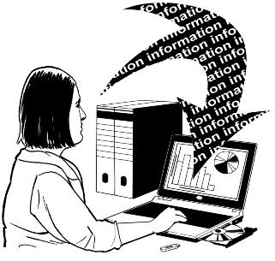
The sorts of things that will be shared with Health New Zealand will be information about your:

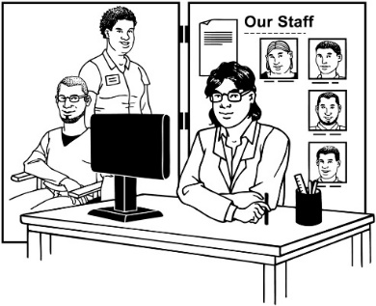
- Enabling Good Lives services

- Needs Assessment and Service Coordination services.

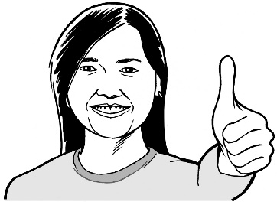
This information will be shared to make sure the new Ministry can keep giving you the funding you need for your disability support services.

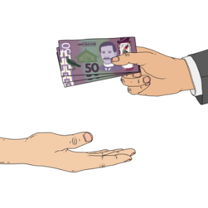
From 1 July 2022 Health New Zealand will make the payments for your disability support services.
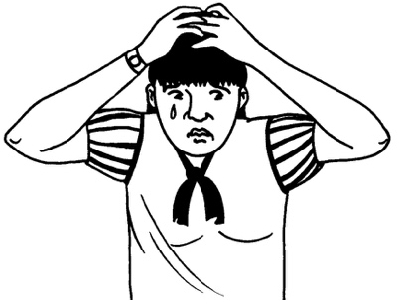

You do not need to worry about this change.

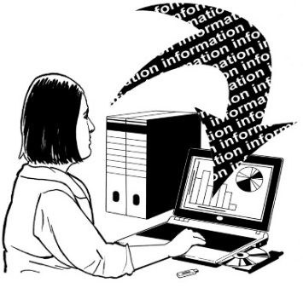
The new Ministry and Health New Zealand will:

- not share any information about you with anyone else

- follow the rules as set out in the Health Information Privacy Code 2020.

If you have any questions about your information being shared you can call Disability Support Services on:

0800 373 664

It will not cost you any money to call this number.

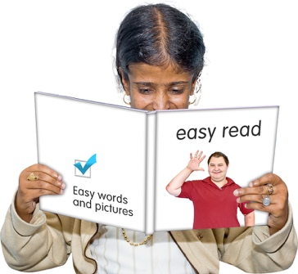
You can also find out more about
Health New Zealand in this
Easy Read document:

https://bit.ly/3y7mB52

How to contact the new

Ministry for Disabled People

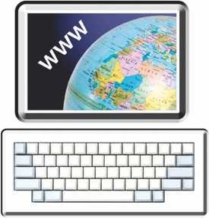
You can find more information about the new Ministry at this website:

www.whaikaha.govt.nz

You can also:

Call: 0800 566 601

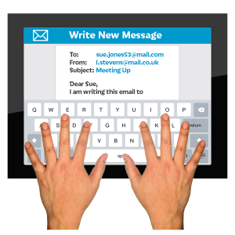
Email: contact@whaikaha.govt.nz

This information has been written by the Ministry of Health.

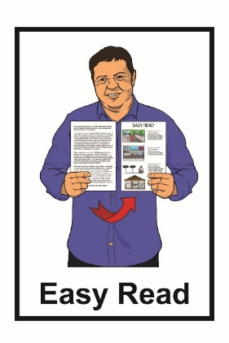
It has been translated into Easy Read with advice from the Make It Easy service of People First New Zealand Inc. Ngā Tāngata Tuatahi.

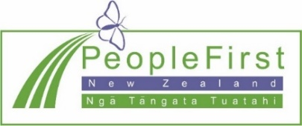
The ideas in this document are not the ideas of People First New Zealand Inc. Ngā Tāngata Tuatahi.

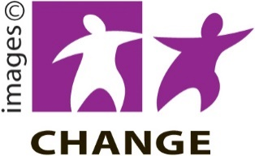
Make It Easy uses images from:

- Changepeople.org
- Photosymbols.com
- Sam Corliss

- Huriana Kopeke-Te Aho.

All images used in this Easy Read document are subject to copyright rules and cannot be used without permission.

