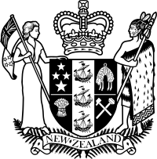
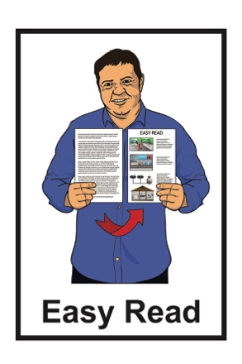

Transcript of a speech by the

Minister for Disability Issues:

Honourable Poto Williams

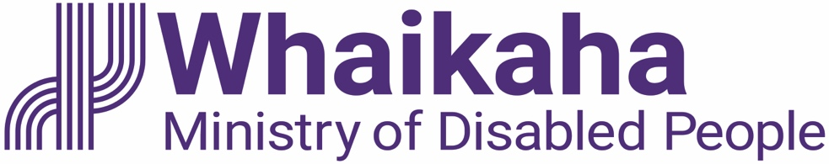

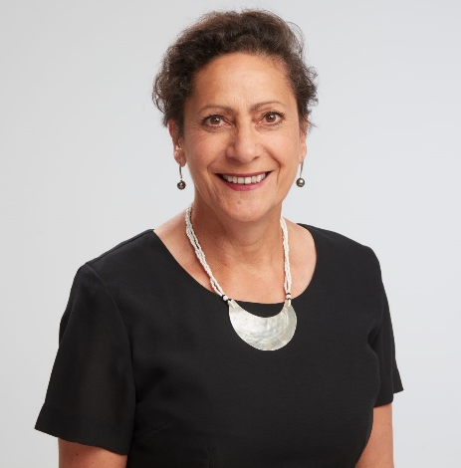

1 July 2022

About this document

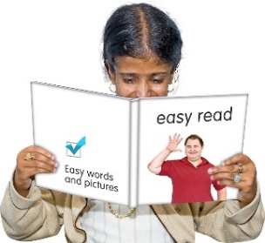
This Easy Read document is a transcript of what the new Minister for Disability Issues said at the launch / start of Whaikaha – Ministry of Disabled People.

Transcript means the words that the Minister said in her speech.

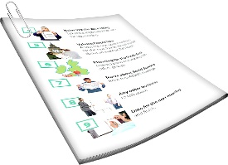
In this Easy Read document we have not changed or translated the words that were said.

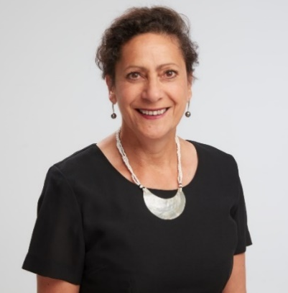
The new Minister for Disability Issues is:

Honourable Poto Williams.

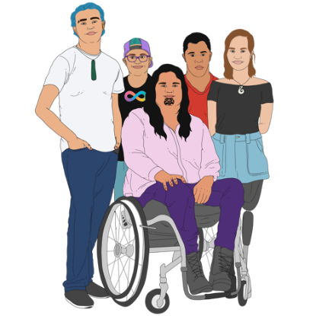
Whaikaha – Ministry of Disabled People is a new part of the New Zealand Government that will:

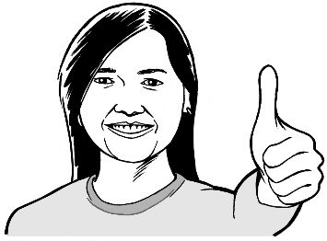
- make disability support services better for disabled people and their whānau / families

- use an Enabling Good Lives way of doing things.

Enabling Good Lives is a way of giving disability support so you have:
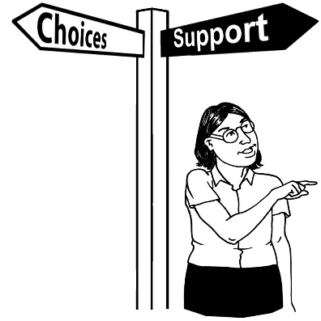
- choice and control in your life
- the support you need and want

- a good life.

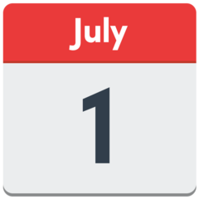
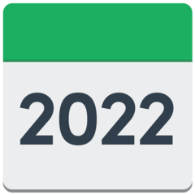
Whaikaha – Ministry of Disabled People started on the 1 July 2022.

You can listen to the speech the Minister gave online at:

www.whaikaha.govt.nz/about-us/welcome-from-our-new-minister

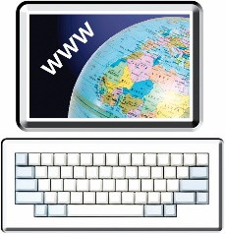
You can also find more Easy Read information about Whaikaha – Ministry of Disabled People online at:

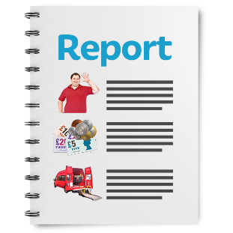
https://tinyurl.com/2wydfpbz

These documents are in Easy Read.

What the Minister said

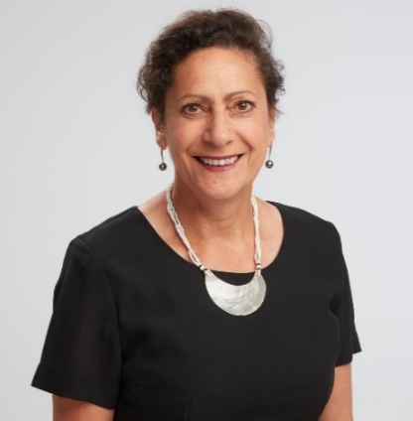
Kia ora koutou / hello

I am absolutely thrilled to be the Minister for Disability Issues.

My recent appointment comes at a historic time for the disability community which has waited a long time for meaningful change.

The launch of Whaikaha – Ministry of Disabled People – is a huge step toward a better, more independent, future for disabled people and their whānau in Aotearoa New Zealand.

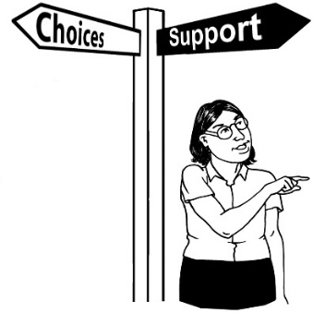
I firmly believe disabled people must have more control over their lives and a big part of achieving that is improving how government support is provided.

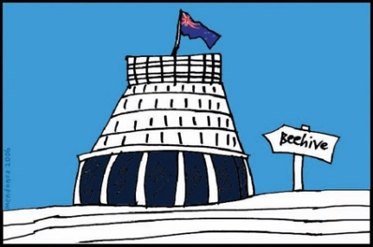
This Government has delivered a new Ministry with a mandate to do this.

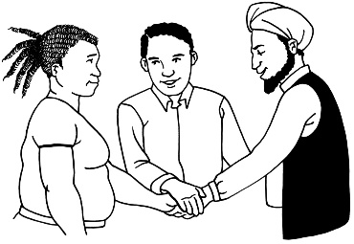
But it will not be doing it alone.

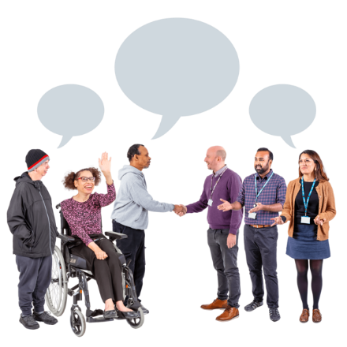
Disabled people know best what is best for them.

That’s why I, along with the new Ministry, will be working closely with the disability community.

I strongly believe in the importance of working closely with community groups to achieve better outcomes for communities.

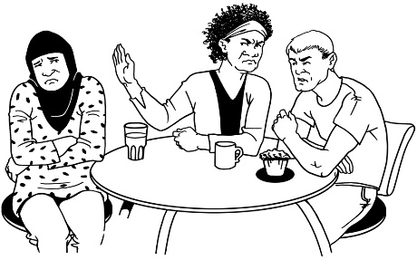
For too long the disability community has had decisions made for them without their say.
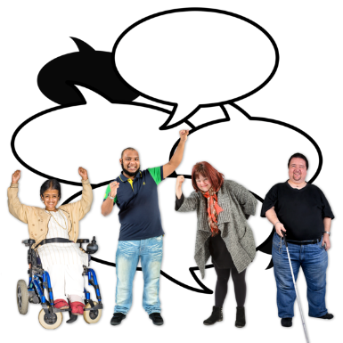

This Ministry will ensure disabled people have a real voice and increased self-determination.

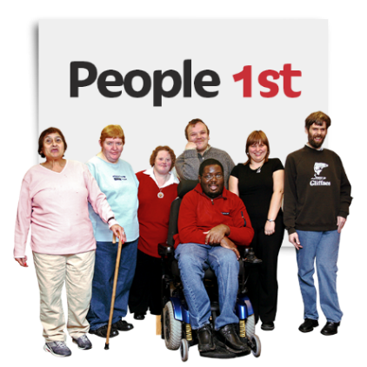
The mantra Nothing about Us, Without Us will be part of its DNA / way of doing things.

I am excited to be part of this journey.

It has been a long one but this is a true turning point and the road ahead is bright.
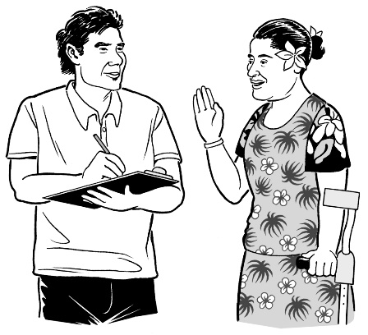
In the beautiful language of the Cook Islands:

- I E ra ke ia na Tiaure ei!

- It is a different day!

Where to find more information

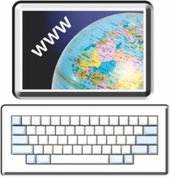
You can find more information about Whaikaha – Ministry of Disabled People at this website:

www.whaikaha.govt.nz

You can also:

Call: 0800 566 601

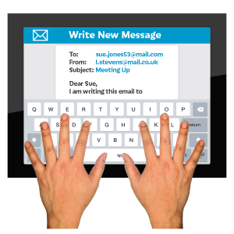
Email: contact@whaikaha.govt.nz

Freepost: Whaikaha – Ministry of Disabled People

Reply No. 262204

PO Box 1556

Wellington
This information has been written by the Office of Hon Poto Williams.

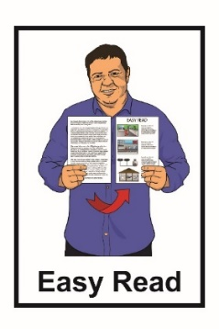
It has been translated into Easy Read by the Make It Easy service of People First New Zealand Inc. Ngā Tāngata Tuatahi.

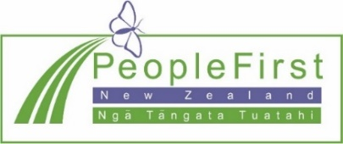
The ideas in this document are not the ideas of People First New Zealand Inc. Ngā Tāngata Tuatahi.
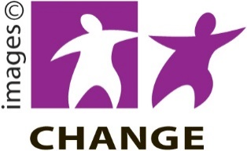
Make It Easy uses images from:

- Changepeople.org
- Photosymbols.com
- Sam Corliss
- Huriana Kopeke-Te Aho.

All images used in this Easy Read document are subject to copyright rules and cannot be used without permission.

