INFORMATION SHEET
Assistive technology | equipment - Joint Funding Ministry of Education and Whaikaha
When should joint funding be considered?
Joint funding of high-cost ($5000 including GST or more) assistive technology/equipment will be considered when the equipment solution helps the student/ ākonga live as safely and independently as possible, and improves their access to their learning curriculum, removing barriers to educational achievement.
What are benefits of considering one item of assistive technology/equipment that will support both the living and learning needs of a student/ ākonga?
- the student/ ākonga and their family/whānau or support person only having one item to learn to use
- better value for money.
In some cases, two separate solutions may be more suitable.
When is it appropriate to make a joint funding application?
- the equipment solution has additional features or accessories that are only needed at school to support the learning needs of the student/ ākonga, and via Whaikaha EMS Advice process it has been determined funding criteria has not been meet for whole of life use.
- the total value of the assistive technology/equipment is $5,000 including GST or more
- one equipment solution will support both the living and learning needs of a student/ākonga and the team agrees that this is the most appropriate option to meet identified needs
- education and health assessors have collaborated from the beginning of the assessment process
Examples of joint-funded assistive technology/equipment, reducing the need for multiple devices.
- A power wheelchair with power seat elevation or other features to enhance access to multiple school environments
- A device that enables both face-to-face communication and has additional features or accessories to provide access to written communication (literacy)

What is each agency responsible for during the assessment, trial, and funding process?
The responsibilities of each agency, as outlined in the Therapy and Assistive Technology/Equipment Operational Protocols, are shown in Table 11. Figure 3 shows funding responsibilities using examples.
Link to Therapy and Assistive Technology/Equipment Operational Protocols
If approved, Whaikaha assistive technology/ equipment may be reissued (from Accessable or Enable New Zealand) or Ministry of Education stores.
How are joint funding applications completed?
The pathway for a joint application is outlined in diagram 1. A joint funding assessment with both health and education assessors is completed with one of the assessors taking the lead role.
Complete the joint funding application form and submit this firstly to MOE for consideration. Once supported forward documentation to Whaikaha via EMS Advice process, including relevant supporting information, such as pre- and post-trial writing samples or relevant wheelchair specification forms.
Link to Joint Funding form
How will the proportion of funding from each Ministry be calculated?
The factors considered when determining the proportion of funding will include the:
- amount of time the student/ ākonga will use the item across all environments i.e. hours and frequency of features requested used per week at home and school
- cost of alternative solutions such as support staff and other equipment/resources
- cost of individual parts or components needed for each environment
- funding criteria
- funding calculations to be undertaken by each Ministry with primary owner undertaking primary responsibility.
How are joint funded items prioritised?
When joint funding is approved, the priority level of the item will be determined on a case-by-case basis considering the:
- individual needs of the student/ ākonga
- priority level recommended by the assessors
- availability of funding
What happens to the assistive technology/equipment during a transition?
Normal transition and asset transfer processes apply for joint funded assistive technology/equipment when the student/ ākonga changes or leaves school. Please refer to respective agencies for assistance if required.
Who supports the ongoing maintenance and repair of assistive technology/ equipment?
Generally, the agency making the greatest contribution to the purchase of the assistive technology/equipment will take responsibility for maintaining and repairing the equipment.
If you have any queries, please contact:
- Assistive technology coordinator at your local Ministry of Education office
- Accessable (Auckland, Northland) 0508 001 002
- Enable New Zealand (rest of New Zealand) 0800 171 995.
Link to Ministry of Education office contact list

1 1

Diagram 1. Joint Funding process Whaikaha / MOE assistive technology/equipment
Joint assessment / Eligibility
Whaikaha and MOE Assessors work together to establish eligibility, determine essential disability related needs and learning needs, identify a range of solutions, and discuss alternatives with the student/ ākonga and family/ whanau if funding is not available for their preferred solution.

All Joint MOE and Whaikaha funding requests require mandatory consultation with an EMS advisor
Mandatory consultation advice
Primary EMS assessor submits an advice request to determine funding criteria to the EMS provider via the EMS provider platform

Complete Joint Funding form
Once proposed joint funding solution is established, assessors will also complete the joint documentation for their agency and the MOE assessor will send the documentation with preliminary quotes to the MOE Regional Assistive Technology Coordinator for review.

Whaikaha EMS review panel engaged when equipment is estimated to cost over $35,000 excl GST.
The panel will determine if funding can be considered for the proposed solution
Funding responsibility check
The MOE Regional Assistive Technology Coordinator and Whaikaha EMS provider Professional Advisor consider funding responsibilities. If solution is supported, trial approval will be provided via the Joint funding form Section 8 and Outcome Summary from Whaikaha EMS Provider to the relevant parties

EMS Portal and Rationale form is completed by primary EMS assessor

Service request is submitted via EMS provider platform
Primary EMS assessor submits a Band 3 Service Request, with required documentation, to the EMS Provider “attention Whaikaha/MOE Joint funding”

Trial
EMS Provider checks reissue items and advises the assessor to proceed to trial from supplier if item not in store

Complete Joint Funding form
Following a successful trial, the MOE assessor completes Section 9, and 10 of the Joint Funding form and sends to the MOE Regional Assistive Technology Coordinator for final review.
MOE Regional Assistive Technology Coordinator will then liaise with and or submit completed documentation to the MOH EMS Provider Professional Advisor for final approval.

Approval, funding responsibility and ownership
EMS Advisor and MOE Regional Assistive Technology Coordinator determine final approval, ‘owner’ and funding responsibilities. Section 11 and 12 of the Joint Funding form completed by the ‘owner’ and completed form is provided to Assessors via the Whaikaha EMS Provider Professional Advisor for their clinical records

Purchase and repairs/ servicing
The Whaikaha or MOE ‘owner’ purchases the equipment and invoices the other funder for the agreed amount
The primary funder (Whaikaha or MOE owner) takes responsibility for all repairs and servicing of the equipment and collects when no longer needed

Diagram 2. Assistive Technology/ Equipment Access Pathway
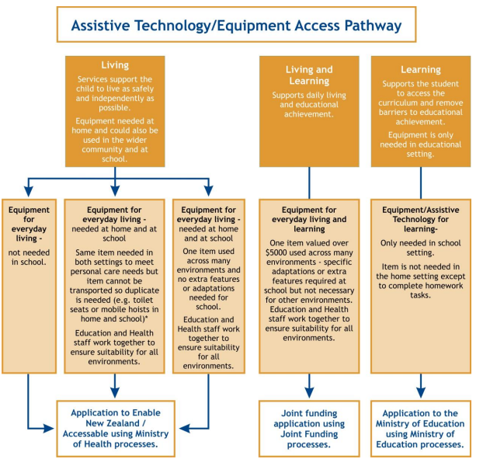

Table 1. Assistive Technology/Equipment Funding Responsibilities
Assistive Technology/Equipment | Task | Whaikaha | Ministry of Education | Joint Funding
 | What is the primary need for the equipment? | To support the student/ākonga in their daily living | To support the student/ākonga in their learning | To support the student/ākonga in both daily living and learning.  One equipment item with a total value of the item is $5,000 or more, which will have different or additional features for use in both settings
 | What will the equipment be used for? | To assist the student/ākonga and/or their family/whänau to live as safely and independently as possible  Examples:  - face to face communication  - personal care  - wheelchair  - standing frame | To remove barriers to educational achievement  Examples:  - written communication  - physical access to classroom resources  - alternative access to classroom resources | To assist with independence and safety at home and in the community and accessing the curriculum  Examples:  - face to face and written communication  - wheelchair with power seat elevation features
 | Where will the equipment mainly be used? | All settings, at home, at school and in some cases in the community | Only in the school setting | All settings, at home, at school and in the community. Joint funding is defined by task not setting.
 | Who will undertake the assessment? | Equipment and Modification Service (EMS) assessors | Education staff | Joint assessment with both Whaikaha and Education assessors, with an application to both agencies

Table 2. Assistive Technology/Equipment Funding Responsibilities
Examples based on principles of operational protocols

Assistive Technology | Equipment | AT/Equipment | Whaikaha | Ministry of Education | Joint funding
 | Hoists | Personal care equipment for home and in the school (e.g. mobile hoist and sling to access toileting), unless the equipment is already available as part of the education property. Replacement slings for ceiling track hoist, if required for personal care due to a change of need or for use by additional students/ākonga | Hoist (ceiling track or mobile) and sling as part of a school property modification if the person is eligible. Classroom hoists and sling in exceptional circumstances. It is preferred that the student/ākonga will have access to one hoist that can be moved throughout the school environment | N/A
 | Wheelchairs | Home and daily living | In exceptional cases a power wheelchair for secondary students/ ākonga maybe considered when all other mobility options have been exhausted. (It is expected that other management strategies are used for students in primary and intermediate schools) Before starting an application, establish that this is not required as part of the person’s general mobility needs | Power wheelchair with additional features to a base chair (Whaikaha funded) to meet school needs such as power seat elevation features
 | Seating | Home and daily living | Classroom seating when school furniture is inadequate | N/A
 | Communication devices | Face-to-face communication | Written communication for learning and literacy | Single device that meets both written and face-to-face communication needs
 | Standing frames | One supplies for use at home or at school | N/A | N/A

Reference Therapy and Assistive Technology/Equipment Operational Protocols Link to Therapy and Assistive Technology/Equipment Operational Protocols
If the request meets the joint funding criteria but the total value of the item is under $5000 including GST, responsibility is determined by primary purpose. If the primary purpose is to help the person to live as safely and independently as possible, the Whaikaha retains responsibility. If the primary purpose is to remove barriers to educational achievement, the Ministry of Education retains responsibility.
If education property (e.g. hoist) is not appropriate, alternatives will need to be well justified
Where the student/ākonga must be moved in and around the classroom AND where they cannot be safely moved without a hoist dues to factors such as weight (refer to ACC guidelines) or have a medical condition that means lifting isn’t safe for the person (e.g. fragile bone conditions) tactile sensitivity or severe behaviour.
Jointly funded when a single device enables both face-to-face communication and has additional features or accessories to provide access to written communication. Assessors to consider the benefits and limitations of learning to use two devices when the students/ākonga needs to communicate (face-to-face) and they are producing written work (learning/ literacy tasks)

