Carer Support Claim Form
Full-time carer details |  |  |  |  | Client number
<Name of full-time carer>  <Mailing address of full-time carer> |  |  |  |  | <Client number>
 |  |  |  |  | Name of client
 |  |  |  |  | <Client name>
Please complete all relevant sections of this form.
Full-time carer (FTC) physical address  (if different from the mailing address above)  <Physical address of full-time carer>  FTC phone number: (<Area code>) <Phone number> |  |  |  |  | Support carer (SC) details
 |  |  |  |  | Full name
 |  |  |  |  |  | <Support carer name>
Claim details (include exact dates care took place) |  |  |  |  |  | Date of birth |  | <dd/mm/yyyy>
Date(s)  of service | Hour(s) if applicable | Tick claim period |  |  |  | SC relationship to client |  |  | <SC relationship to client>
 |  | Half day* | Full day⁺ |  |  | Physical address
<dd/mm/yy> | <No. of hours> |  |  |  |  | <Physical address of support carer>
<dd/mm/yy> | <No. of hours>
<dd/mm/yy> | <No. of hours> |  |  |  |  | Mailing address (if different from above)
<dd/mm/yy> | <No. of hours> |  |  |  |  | <Mailing address of support carer>
<dd/mm/yy> | <No. of hours>
<dd/mm/yy> | <No. of hours> |  |  |  |  |  | Tick if you have previously provided support care
<dd/mm/yy> | <No. of hours>
<dd/mm/yy> | <No. of hours> |  |  |  | Daily rates(all rates are GST exclusive)
Total days claimed |  | <No. of days> |  |  | <Daily rates>
Daily rate |  | <Daily rate>
If the support carer is registered for GST,
then a tax invoice must be attached to this claim form.
GST – if any – (tax invoice attached)
Total claimed (days x rate) |  | $<Total claim>
Amount already paid to support carer# |  | $<Amount paid>
* Half day is 4 up to 8 hours care.
⁺ Full day is over 8 up to 24 hours care.
At the completion of service, complete either box 1 or 2
1 Payment direct to support carer |  |  |  |  | 2 Reimburse the full-time carer
I confirm that this information is a true and correct record of the services provided. |  |  |  |  | I confirm that this information is a true and correct record of the services provided and that I have already been paid the amount shown (# on left) for those services before this claim was submitted.
Signature of support carer |  |  |  |  | Signature of support carer
Date |  |  |  |  | Date
I confirm that the support carer provided the above services and request that the support carer be paid directly. |  |  |  |  | I confirm that the support carer provided the above services and that I have already paid the support carer the amount (# on left) shown and request reimbursement of the lesser of the subsidy claimed or the amount already paid to the support carer.
Signature of full-time carer |  |  |  |  | Signature of full-time carer
Date |  |  |  |  | Date
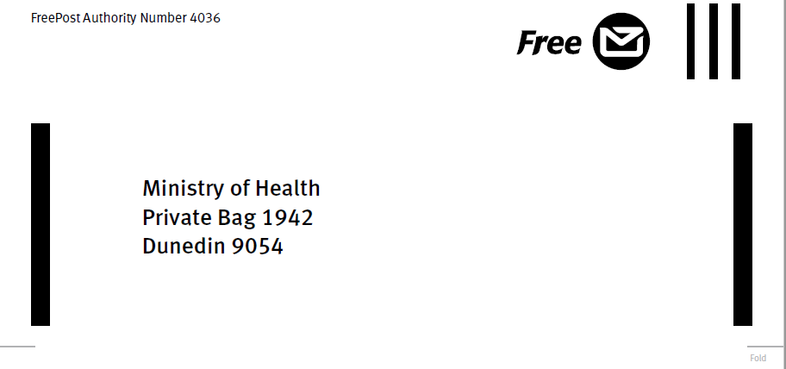
Carer support claim terms and instructions
Standard Terms and Conditions
1. Please refer to the How to Claim Carer Support booklet from www.health.govt.nz/sectorservices for instructions on completing this claim form.
2. A copy of the Carer Support Guidelines is available on request by calling 0800 855 066.
3. If there are missing details, we will return the form to the full-time carer to complete, before we can make payment.
4. Where a potentially false claim has been identified, the Ministry of Health may delegate audit agents to investigate. These audit agents can also carry out random audit checks, investigate claims or complaints. False claiming can result in legal action as well as criminal prosecution.
5. You are responsible for any income tax or GST liability that may arise in respect to this claim.
6. The completed claim form must be lodged within 90 days of the last date of relief care.
7. Correctly completed claim forms will be paid within 10 working days of receipt.
8. Any changes or corrections made to this claim form must be signed by both the full-time carer and support carer.

Instructions for full-time carers
1. If you have moved or are moving, please notify your needs assessor, who will notify the carer support team of your new address(es) and the effective date of the change(s). Changes of client address are also to be notified to the needs assessor in the first instance.
2. If this is your first claim for reimbursement then you must supply bank verification of the payment account. This can be a bank printed deposit slip, the top of a bank statement, showing name and full account number or some other form stamped by the bank, showing name and complete bank account number. All future payments will be made into this account until new account details are provided. Bank accounts are formatted as follows:
12-3456-7890123-45 (or 456).
If you have any doubt about bank account numbers please supply bank-verified details with your claim.
3. If, for any reason, you cease to be the full-time carer for this client, you need to notify your needs assessor immediately, specifying your last date as a full-time carer.
4. A separate form must be completed for each support carer.
5. The amount of reimbursement payable to the full-time carer will be the lesser of the actual amount paid to the support carer or the subsidy payable for the period of care.
Instructions for support carers
1. If this is your first claim for reimbursement then you must supply bank verification of the payment account. This can be a bank printed deposit slip, the top of a bank statement, showing name and full account number or some other form stamped by the bank, showing name and complete bank account number. All future payments will be made into this account until new account details are provided. Bank accounts are formatted as follows:
12-3456-7890123-45 (or 456).
If you have any doubt about bank account numbers please supply bank-verified details with your claim.
2. GST-registered providers (formal providers) must attach a tax invoice to this claim form. The daily rates are exclusive of GST and GST will only be added to claims made by GST-registered providers.

