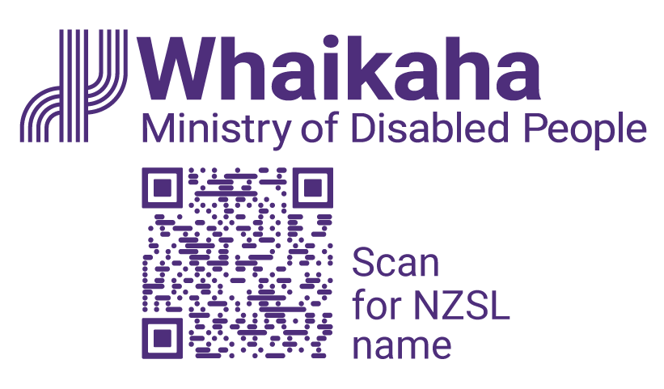
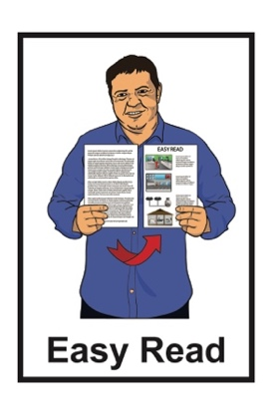

Expression of Interest Form:

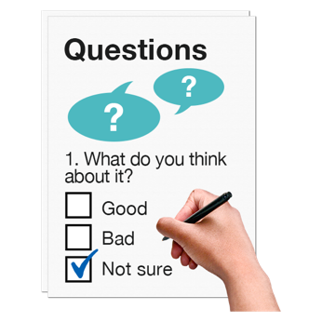

Do you want to join a Disability Strategy Working Group?



Published: February 2025

Before you start

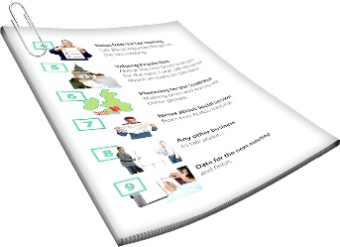
This is a long document.


It can be hard for some people to read a document this long.

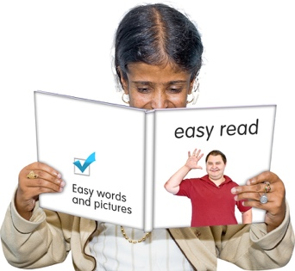
Some things you can do to make it easier are:
read it a few pages at a time
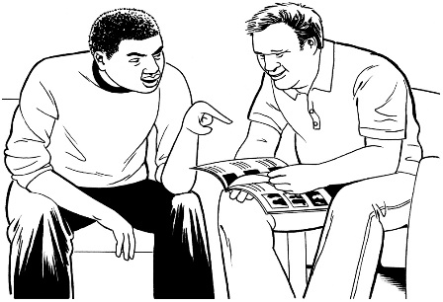
set aside some quiet time to look at it
have someone read it with you to support you to understand it.

What you will find in here

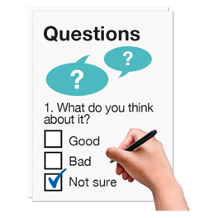
Page number:

About this Easy Read 4


About you 12


Do you have the right skills to
be a Working Group Member 17


Conflict of Interest 23

Tells us about your experience 26
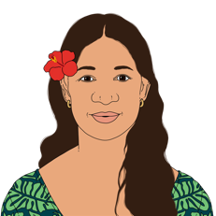
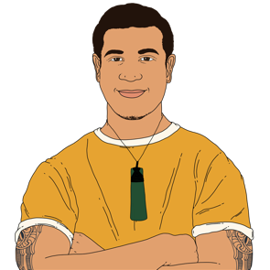

Referees 31

Page number:


Do you have time to be
a Working Group member? 36


Do you need support to be
a Working Group member? 38


Other information we may need 41


Consent 44

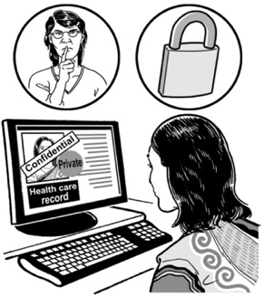
Extra information 47

About your privacy 49


How to send your form to us 51

About this Easy Read

This Easy Read document is an expression of interest form from the Ministry of Disabled People — Whaikaha.


Expression of interest means saying that you are interested in doing or taking part in something.


We call the Ministry of Disabled People — Whaikaha the Ministry for short in this document.

When you see the words we / us in this form it means the Ministry.

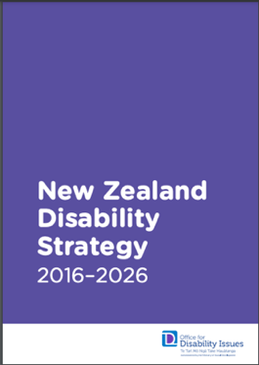
This year the Ministry is updating the
New Zealand Disability Strategy 2016 to 2026.


Updating means to look at something to see what needs to be done to make it better like:
changing it
adding something.


Here a strategy is a set of long term plans that are made to reach a goal.

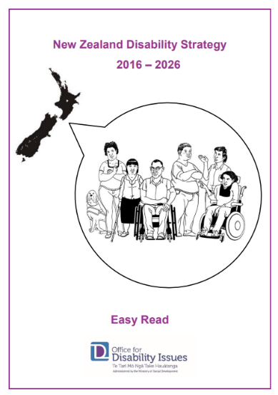
You can find the Easy Read called the New Zealand Disability Strategy 2016 – 2026 at this website link:

https://tinyurl.com/yc6me9br

In this document we call the
New Zealand Disability Strategy the Disability Strategy for short.


The Disability Strategy is an important document that guides the work government agencies do about things to do with disability.


We will make Working Groups to support the work to update the Disability Strategy.

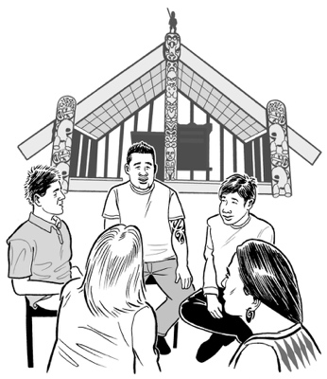
Our Working Groups will have disabled people on them like:
tāngata whaikaha Māori
people from the Deaf community
whānau / family of disabled people.


Members of our Working Groups should have experience in one of the main outcome areas.

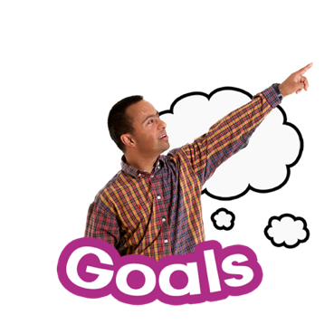
Here an outcome is the work needed to reach a planned goal for a job.


Outcome areas:
are the main areas of work the Disability Strategy will set out
and

will guide the government in its work to make lives better for disabled people.



The main outcome areas are:

education
employment
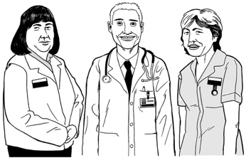
health.

The other main outcomes areas are:

housing
justice.


Here justice is to do with people being treated fairly by the justice system like the courts.

We will make a Working Group for each outcome area.


Do you:
know a lot about an outcome area?
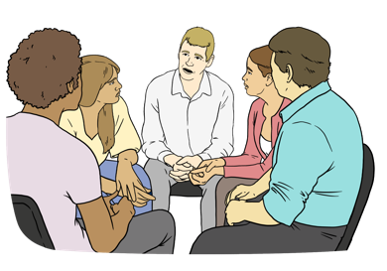
have the skills to be a member of a Working Group?
want to be on a Working Group?

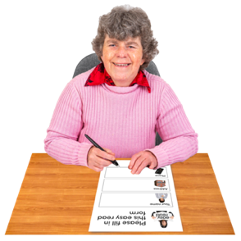
If you want to join a Working Group you should fill out this expression of interest form.

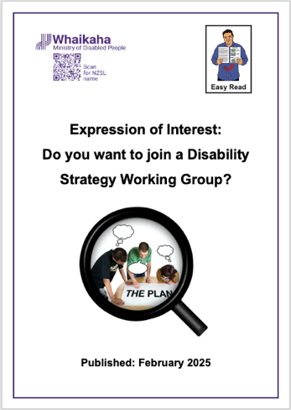
We have made the Expression of Interest: Do you want to join a Disability Strategy Working Group? document to support you to fill out this form.

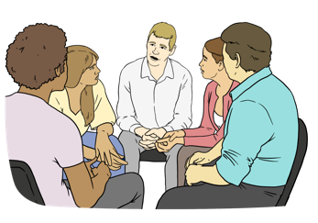
It has information about:
the Disability Strategy
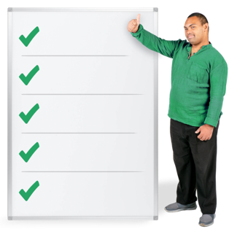
Working Groups
what skills you need to be on a Working Group.

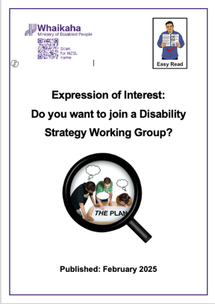
You can find the Expression of Interest: Do you want to join a Disability Strategy Working Group? to support you fill out this form at this website:

whaikaha.govt.nz/strategy-refresh


You can:
print this form out
and

write your answers in the answer boxes.

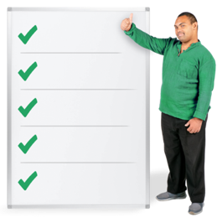
Please try to fill out all the parts of this expression of interest form.


You need to send it back to us by
6 March 2025.


If you have any questions email us at:

disabilitystrategy@whaikaha.govt.nz

About you
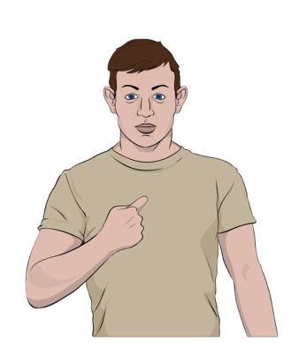

This part of the form asks questions about you.


Write your name in this box:


Write your email address in this box:



Write your phone number in this box:

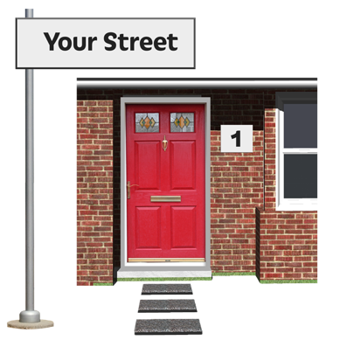
Write your address in this box:


Tick this box if you were born in New Zealand.


Tick this box if you have
citizenship from a country that is not New Zealand.

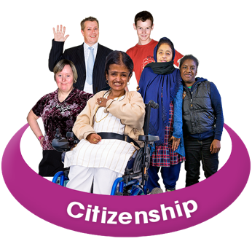
Citizenship means a person can do things in a country like:
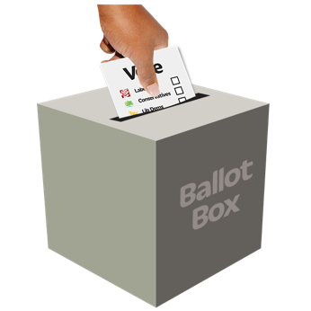
live
work
vote.

Tell us the country you have citizenship in if you do not have it for New Zealand:


Tick the box next to each choice that is right for you.


Tell us which Working Group outcome area you would like to be a part of.
education

employment
health

housing

justice.
Tick the box next to each choice that is right for you.

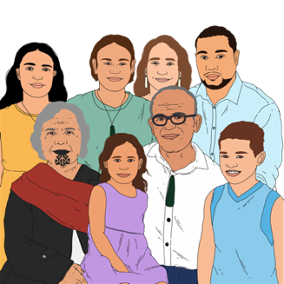
Tell us which communities you know a lot about:

Tāngata whaikaha Māori / Whānau hauā / Māori disabled

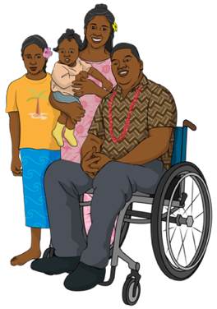
Turi Māori or Deaf

Disabled person


Pacific disabled

Rainbow disabled


whānau / family.


Tick the box next to each choice that is right for you.

Tell us which communities you know a lot about:

youth

Rangatahi Māori
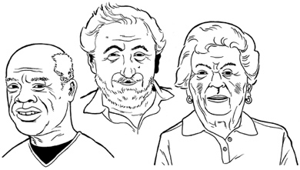
disabled older people
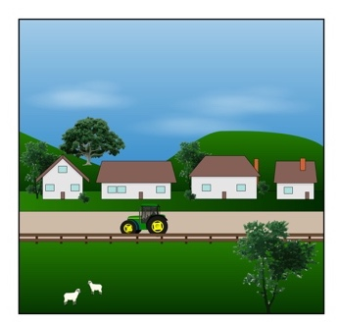
rural / living in the country

other.


If you ticked the Other box tell us the community you know a lot about.

Please write your answer here:

Do you have the right skills to be a Working Group member?



Think about the outcome area you want to be on if you are in a
Working Group.

How do you think your experience of disability makes you the right person to be on this Working Group?

Please write your answer here:


Think about the outcome area you are interested in.


Write the outcome area in this box:



What experiences can you bring to the Working Group?

Please write your answer here:


Tick the box if the choice is right for you.

You are a good leader

If you ticked the box tell us why here:

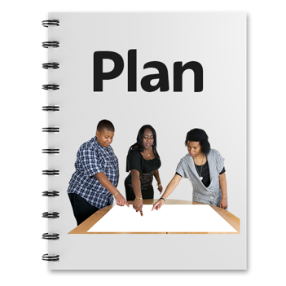
Tick the box if the choice is right for you.

You are good at thinking up plans to get work done

If you ticked the box tell us why here:


Tick the box if the choice is right for you.

You are good at making decisions.

If you ticked the box tell us why here:

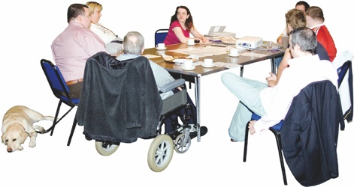
Tick the box if the choice is right for you.

You are good at taking part in talks during a meeting to sort out a problem.

If you ticked the box tell us why here:

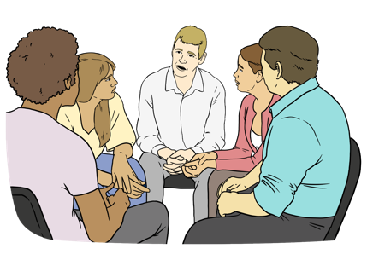
Tick the box if the choice is right for you.

You work well with other people to do things like:
make work plans
sort out problems.

If you ticked the box tell us why here:

Tick the box if the choice that is right for you.

You can work well with people from different communities.

If you ticked the box tell us why here:

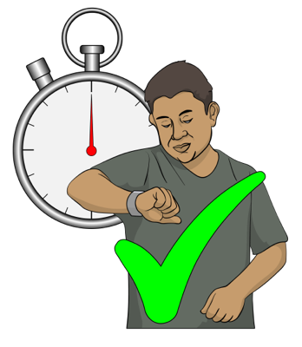
Tick the box if the choice is right for you.

You are good at getting your work done in the time that you are asked to do it in.

If you ticked the box tell us why here:

Conflict of interest


Here a conflict of interest is when a person may have a problem between:
the Working Group
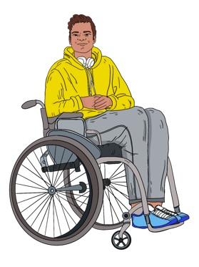
and
their personal life.


An example of a conflict of interest may be if a person is making a decision:
they might choose to do what is best for them
and
they know is not the right thing for the Working Group.

You need to think if you may have a conflict of interest if you are chosen to be a Working Group member.

You will need to think about the things like:
the place you work for
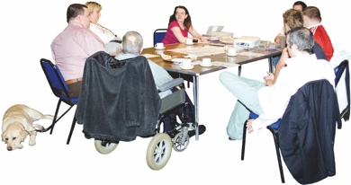
any groups you belong to.

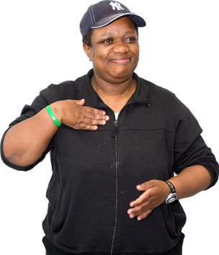
You are chosen as an individual person.

Here individual means 1 person.

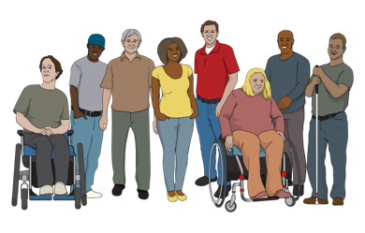

You are not chosen because you belong to a:
group
organisation.

You can email us if you want to find out more about conflict of interest at:

disabilitystrategy@whaikaha.govt.nz


Tell us if you think you may have a conflict of interest if you are chosen to be a Working Group member.

Please write your answer here:

Tell us about your experience

We would like to know about:
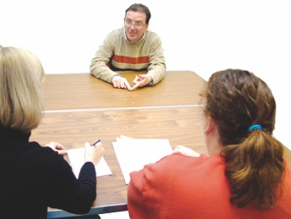
your experiences to do with the Working Group outcome area you want to be a member of
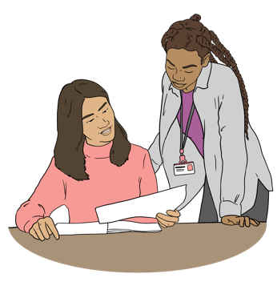
and
how you think these experiences could support your work as a Working Group member.


Tell us about:
- work you have done
- voluntary work you have done.

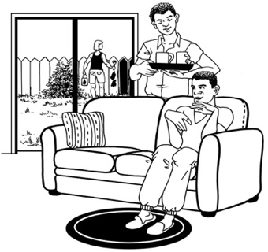
Voluntary means you did not get paid when you did work for an organisation.
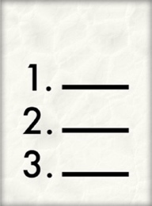
Tell us about your jobs to do with the outcome area you are interested in.

Please list your jobs here:


Do you have experience of working on a:
government group

board.


A board is a group of people that:
know a lot about organisation
lead the organisation.

Tick the box if the choice is right for you.

You have experience working on a:
government group
board.

Tell us about your experience here:


Do you have qualifications that are about the outcome area you would like to work in?


Qualifications are the skills a person has learned when they have been somewhere like:

school
university
on a course.

Tell us about your qualifications here:


Tell us about other experiences you have to support you to become a Working Group member.

Tell us about your other experiences here:

Referees

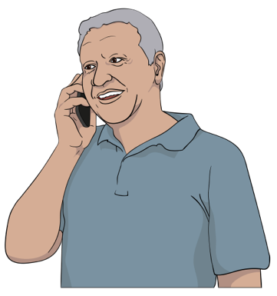
Here referees are people you have:
chosen to talk to us about your work experience
said yes to say we can talk to them about you.
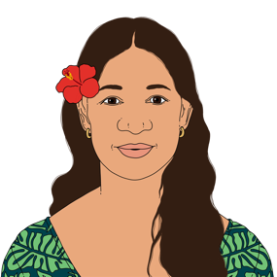
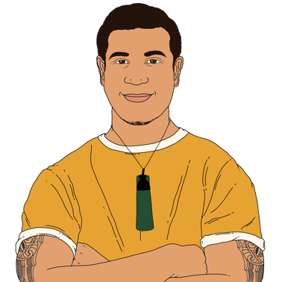
If we choose you to be on a Working Group we will need to talk to 2 referees about you.

It is best if they come from an organisation you have worked in.


Pages 32 to 35 ask about information about your referees.

Referee Number 1
Write their name in this box:


Write the name of the organisation they work for in this box:

Tell us how you know each other in this box:

More information about Referee Number 1

Write their email address in this box:


Write their phone number in this box:

Referee Number 2
Write their name in this box:

Write the name of the organisation they work for in this box:

Tell us how you know each other in this box:

More information about Referee Number 2
Write their email address in this box:

Write their phone number in this box:

Do you have time to be a
Working Group member?

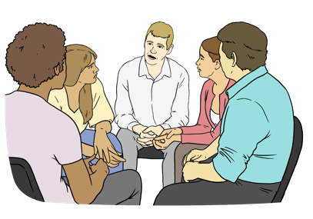
People who are chosen to be on a Working Group need to have the time to:

go to Working Group meetings
get ready for meetings.

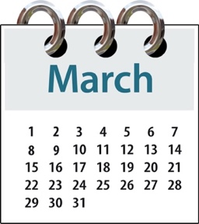
Do you think you can you work for
50 to 90 hours between:
March 2025
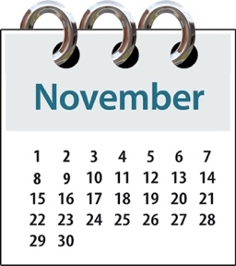
and
November 2024.


Tick the box next to the choice that is right for you.


Do you have time to do the work needed to be on a Working Group?


Yes


No


I will need to find out

Do you need support to be a
Working Group member?

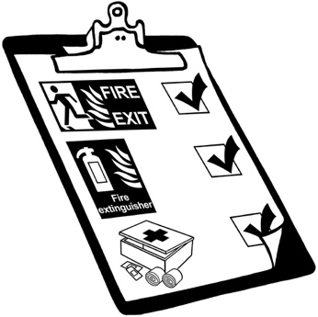
We would also like to know if you will need some support to work in the Working Group.

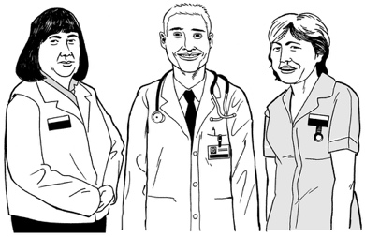
Please tell us any information you think we should know like:

about your health
about your disability
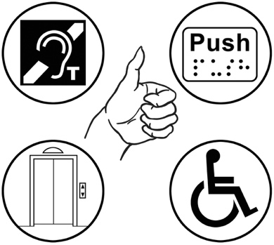
if you need reasonable accommodation to be a Working Group member.


Reasonable accommodation is making changes to something so disabled people can do things like:
work
get information

use services
get to where they want to go.

Tick the box next to the choice that is right for you.


Will you need support to take part on the Working Group?

yes

no

If you ticked yes tell us what support you may need.

Please write your answer here:

Other information we may need


If you are chosen to be on a Working Group we may need to know some extra things.


We may need to know if you have broken the law.


A law is rule made by the government that everyone has to follow.

If you have done something to break the law you may have a criminal conviction.

A criminal conviction is when a person has been found to have done a crime by the courts.


This does not always mean you
can not be on the Working Group.


We will have to find out more information to be able to decide if you:
can be on the Working Group
can not be on the Working Group.



You may not need to tell us about your criminal convictions if the Criminal Records (Clean Slate) Act law says you do not have to.


You can find out more about the Clean Slate law at this website:

www.justice.govt.nz/criminal-records/clean-slate/

We may also need to find out about your credit status.


Credit status tells someone how good you are at paying:
back money you have borrowed from something like a bank
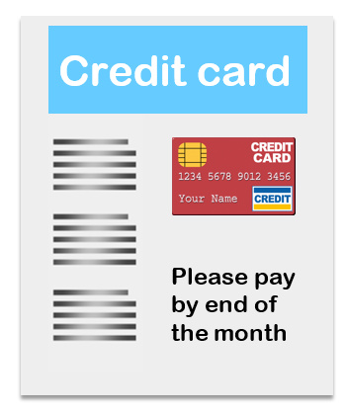
things like your:
- credit card bill
- power bill.

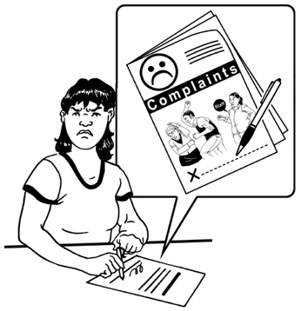
We may also need to know if you have had any serious complaints made about you at the places you have worked at.

Consent


Consent means saying yes to something.

This part of the form is about asking for your consent to talk to your referees.


I consent to the Ministry asking for information about me from my referees.


Their names are on pages 32 to 35.

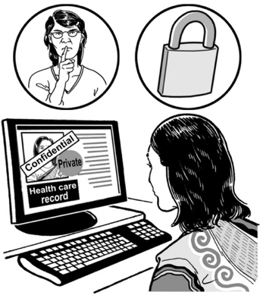
I understand the information you get from my referees will:
be kept private
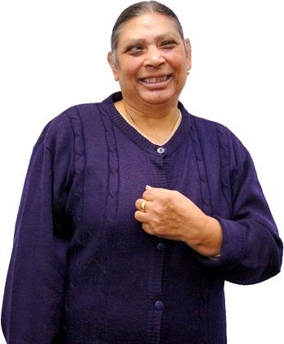
not be given to me
be used to find out if I am the right person to be on a Working Group.

I have told you about any conflicts of interest I may have that I know about.


The information I am giving the Ministry:

is true
is everything I think they need to know
will be used to decide if I can be on a Working Group.
The information on pages 44 to 45 of the Consent part of this form is true.

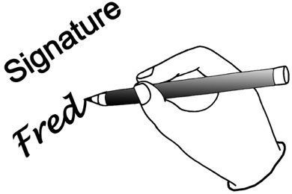
Sign your name in this box:


Write the date you sign this form in this box:

Extra information

If you want to give us extra information you should tell us what you are sending.

Tick the box next to each choice that is right for you.

Tell us what extra information you are sending to.

CV / Resume
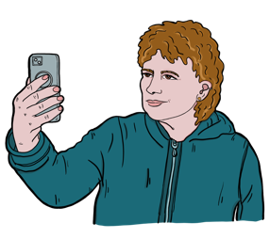

video


alternate format like Braille or Easy Read

Tick the box next to each choice that is right for you.

Tell us what extra information you are sending to.
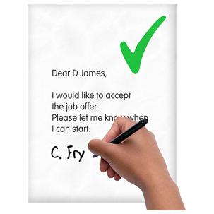

letter

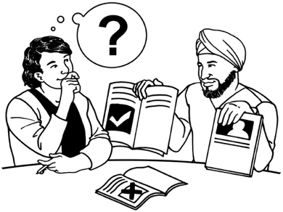
something else

If you ticked something else tell us what you sent in the box.

Please write your answer here:

About your privacy


We are getting information about you to decide if you should be a
Working Group member.

You may still be able to be on a Working Group if you have not answered all the questions on this form.


You can not be on a Working Group if you do not give us your:
name
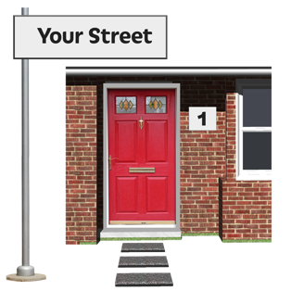
address
email address.


You can ask for a copy of the personal information we have about you at any time.

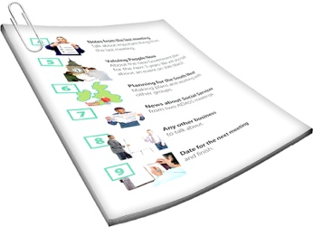
You can ask to fix something if you think there is a mistake in the information we have about you.


You can send an email to us to tell us about the mistake at:

privacy@whaikaha.govt.nz

How to send your form to us

This part of the form tells you how to send your expression of interest form to us.

You can email your form to us at:

disabilitystrategy@whaikaha.govt.nz


You can post your form to us.

You do not have to put a stamp on the envelope.

Post your form to:
Partnerships and Stewardships Group

Ministry of Disabled People - Whaikaha
Reply paid: 262204
PO Box 1556
Wellington 6140


You can also send your expression of interest by:
video
using an alternate format like:
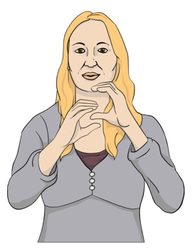
- Braille
- New Zealand Sign Language
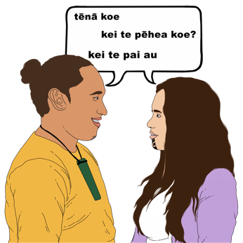
- Te Reo Māori
- audio
- Large Print.

Email us to find out about making your expression of interest in a different way at:

disabilitystrategy@whaikaha.govt.nz

You need to send your expression of interest back to us by 6 March 2025.

We will decide who will be on our Working Groups.


By 21 March 2025 we will tell you if you:
are on the Working Group
are not on the Working Group.


We hope to have made the Working Groups by 28 March 2025.

This information has been written by Ministry of Disabled People – Whaikaha.


It has been translated into Easy Read by the Make it Easy Kia Māmā Mai service of People First New Zealand Ngā Tāngata Tuatahi.

The ideas in this document are not the ideas of People First New Zealand Ngā Tāngata Tuatahi.

All images used in this Easy Read document are subject to copyright rules and cannot be used without permission.


Make it Easy uses images from:


- Photosymbols

- Change Images


- Huriana Kopeke-Te Aho

- SGC Image Works

- T Wood


- Studio Rebeko

- Inga Kramer.

