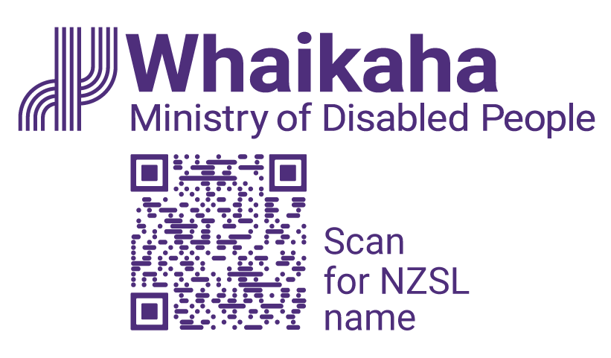
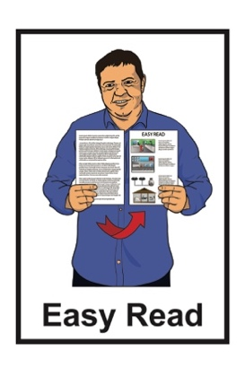

Expression of Interest:
Do you want to join a Disability Strategy Working Group?
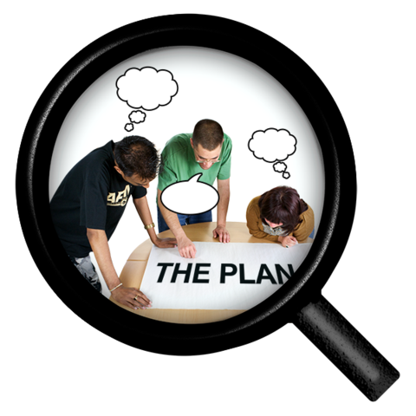

Published: February 2025

Before you start

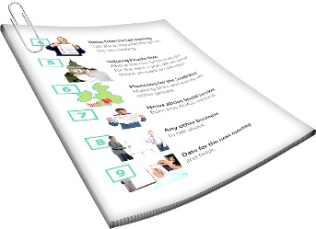
This is a long document.


It can be hard for some people to read a document this long.

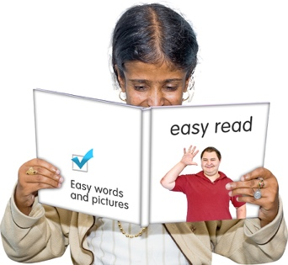
Some things you can do to make it easier are:
read it a few pages at a time
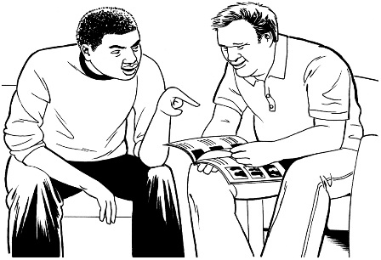
set aside some quiet time to look at it
have someone read it with you to support you to understand it.

What is in this document

Page number:

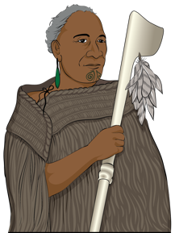
Whakataukī 4

About this document 6
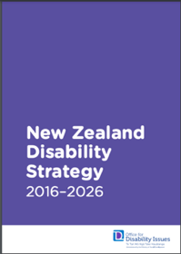

What is the Disability Strategy? 11


Why are we updating the
Disability Strategy? 15

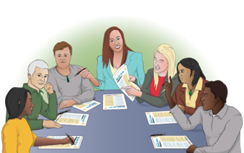
What is a Working Group? 18

Page number:


Who will be in each Working
Group? 22
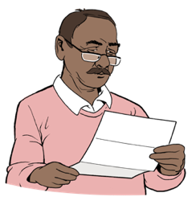

What skills should a Working
Group member have? 24
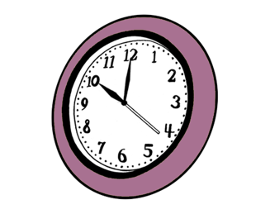

How much time will it take? 27


Do Working Group members
get paid? 28


How to tell us you want
to be a Working Group member 31

Whakataukī

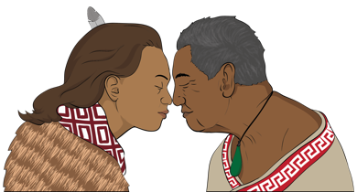
A whakataukī is a Māori saying that shares an important message.


Kia hiwa rā kia hiwa rā

Kia kōkiri ake, kia mataara.

He karanga atu ki te ao whānui
ki te ao whaikaha.
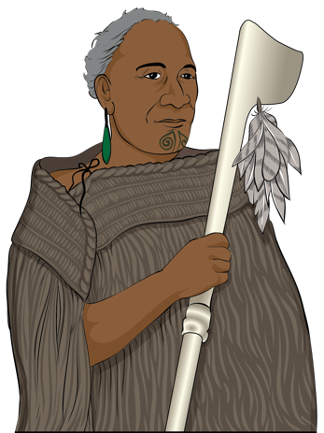

Haere mai ōu whakaaro rangatira ki tēnei kaupapa whakahirahira nau mai e te iwi e.

Here are the English words of the whakataukī.

Be watchful, be alert.

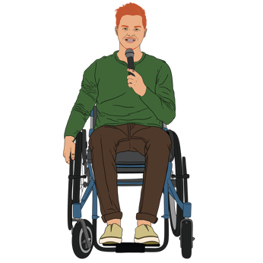
Rise up, come forward

Be counted, be alert.


A call going out to the world, to the disabled world.

We welcome your chiefly thoughts to this important discussion.

We welcome all.

About this document

This Easy Read document is from
the Ministry of Disabled
People – Whaikaha.


We call the Ministry of Disabled People – Whaikaha the Ministry for short in this document.

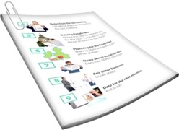

When you see the words we / us in this document it means the Ministry.

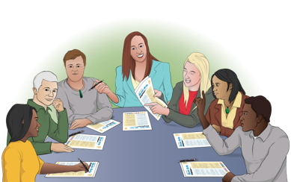
The Ministry is updating the
New Zealand Disability Strategy 2016 to 2026.


Updating means to look at something to see what needs to be done to make it better like:
changing it
adding something.
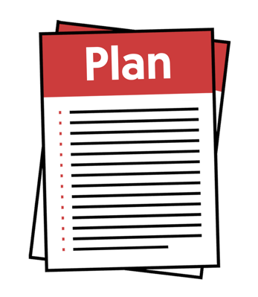

Here a strategy is a set of long term plans made to reach a goal.

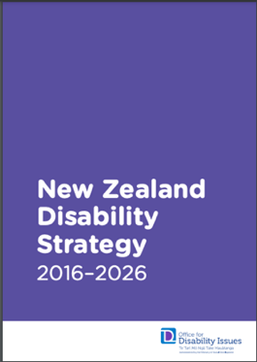
In this document we call the
New Zealand Disability Strategy the Disability Strategy for short.

The Disability Strategy is an important document.

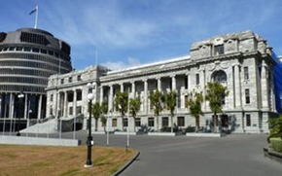
It guides the work of government agencies about disability issues.

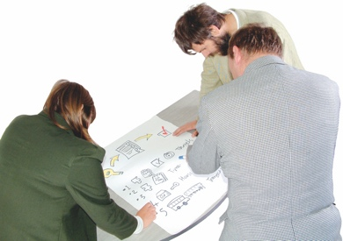
The Disability Strategy:
was made nearly 10 years ago
will be updated this year.
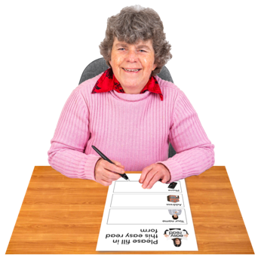


We need to find out what is happening for disabled people like the:
things that are working for them

things that are not working for them
barriers stopping them living a good life.

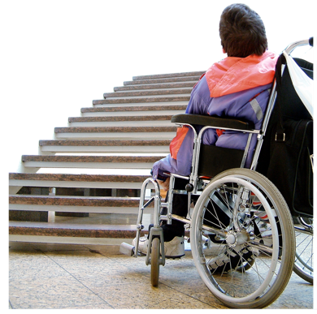
Barriers are things stopping disabled people being able to:
take part in in their community
do the things they want to do.
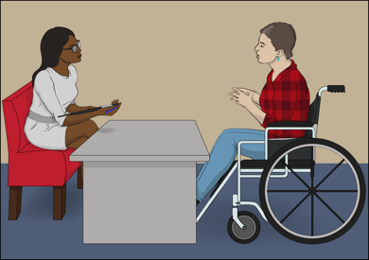
We want to hear what people who have lived experience of disability think.

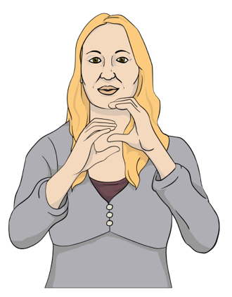
To find out what work needs to be done we will work with:
disabled people
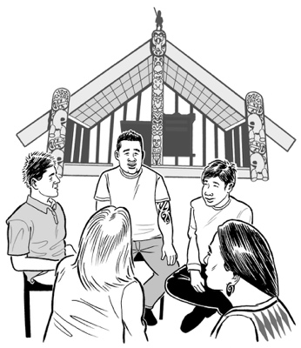
the Deaf community
Turi Māori / Deaf Māori
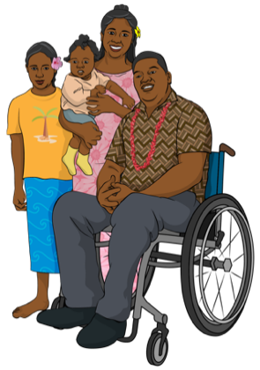
tāngata whaikaha
Māori / disabled Māori
whānau hauā / family who are disabled

Pacific peoples
whānau / families.


You can find more about the Disability Strategy on page 11 of this document.

What is the Disability Strategy?

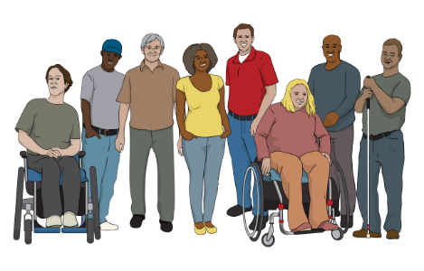
The Disability Strategy guides the work government agencies do to make life better for disabled people.
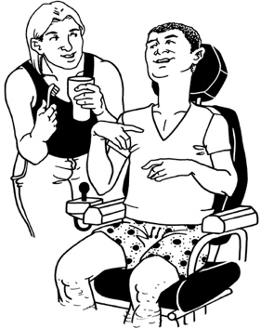

The Disability Strategy should:
support disabled New Zealanders to live better lives
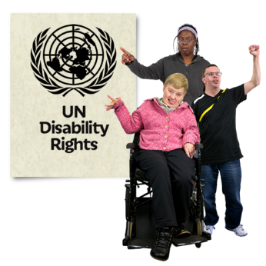
follow what the United Nations Convention on the Rights of Persons with Disabilities says to make sure disabled
New Zealanders are getting their rights.


The United Nations Convention on the Rights of Persons with Disabilities is called the UNCRPD for short.


The UNCRPD is a document lots of countries have agreed to.

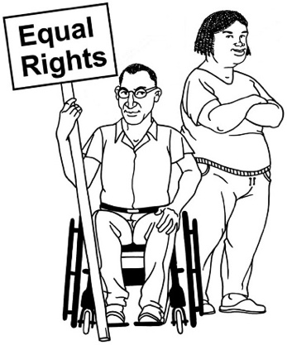
The UNCRPD says what governments must do to make sure disabled people get the same rights as everybody else.

The Aotearoa New Zealand Government said that we agree with the UNCRPD in 2008.


Rights are things that everyone should have to be able to live a good life like:
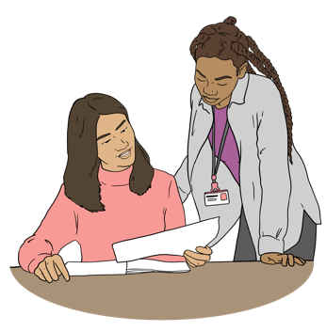
having a safe place to live
being kept safe
getting the services they need.

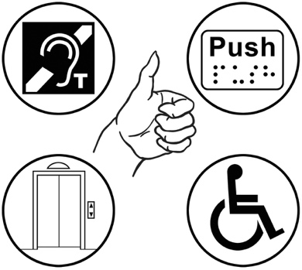
Government agencies follow the Disability Strategy to support disabled people to get their rights.

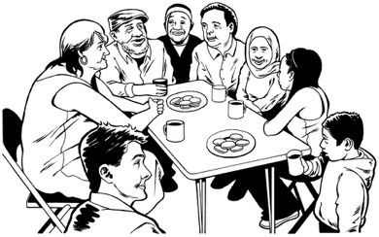
There is still a lot of work to do in Aotearoa New Zealand to make sure disabled people can live good lives.

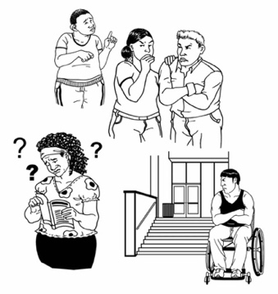
Disabled people face many barriers stopping them being able to live a good life here in Aotearoa New Zealand.
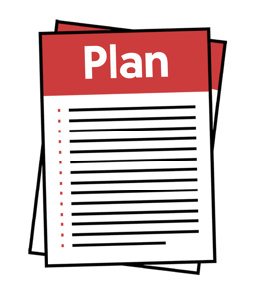
The new Disability Strategy will support work to take away these barriers.


You can find out more information about the Disability Strategy at our website:

https://tinyurl.com/4rwbv4f8

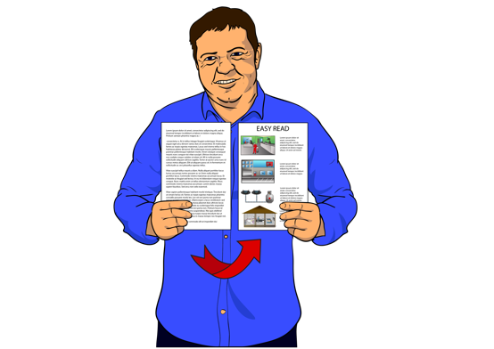
Some of this information is in
Easy Read.

Why are we updating the
Disability Strategy?

The new Disability Strategy will say what work needs to be done to make sure Aotearoa New Zealand is following what the UNCRPD says.

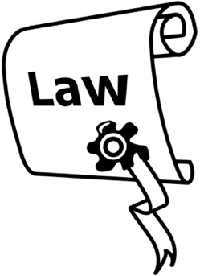
It will also follow what the Pae Ora Healthy Futures Act law says.

A law is a rule made by the government that everyone has to follow.

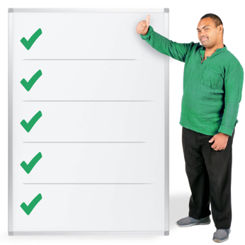
The Disability Strategy will have a set of outcome areas to support its work.

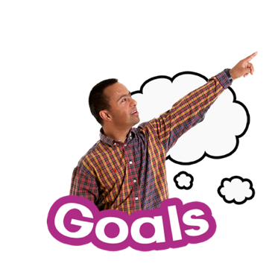
Here an outcome is the work needed to reach a planned goal for a job.

The main outcome areas will work to:
change things to make life better for disabled people
take away barriers disabled people face a lot.

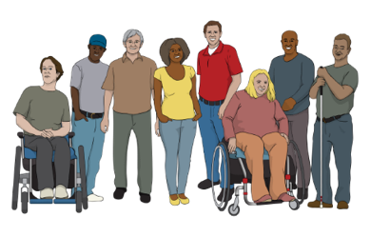
We will work to update the Disability Strategy with people:

in the disability community
in the business community
who work in industry

who are interested in disability rights.

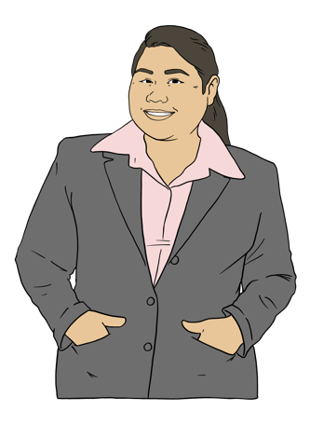
Here industry is a group of businesses that:
make or sell similar things
provide similar services.


The Minister for Disability Issues will have to agree to the new Disability Strategy when it is finished.

What is a Working Group?

We think there will be 5 main outcome areas in the new Disability Strategy.

We will make a Working Group to work on each outcome area.

These 5 outcome areas will fit in with the work the Government has planned for public services like:
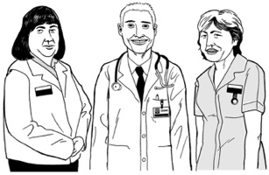
health
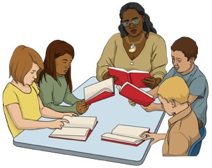
education
employment
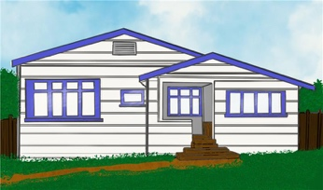
housing
justice.
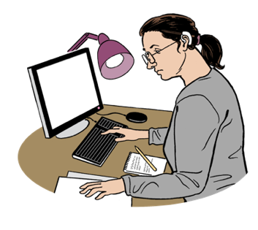
Here employment means things to do with jobs.

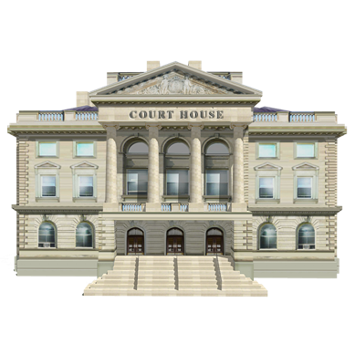
Here justice is to do with people being treated fairly by the justice system like the courts.

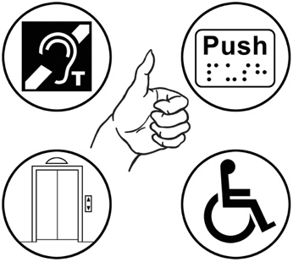
We will also think about 3 things when we are working on each outcome area like:
accessibility

data
equity.

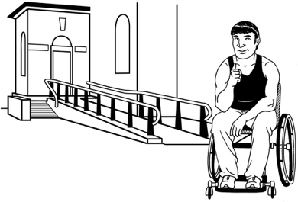
Here accessibility is about disabled people being able to:
use something
do something.

Here data is information that is collected to support making decisions about the work to be done in each outcome area.

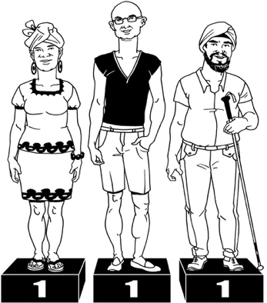
Equity means an understanding that every person:
is different
may sometimes need different support to be able to do the same things as others.


Cabinet will decide if we have chosen the right outcome areas to have in the new Disability Strategy.

Here Cabinet:

is a group of senior government ministers
meets to make important decisions.
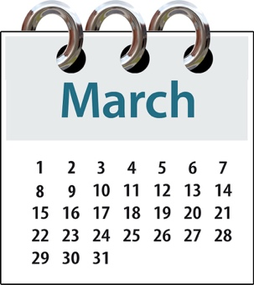

Cabinet will talk about this when they meet in March this year.

The 5 Working Groups will support the work to make the new Disability Strategy.

We think the main work will happen between:
March 2025
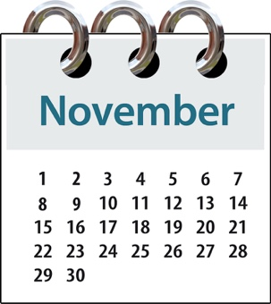
and
November 2025.

Who will be in each Working Group?


Each Working Group will be made up of 3 people with lived experience of disability like:
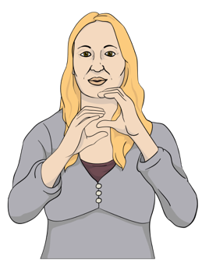
disabled people
people in the Deaf community
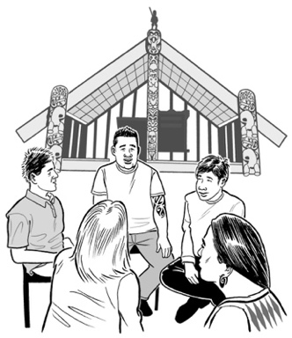
Turi Māori – Deaf Māori
tāngata whaikaha Māori / disabled Māori
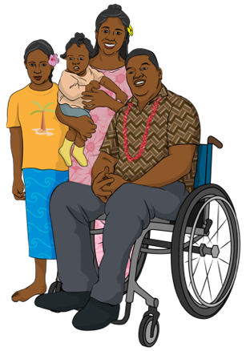
- whānau hauā / family who are disabled
Pacific people
whānau / family of disabled people.
Each working group will also have:
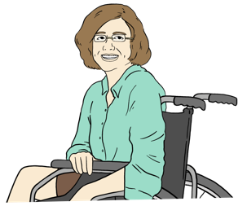
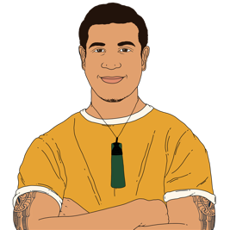
2 people who work for the government
up to 2 experts from the outcome area who work in:
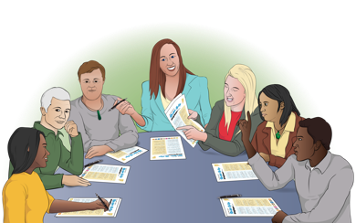
- business
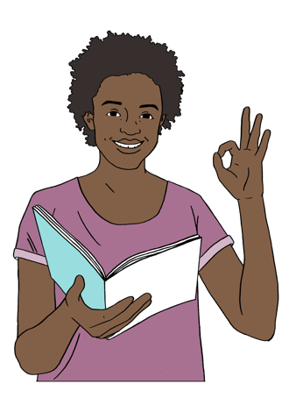
- industry.

An expert is a person that knows a lot about something.

Some people who work at Whaikaha will support the Working Groups.

What skills should a Working Group
member have?


Working Group members should be good at:
sharing their experiences about disability
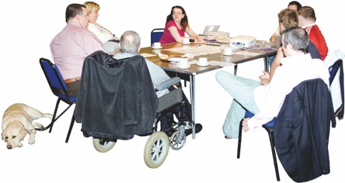
seeing how the work they are doing can work with other disability rights work
working with:
- government agencies
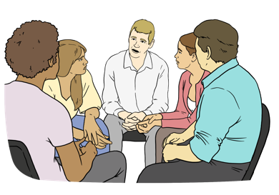
- people in their Working Group
- business / industry groups

- different communities.

Working Group members should also be good at working with government workers.

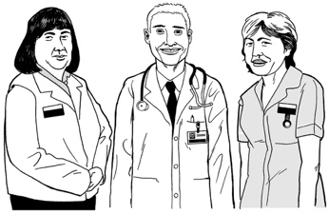
If you want to be on a Working Group you should know a lot about an outcome area like:
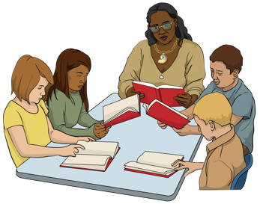
health
education
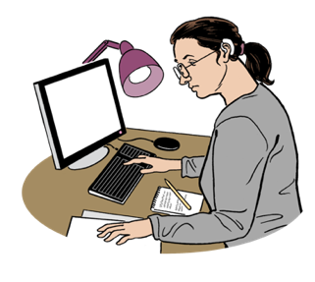
employment
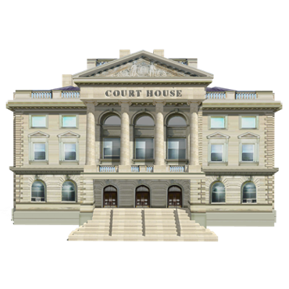
housing
justice.

To be on a Working Group you should also be good at:
thinking up plans to get work done
thinking about different ways to find answers to problems
making decisions.
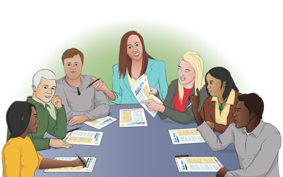
taking part in discussions

working with other people
getting your work done in the time that you are asked to do it.

How much time will it take?

Working Group members will have to go to the Working Group meetings.

This will take about 50 hours between:
March 2025
and
November 2025.

Working group members will also have to meet with communities to support their work.
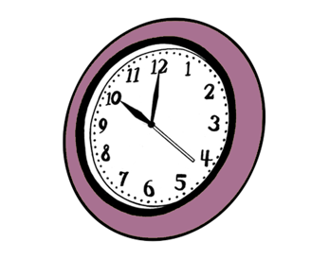

We think these meetings will take about 40 hours.

Do Working Group members get paid?


Working Group members will get paid 60 dollars an hour.

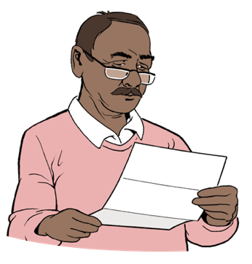
You will be paid for things like:
time to get ready for each meeting
going to the Working Group meetings

having meetings with different communities.


We will give you a reasonable accommodation if you need it.

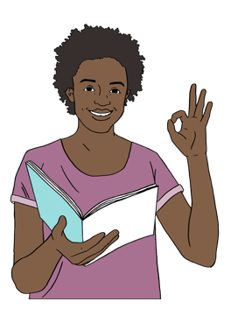
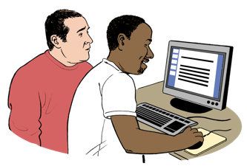
A reasonable accommodation is making changes to something so disabled people can do things like:
work
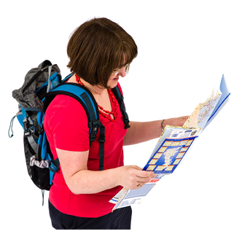
get information
use services
get to where they want to go.

We will pay for all your travel costs when you go to a meeting like:
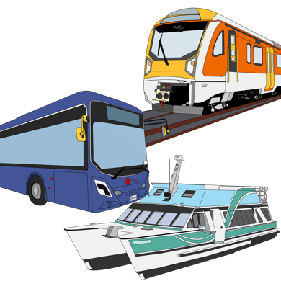
fares for:
- bus
- train
- taxi
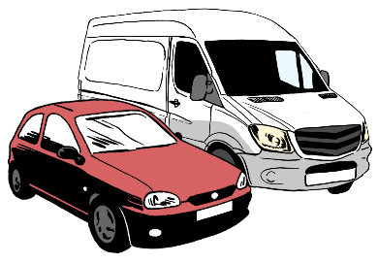
petrol
parking.
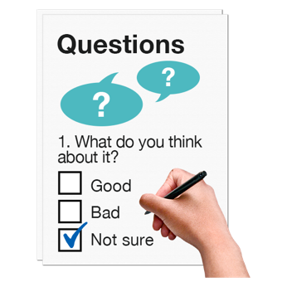
You have to fill out an Expression of Interest form if you want to be on a Working Group.


Expression of interest means saying that you are interested in taking part in something.

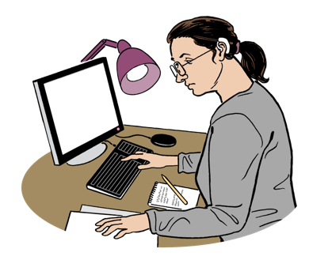
The Ministry will:
look at all of the information you give us
and
decide if you have the rights skills to be on a Working Group.

Find out how to tell us you want to be a Working Group Member on
pages 31 to 35.

How to tell us you want to be a
Working Group Member

You will have to fill out an
Expression of Interest form if you would like to be on a Working Group.
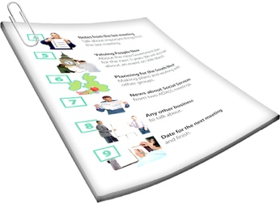

We will ask for more information about:
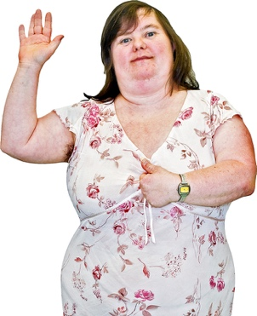
you
your experience.

You can send us an email if you want:
an Expression of Interest form

to ask us questions about the Working Groups.

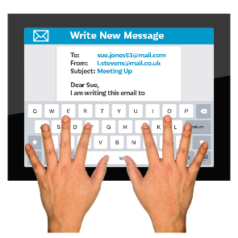
Email us at:

disabilitystrategy@whaikaha.govt.nz


You can also download the
Easy Read form from our website at:

whaikaha.govt.nz/strategy-refresh

You can send your form by email at:

disabilitystrategy@whaikaha.govt.nz

You can post your form to us.
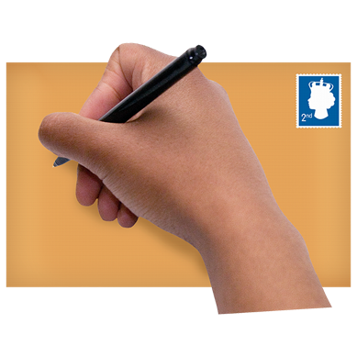


You do not have to put a stamp on the envelope.


You can post your form to:
Partnerships and Stewardships Group
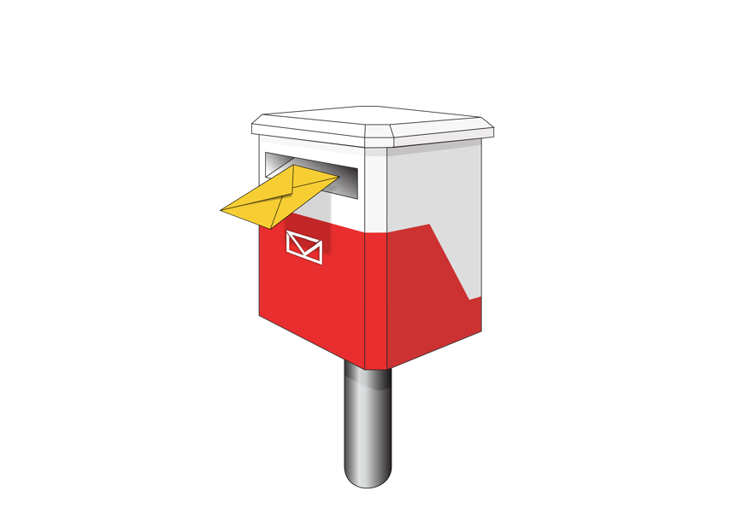
Ministry of Disabled People – Whaikaha

Reply paid: 262204
PO Box 1556
Wellington 6140

You can also send your Expression of Interest by:
video
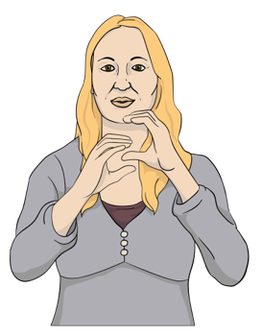
using an alternate format like:
- Braille
- New Zealand Sign Language
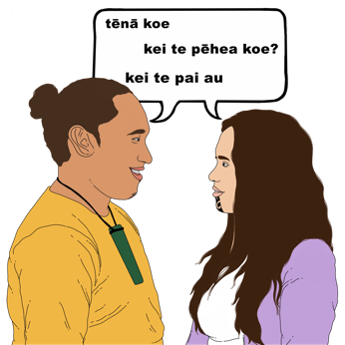
- te reo Māori
- audio
- Large Print.

To find out about making your expression of interest in a different way you can email us at:

disabilitystrategy@whaikaha.govt.nz


You need to send your Expression of Interest back to us by 6 March 2025.

We will decide who will be on our Working Groups.

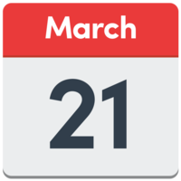
By 21 March 2025 we will tell you if you:
are on the Working Group
or
are not on the Working Group.

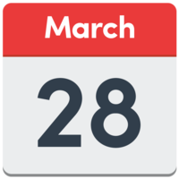
We hope to have made the Working Groups by 28 March 2025.

This information has been written by Ministry of Disabled People – Whaikaha.

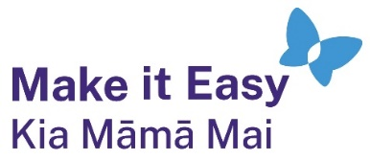
It has been translated into Easy Read by the Make it Easy Kia Māmā Mai service of People First New Zealand Ngā Tāngata Tuatahi.

The ideas in this document are not the ideas of People First New Zealand Ngā Tāngata Tuatahi.

All images used in this Easy Read document are subject to copyright rules and cannot be used without permission.


Make it Easy uses images from:


- Photosymbols

- Change Images


- Huriana Kopeke-Te Aho

- SGC Image Works

- T Wood


- Studio Rebeko

- Inga Kramer.

