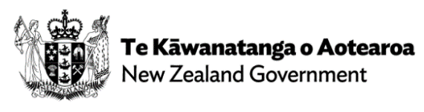
Continuing to Establish a Ministry of Disabled People
This funding will support the continued establishment of Whaikaha as a Ministry of Disabled People.
Vote Social Development 2023

Government has allocated $21.1 million to support Whaikaha – Ministry of Disabled People to establish roles that extend our capability and capacity in the areas of voice, partnership, communication, and culture.
This initiative supports the establishment of Whaikaha – Ministry of Disabled People.
- Whaikaha - Ministry of Disabled People is committed to working across Government and in partnership with the disability community and Māori to transform the lives of disabled people and their whānau.  - This partnership approach will help us to transform the disability support system in line with the Enabling Good Lives approach. | - To be effective Whaikaha must ensure it has robust systems and processes in place. It also needs to ensure it can recruit the right people to its organisation.  - This initiative will fund:  - About 10 new roles to deliver on voice, partnership, communication, and culture  - About 13 new connector roles in Enabling Good Lives sites  - Cost pressures on the Whaikaha work programme
Costs  (operating) $m | 2022/23 | 2023/24 | 2024/25 | 2026/27 | 2027/28 & outyears | TOTAL
 | - | 5.176 | 5.308 | 5.308 | 5.308 | 21.100

