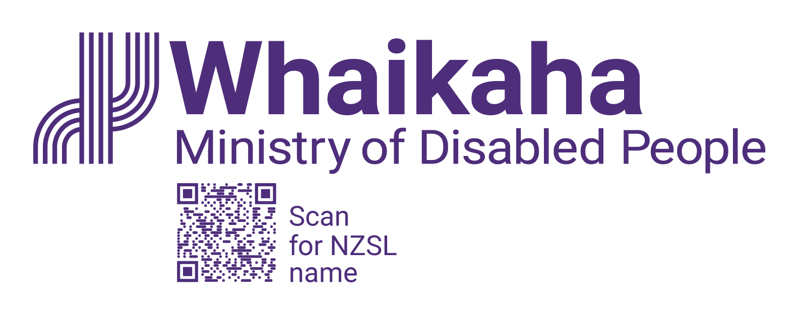
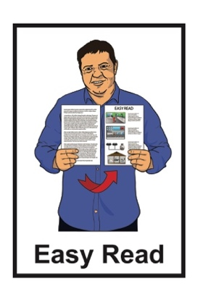

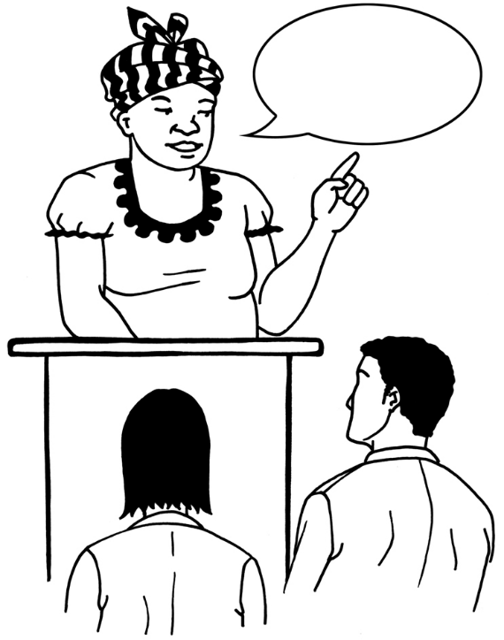
A message from Whaikaha –

Ministry of Disabled People

to disabled survivors of abuse in care
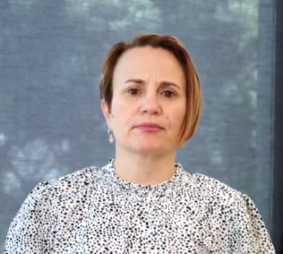

Paula Tesoriero
Chief Executive
Published: November 2024

Before you start


This Easy Read document talks about abuse.

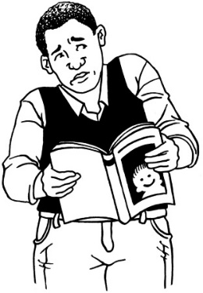

This information may upset some people when they are reading it.

This information is not meant to scare anyone.

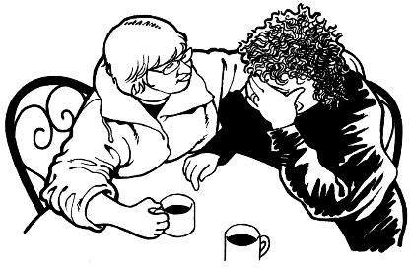
If you are upset after reading this Easy Read document you can talk to your:
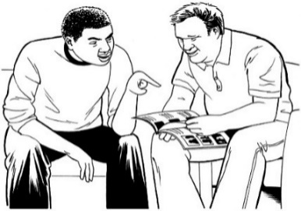
- whānau / family
- friends.


You can contact the Survivor Experiences Service for support.

In New Zealand you can phone:

0800 456 090
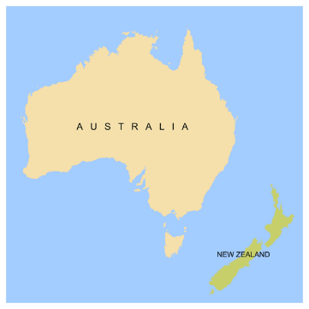

If you are calling from Australia you can phone:


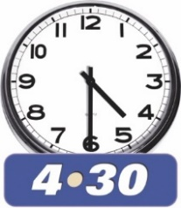
1 800 456 032

You can call this number:

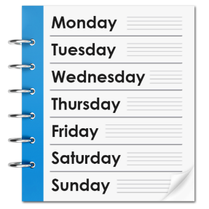
- between 8:30 am to 4:30 pm
- from Monday to Friday.



These times are for the New Zealand time zones.

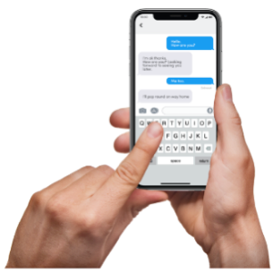
You can also send a text to the Survivor Experiences Service.


In New Zealand you can send a text to:

8328
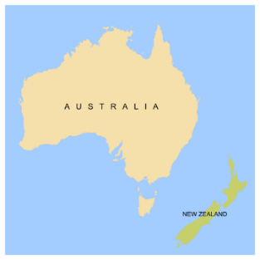
If you are texting from Australia you can send a text to:

+61 438 384 957


It does not cost any money to
call / text the Survivor Experiences Service.

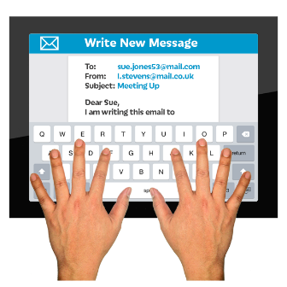
You can also send the Survivor Experiences Service an email at:

contact@survivorexperiences.govt.nz

About this document

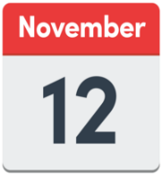
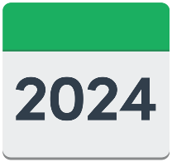
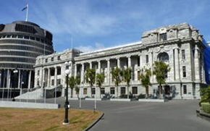
On the 12 November 2024 different parts of Government made a public apology to people who had been abused while in:
- state / government care
- faith-based care.
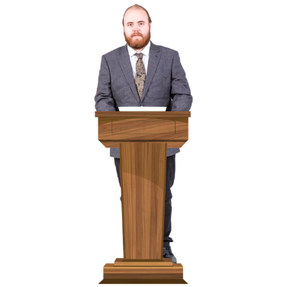

Sorry

A public apology is when someone says sorry to a group of people in a way that means everyone can be a part of what is said.


This Easy Read document is from Whaikaha – Ministry of Disabled People.

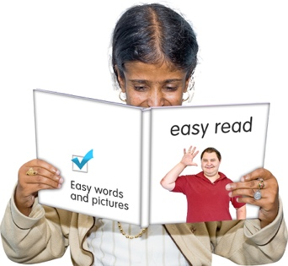
This document is a summary of the transcript of a video message from Paula Tesoriero.

A summary is:
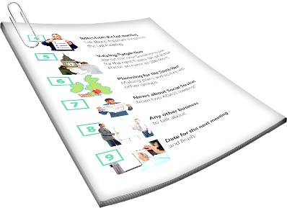
shorter than the original
message
tells you what you need to know.


A transcript is a written document
of the words someone has said.

Paula Tesoriero is the Chief Executive of Whaikaha – Ministry of Disabled People.

A Chief Executive is the person in charge of an organisation.

Sorry

The video message is in support of the public apology that has been made to the survivors of abuse in care.

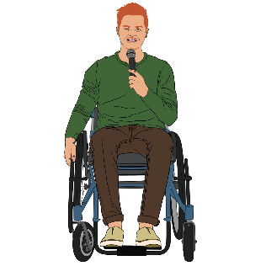
This document includes some quotes from Paula Tesoriero.
“Hello”

A quote is an exact copy in writing
of what someone has said.

The quotes are in yellow boxes like this.

Message from Paula Tesoriero
Chief Executive of Whaikaha –

Ministry of Disabled People

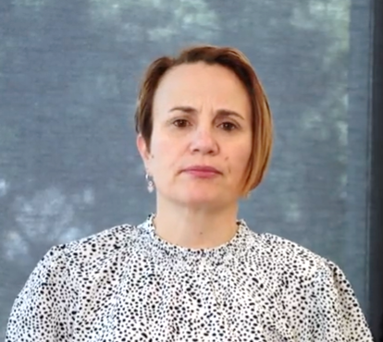
The message begins with Paula Tesoriero greeting everyone in:
te reo Māori
Pacific languages.

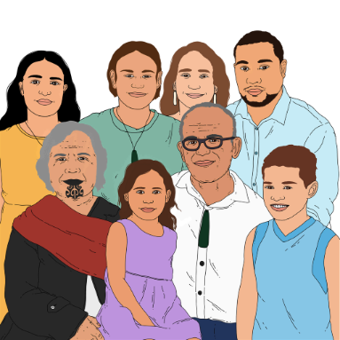
Paula says:

“E ngā mana, e ngā reo, e ngā mōrehu o te motu, tēnā koutou katoa.

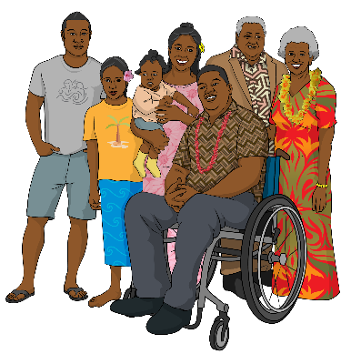
Talofa lava, kia orana, mālō e lelei, nisa bula vinaka, warm Pacific greetings.”

Paula also introduces herself in te reo Māori by saying:

“Ko Paula Tesoriero tōku ingoa.

Ko te Tumu Whakarae ahau i te Manatū Whaikaha, Ministry of Disabled People.”

Paula then says in English:

“My name is Paula Tesoriero, and I am the Chief Executive of Whaikaha – Ministry of Disabled People

I am a disabled woman with short brown hair wearing a white top with black spots.”

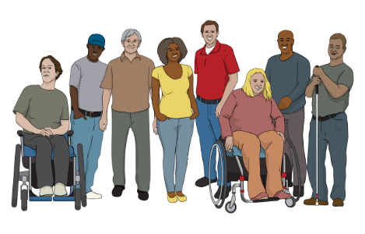
“I would like to begin by acknowledging how important, and also how challenging today is for:
- disabled people
- Deaf
- tāngata whaikaha Māori
- tāngata Turi

right across Aotearoa.

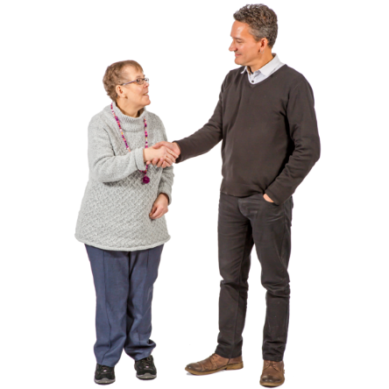
Acknowledge means you:
say you know that something happened
understand something is true.
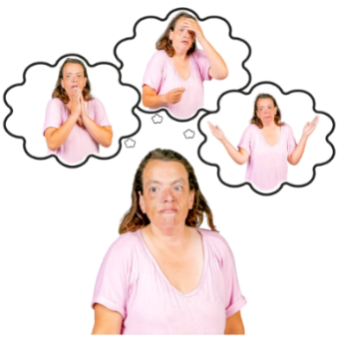

Challenging means hard / difficult.

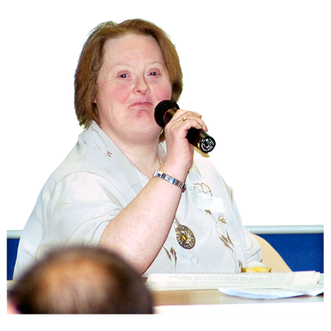
“Survivors, you courageously shared your experiences in the hope your peers, those that follow, will not endure what you did.

I have heard and read many of your experiences, I have witnessed your pain, and I have seen your strength.

Thank you for sharing with Aotearoa.”
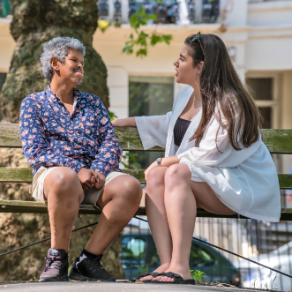

People who have been through abuse in care are called survivors.


Courageous means someone is:
very brave
mentally strong which means being strong in your mind.


Endure means to go through something that is not nice.

Sorry
“I am making this statement today to support the apologies for abuse in care made by the Prime Minister and my Chief Executive colleagues that deliver care.”
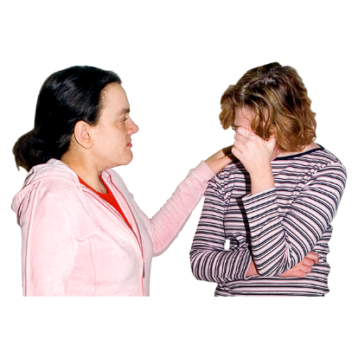

“The apology, which was made today [12 November 2024], is also challenging for:
- whānau / family
- carers
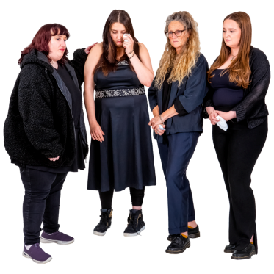
- supporters

and
- friends.”
For many, you were told by people you should have been able to trust, that it was best if your disabled or Deaf whānau member was cared for professionally by the state.

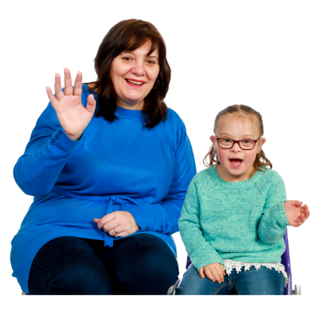

Professionally means the people who were being paid as carers should have:
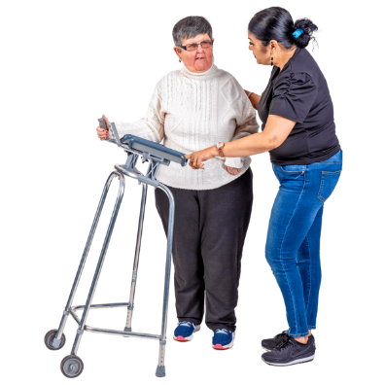
- looked after people well
- given the care / support needed
- kept people safe.


“You thought you were doing right by them. And in many situations this decision was made for you, not with you.

Sadly, the state failed you too.”

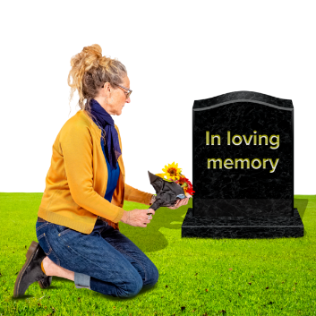
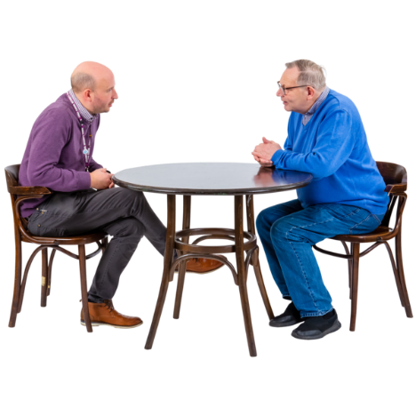

“Because of the poor health outcomes for disabled people, there are many disabled people survivors who were too unwell or not alive to share their experiences with the Royal Commission [Abuse in Care]
or to be part of this significant day.

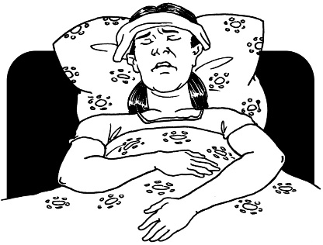
I acknowledge their passing.”


There were many more survivors who:
- did not speak to the Royal Commission
- could not come forward because they were ill.

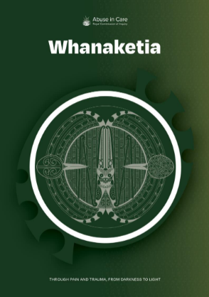
“I know that today can mean nothing without action.

Whanaketia, the title of the Royal Commission’s final report, means moving from the darkness to the light.
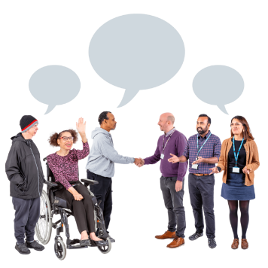

We must do this together.

I join my Chief Executive colleagues in their commitment to change.”
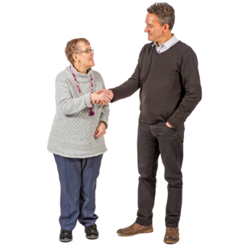

A commitment is an agreement to do something.


“We know disabled people experience poorer outcomes in many areas compared to non-disabled people.”


“The creation of Whaikaha, the Ministry of Disabled people provides a dedicated voice for disability in the leadership of government agencies.

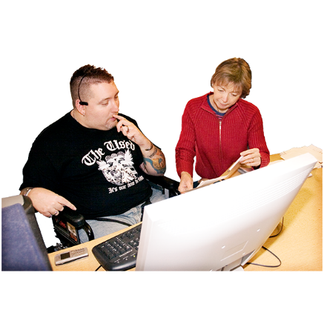
Our role is to work with other government agencies to improve things for disabled people.”

Creation means to make or set something up.
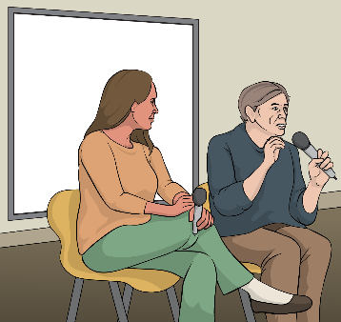

Here dedicated voice means to give disabled people a voice so they can be heard / seen


Improve means to make things better.

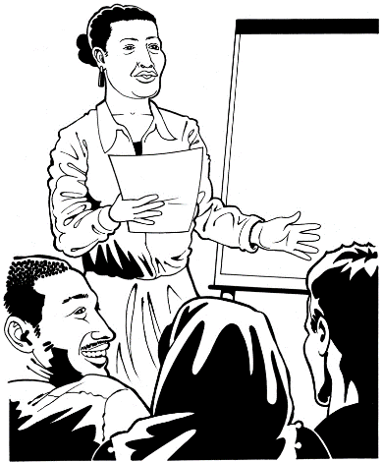
“We must educate and change attitudes.

When society values disabled people and works to remove barriers to full inclusion, we reduce the risk of violence towards our community.”
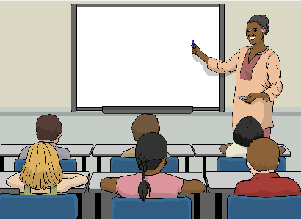

Educate means to teach people.

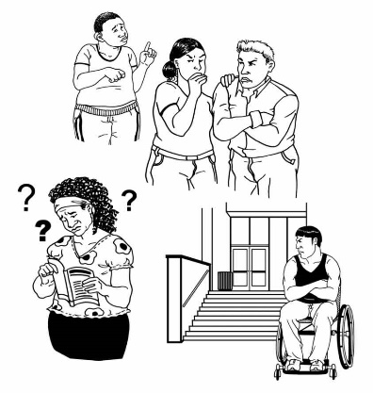
Attitudes means how people think about things.

Barriers are things that make it hard to do things.


Reduce means to make something smaller / less.

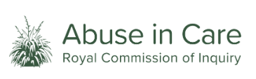
“I have engaged with the Abuse in Care Royal Commission, and I have been responsible for people’s care through providing disability supports.

I have gained a greater understanding for what is involved in building a system where people are free from abuse and neglect.

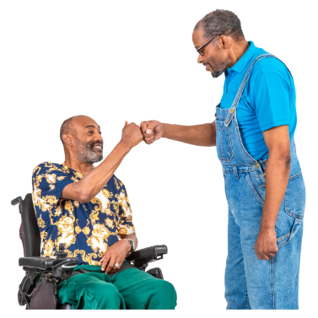
There is still so much work to do.”

Engaged means to work together.

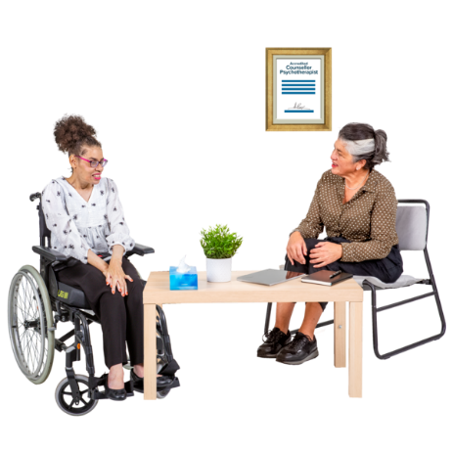
“For example, much more needs to be done to ensure disabled people can also access mainstream safeguarding and support services.”

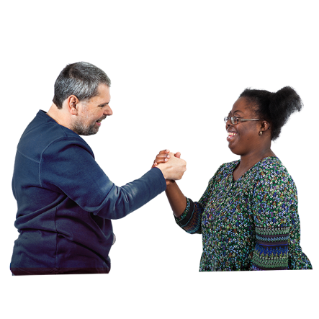
Mainstream safeguarding and support services means support services that:
are for everyone
keep people safe.
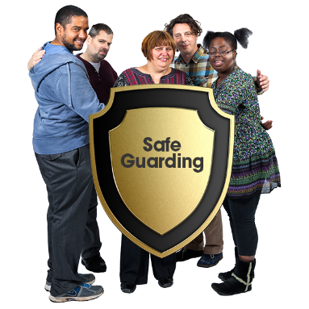


Safeguarding protects the rights of a person to make their own decisions about their life.

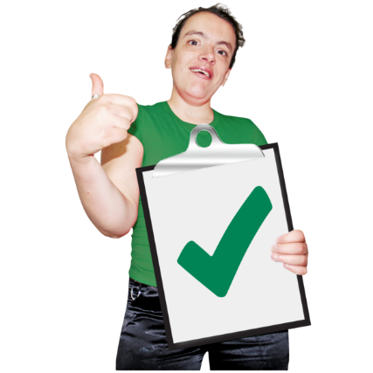
“I am proud of the actions that Whaikaha took to strengthen the quality and safeguarding system for disabled people.”

Quality is about how good or bad something is.

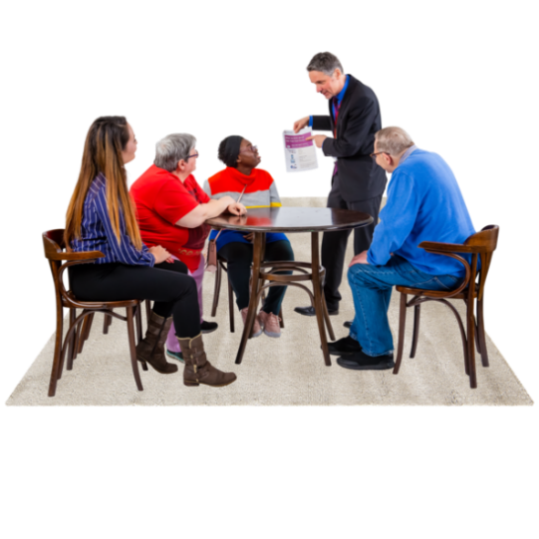
“This includes, developing a quality framework for disability support services, and services to prevent violence and abuse of disabled people.

These [services] are informed by and led by disabled people.”

“As we move towards the future, we must have a system that allows all people to flourish, and to live a life where they are safe and shown unconditional care and respect.”


The future in time / years to come.

Flourish means to:
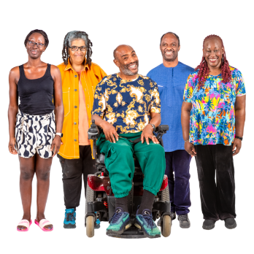
- do well in life
- make your own choices / decisions
- be safe from harm.
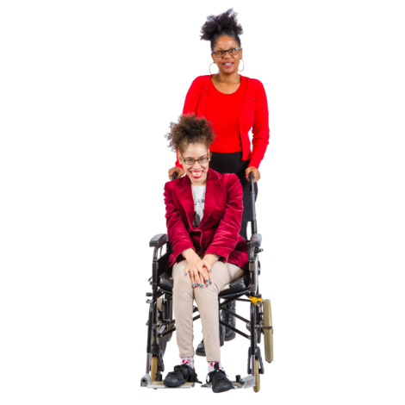

Unconditional care and respect means to accept somebody for who they are.


“Thank you for your strength throughout history, your strength today and your strength as you continue to engage with the state so future generations have a better experience.”
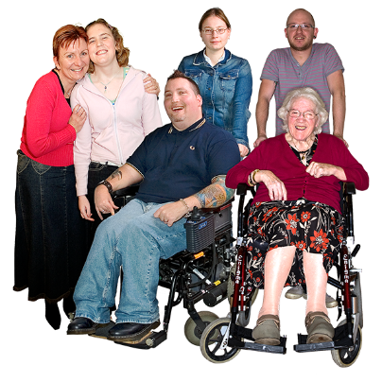

Future generations are people who live in the years to come.

“A heartfelt personal thanks to survivors both past and present who have engaged with our work, and across government to give disabled people more choice and control.

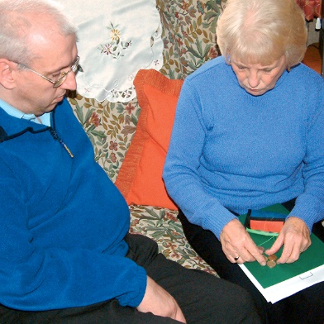
Your courage, your stories, your work will guide me, my colleagues, and the next generation of leaders.

This, this will be your legacy.”

Here legacy means the things someone does now will mean good changes for other people in the time to come.

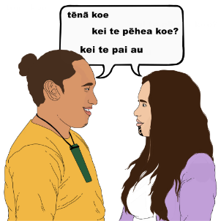
Paula ends her message by thanking everyone in te reo Māori.

Paula says:
“Ngā mihi nui, ki a koutou katoa.”

This information has been written by Whaikaha – Ministry of Disabled People.

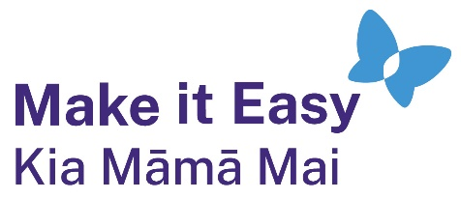
It has been translated into Easy Read by the Make it Easy Kia Māmā Mai service of People First New Zealand Ngā Tāngata Tuatahi.
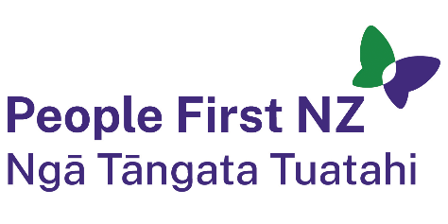
The ideas in this document are not the ideas of People First New Zealand Ngā Tāngata Tuatahi.
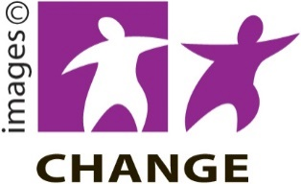
Make it Easy uses images from:


- Changepeople.org


            - Photosymbols.com


- SGC Image Works
- Huriana Kopeke-Te Aho
- T. Wood.

All images used in this Easy Read document are subject to copyright rules and cannot be used without permission.

