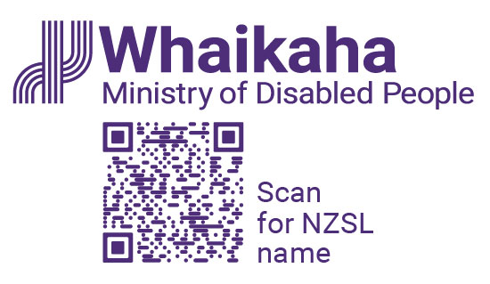

# Message from the Chief Executive of Whaikaha to Disabled Survivors of Abuse in Care

E ngā mana, e ngā reo, e ngā mōrehu [survivors] o te motu, tēnā koutou katoa.

Talofa lava, kia orana, mālō e lelei, nisa bula vinaka, warm Pacific greetings.

Ko Paula Tesoriero tōku ingoa, Ko Te Tumu Whakarae ahau i Te Manatū Whaikaha, Ministry of Disabled People.

My name is Paula Tesoriero, and I am the Chief Executive of Whaikaha – Ministry of Disabled People.

I am a disabled woman with short brown hair wearing a white top with black spots and I’m standing in front of a window, and I have an NZSL interpreter to my left.

My sign name is this [Paula] – which is two closed fists symbolising two bicycle pedals moving in a forward direction.

I would like to begin by acknowledging how important, and also how challenging today is for disabled people, Deaf, tāngata whaikaha Māori and tāngata Turi right across Aotearoa.

Survivors, you courageously shared your experiences in the hope your peers, those that follow, will not endure what you did. I have heard and read many of your experiences, I have witnessed your pain, and I have seen your strength.

Thank you for sharing with Aotearoa.

I am making this statement today to support the apologies for abuse in care made by the Prime Minister and my Chief Executive colleagues that deliver care.

Receiving the apology, which was made today is also challenging for whānau, family, carers, supporters, and friends. For many, you were told by people you should have been able to trust, that it was best if your disabled or Deaf whānau member was cared for professionally by the state.

You thought you were doing right by them. And in many situations this decision was made for you, not with you.

Sadly, the state failed you too.

Because of the poor health outcomes for disabled people, there are many disabled people survivors who were too unwell or not alive to share their experiences with the Royal Commission or to be part of this significant day. I acknowledge their passing. I know that today can mean nothing without action.

Whanaketia, the title of the Royal Commission’s final report, means moving from the darkness to the light. We must do this together.

I join my Chief Executive colleagues in their commitment to change.

We know disabled people experience poorer outcomes in many areas compared to non-disabled people.

The creation of Whaikaha, the Ministry of Disabled People provides a dedicated voice for disability in the leadership of government agencies.

Our role is to work with other government agencies to improve things for disabled people.

We must educate and change attitudes. When society values disabled people and works to remove barriers to full inclusion, we reduce the risk of violence towards our community.

I have engaged with the Abuse in Care Royal Commission, and I have been responsible for people’s care through providing disability supports, I have gained a greater understanding for what is involved in building a system where people are free from abuse and neglect. There is still so much work to do.

For example, much more needs to be done to ensure disabled people can also access mainstream safeguarding and support services. I am proud of the actions that Whaikaha took to strengthen the quality and safeguarding system for disabled people.

This includes, developing a quality framework for disability support services, and services to prevent violence and abuse of disabled people.

These are informed by and led by disabled people. As we move towards the future, we must have a system that allows all people to flourish, and to live a life where they are safe and shown unconditional care and respect.

Thank you for your strength throughout history, your strength today and your strength as you continue to engage with the state so future generations have a better experience.

A heartfelt personal thanks to survivors both past and present who have engaged with our work, and across government to give disabled people more choice and control. Your courage, your stories, your work will guide me, my colleagues, and the next generation of leaders. This, this will be your legacy.

Ngā mihi nui, ki a koutou katoa.

End of **Message from the Chief Executive of Whaikaha to Disabled Survivors of Abuse in Care**

This Large Print document is adapted by Blind Citizens NZ from the standard document provided by the Whaikaha | Ministry of Disabled People