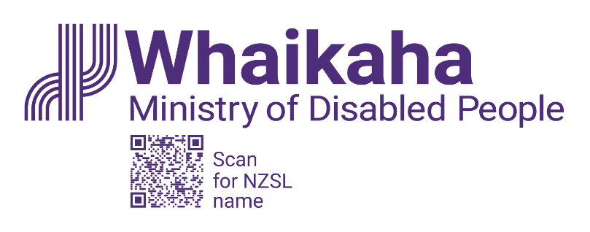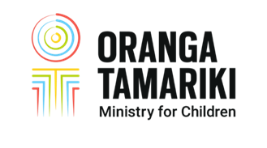

Roles and

Responsibilities
Guidelines to support the implementation of the Memorandum of Understanding:
Whaikaha - Ministry of Disabled People and Oranga Tamariki - Ministry for Children, 2023

Released 2024
Whaikaha.govt.nz
This document is available at whaikaha.govt.nz

This work is licensed under the Creative Commons Attribution 4.0 International licence. In essence, you are free to: share, i.e. copy and redistribute the material in any medium or format; adapt i.e. remix, transform, and build upon the material. You must give appropriate credit, provide a link to the licence, and indicate if changes were made.

Foreword
This Roles and Responsibilities Guideline is a resource which supports the implementation of the Memorandum of Understanding (MoU) between Whaikaha -Ministry of Disabled People (Whaikaha) and Oranga Tamariki - Ministry for Children (Oranga Tamariki).
The MoU was signed on 29 June 2021 by the Disability Directorate of the Ministry of Health and Oranga Tamariki. On 1 July 2022, the Disability Directorate of the Ministry of Health transitioned to Whaikaha.
The mandate to transfer the functions set out in the MoU from the Ministry of Health to Whaikaha comes from the October 2021 Cabinet Paper, Disability System Transformation: establishing a Ministry for Disabled People and national implementation of the Enabling Good Lives approach [refer Disability System Transformation: establishing a Ministry for Disabled People and national implementation of the Enabling Good Lives approach Ministry of Social Development (msd.govt.nz)].
The MoU provides a framework for Whaikaha and Oranga Tamariki to implement, administer and review the arrangements for supporting disabled tamariki and rangatahi who are eligible for Disability Support Services (DSS), including those who may need extended care or custody under the Oranga Tamariki Act 1989.

The tamariki and rangatahi covered by the MoU are all eligible for DSS and are supported by Whaikaha and Oranga Tamariki. In addition, the Funding Schedule describes the funding model used by Whaikaha and Oranga Tamariki to fund out-of-home services for DSS eligible tamariki and rangatahi in extended care or custody under the Oranga Tamariki Act 1989.

Disabled tamariki and rangatahi belong with their families/whānau, yet their situations can be complex. Whaikaha and Oranga Tamariki are committed to working together to support families/whānau to care for their disabled tamariki and rangatahi at home.
Whaikaha and Oranga Tamariki will work together in good faith and in a timely way to meet the needs of DSS-eligible tamariki and rangatahi. This includes ensuring eligible disabled tamariki and rangatahi who are in foster care placements or remain in the care of their whānau, receive the supports they need to thrive.
The scope of the MoU includes the transition to adult disability support services for eligible rangatahi when they turn 18 years of age.

Refer to MoU
Section 2: Title and Status
Section 4: Context
Contents
Foreword iii
Section 1: Document Overview vi
Important Information viii
Glossary of Terms x
Section 2: Roles and Responsibilities 1
2.1 Whaikaha – Ministry of Disabled People 1
2.2 Needs Assessment and Service Coordination (NASC) Organisations 3
2.3 Enabling Good Lives (EGL) 4
2.4 Oranga Tamariki – Ministry for Children 6
Section 3: Working together 11
3.1 Regular Meetings 12
3.2 Case Meetings/Multi-Disciplinary Meetings 12
3.3 Joint assessments 14
3.4 Shared planning 14
3.5 Family Group Conference (FGC) 15
3.6 Inter-Agency Referrals 17
3.7 Referrals to NASC and EGL Teams from Oranga Tamariki 19
3.8 Referrals to Oranga Tamariki from NASC and EGL Teams 20
3.9 Clarifying roles and responsibilities 21
3.10 Transition Planning 22
3.11 Community-Based Disability Support Services 25
3.12 Working with other disability-related agencies/organisations 26
3.13 Resolving Differences 32
Section 4: Funding 34
Process to place tamariki and rangatahi on the Funding Schedule 36

Section 1: Document Overview
The goal of these guidelines is to ensure that disabled tamariki, and rangatahi, and their families/whānau receive the supports they need to thrive.

Refer to MOU Section 7: Shared outcomes

Document Purpose
The purpose of this document is to provide professionals working in Oranga Tamariki, Whaikaha, Needs Assessment Service Coordination (NASC) agencies, and Enabling Good Lives (EGL) with guidance to support the implementation of the Memorandum of Understanding (MoU). This document should be read in conjunction with the latest version of the MoU.
The document has been developed with input from operational staff in Oranga Tamariki, Whaikaha and NASC.
Refer to MOU:
Section 5: Purpose
Section 6: Scope

Document Structure
Throughout the document there are references to the specific section of the MoU that is relevant to the topic being outlined. The intention is to avoid repeating information across the two documents.
Where possible you will be linked to additional appropriate sites for further information via a hyperlink.
This document is a ‘living document’ which is intended to be updated as required and reviewed at least annually as agreed in the MoU.
Refer to MOU:
Section 20: Review and variation

Important Information

Working Together Framework
The diagram below provides an overview of the framework to support disabled tamariki and rangatahi and their families/whānau:
Text description: Oranga Tamariki has a legislative mandate for this work under the Oranga Tamariki Act 1989.
Whaikaha has a mandate for this work under the Disability Framework and Strategy. Oranga Tamariki and Whaikaha have signed a Memorandum of Understanding and developed Roles and Responsibilities guidelines to support staff to implement the Memorandum of Understanding.

The outcomes will be:
- Improved wellbeing and life outcomes for disabled tamariki and rangatahi
- Strengthening the resources of families and whanau
- Achieving stability for disabled tamariki and rangatahi

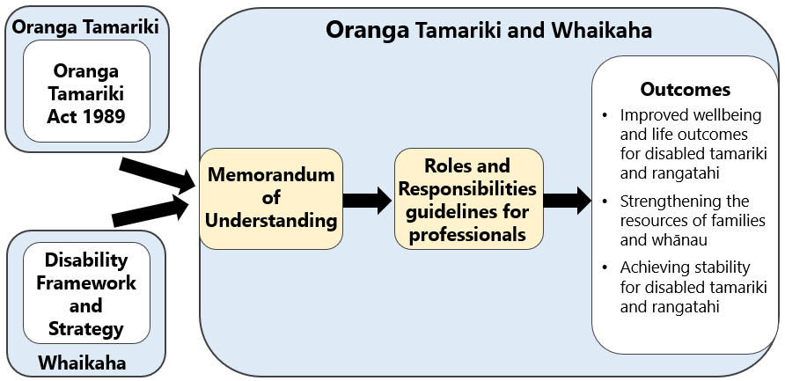

Refer to MOU
Section 3: Parties to the MOU
Section 10: Roles and Responsibilities

Shared Outcomes

The MOU describes the following shared outcomes for Whaikaha and Oranga Tamariki:
- Disabled tamariki and rangatahi receive the same standards of care, rights, and protections, with the same processes and safeguards, as all other tamariki and rangatahi
- There is both a consistent approach for all disabled tamariki and rangatahi who require out-of-home care (including for the funding arrangements), and sufficient flexibility in approach to meet needs and support transition to adult services
- In all cases, the parties work with whānau and utilise all supports to try and keep tamariki or rangatahi at home
- All appropriate government supports are offered to whānau to support tamariki or rangatahi to remain at home.
Refer to MOU:
Section 7: Shared Outcomes

Eligibility for Support
Tamariki and rangatahi covered by the MOU are all eligible for Disability Support Services, (DSS) and are supported by Whaikaha and Oranga Tamariki.

A small proportion of disabled tamariki and rangatahi are placed in long-term out-of-home care with staffed-care arrangements that are specific to meeting disability-related need. These are placements in which both the assessed care needs, and most disability support needs of tamariki or rangatahi are included in the care provider’s service. The care provider is contracted by Oranga Tamariki to provide fully staffed 24/7 services. The funding model covers tamariki and rangatahi in these out-of-home services.
The practice of Whaikaha, Oranga Tamariki, NASC agencies and EGL teams is guided by policies and procedures that are specific to their organisations. Some of these policies and procedures are referred to in this Guideline.

Governance
The Joint Oversight Group (JOG), monitors the implementation of the MOU and related work, provides a point of escalation for disagreements if needed, and oversees funding and expenditure at a population level. It consists of decision makers at General/Group Manager level from each of the parties.

Refer to MOU:
Section 1: Interpretation – Joint Oversight Group
Section 13: Governance
Section 14: Mutual Cooperation
Section 15: Problem Resolution

Glossary of Terms
CCS | CCS Disability Action, a service provider and advocacy organisation; formerly the Crippled Children’s Society.
CDS | Child Development Services
CAMHS | Child and Adolescent Mental Health Services
CP FGC | Care and Protection Family Group Conference
CYWS | Child and Youth Wellbeing Strategy
DHBs | District Health Boards. Refer to Te Whatu Ora – Health New Zealand
DSS | Disability Support Services
FGC | Family Group Conference
HCN | High and Complex Needs
IRF | Interim Response Fund (provided by the Ministry of Education)
IWS | Intensive Wraparound Services
JMS | Joint Ministerial Statement
JOG | Joint Oversight Group
MoE | Ministry of Education – Te Tāhuhu o te Mātauranga
MoH | Ministry of Health – Manatū Hauora
MoU | Memorandum of Understanding
NASC | Needs Assessment and Service Coordination Agency: the organisation that allocates disability support levels
NGOs | Non-Governmental Organisations
NRC | National Referral Centre
Oranga | Oranga is different for all whānau. Oranga is fluid, ebbing and flowing through various states over a lifetime, including both experiences of harm and wellbeing through which resilience and potential can be developed.  Whilst all cultures have their own ways of understanding oranga, an inclusive and holistic view drawing from Te Ao Māori wellbeing principles includes:  • Wairua – the dimension of values and beliefs  • Hinengaro – the dimension of intellectual and mental wellbeing  • Ngākau - the dimension of emotional wellbeing  • Tinana – the dimension of physical wellbeing  • Whānau - the dimension of family wellbeing  In the practice context, understanding oranga in this way helps to recognise harmful impacts on oranga, and respond to the kaitiakitanga of tamariki in restorative and relational ways.
Oranga Tamariki | Oranga Tamariki – Ministry for Children
Oranga Tamariki Act | The Oranga Tamariki Act 1989: The OT Act contains provisions relating to care and protection and youth justice.
RDA | Regional Disability Advisors
SDM | Supported Decision Making
SF | Strengthening Families
SLM | Service Level Measure
Te Whatu Ora | Te Whatu Ora – Health New Zealand
Whaikaha | Whaikaha – Ministry of Disabled People
W&I | Work and Income – Te Hiranga Tangata
UNCRPD | United Nations Convention on the Rights of Disabled Persons
UNCROC | United Nations Convention on the Rights of the Child
YJ FGC | Youth Justice Family Group Conference
VOYCE | VOYCE – Whakarongo Mai (Voice of the Young and Care Experienced)

Refer to MOU Section 1: Interpretation

Section 2: Roles and Responsibilities

2.1 Whaikaha – Ministry of Disabled People
Whaikaha - Ministry of Disabled People (Whaikaha) is committed to ensuring disabled tamariki, rangatahi, adults and their whānau have greater choice and control over their supports and lives to help them live the life they want.
Refer to MOU:
Section 3: Parties to the MOU
The Roles and Responsibilities Schedule 6.1: Ministry of Health roles and responsibilities

Whaikaha - Ministry of Disabled People
The establishment of Whaikaha is a world-first and sees New Zealand continuing take a lead role internationally in promoting the rights of disabled people. The new Ministry is a key moment in the growth in the status of disability issues and disabled people in Aotearoa New Zealand. The new Ministry aims to achieve the following goals:
- Transform how its services are funded and provided for disabled people who need support to live the lives they want
- Tackle questions of equity/inequity and fragmentation in the disability system
- Meet Te Tiriti o Waitangi obligations – through partnerships with Māori in decisions about the transformation and through pursuing equitable outcomes for tāngata whaikaha Māori
- Influence how all other government agencies reflect the needs of disabled people in the delivery of their policy and mainstream services.
This role involves working with the community to reconceptualise the status of disabled people and their whānau – how they are supported and how they can lead in transforming how society enables them to live good lives with greater choice and control.
Whaikaha is responsible for providing the oversight of 'end-to-end' activities and functions for eligible disabled people and their whānau, including the planning and funding of Disability Support Services (DSS). These services may include, for example, child development services, behaviour support services and equipment and housing modifications.
Whaikaha contracts with a range of organisations to provide DSS. Oranga Tamariki staff wanting information on the range of services and entry criteria for specific services should talk to their local NASC or EGL team.

Disability Support Service (DSS)
DSS are purchased by Whaikaha for people with a long-term physical, intellectual and/or sensory impairment that requires ongoing Government support to enhance their health and wellbeing.
Whaikaha contact details
Whaikaha website
0800 566 601
contact@whaikaha.govt.nz

2.2 Needs Assessment and Service Coordination (NASC) Organisations
NASCs are organisations contracted by Whaikaha to work with disabled people and their family, whānau, aiga, or carers to:
- Identify their strengths and support needs
- Outline what disability support services are available
- Determine eligibility for support services funded by Whaikaha.

Needs Assessments
A facilitated Needs Assessment is undertaken in conjunction with the disabled child or young person and their family or whānau. It is a process of defining the current abilities, resources, goals and needs of tamariki or rangatahi and their family and identifies which of these is the most important.

Service Coordination
NASC services are delivered by service providers throughout the country. It is the NASC role to ensure that support is allocated in a fair way and fits within the available disability support services funding.
Service coordination is a process of identifying, planning, and reviewing the package of support required to meet the prioritised needs and goals of tamariki or rangatahi and their family, whānau and carers.

Budget Management
Budget management involves allocating cost-effective packages of services within an indicative budget. This process is guided by the Support Package Allocation tool within benchmarks determined by Whaikaha.
Helpful Resources:
Needs Assessment and Services Coordination Organisations

2.3 Enabling Good Lives (EGL)
Enabling Good Lives (EGL) is a principle-based approach that was developed by an independent working group of disabled people, whānau, tāngata whenua and service providers. EGL was established in 2011 with the aim of supporting disabled people to live the lives they want and ensuring they can actively participate in society.
The vision of EGL is that disabled people, and their families and whānau, will have greater choice and control over their supports and lives and make more use of natural and universally available supports. The intent of the EGL approach is to make changes so that disabled people and their families have control of their lives. This includes having the “say so” in how resources are used.

Principles of EGL approach
The principles of EGL are:
Beginning early
Invest early in families and whānau to support them; to be aspirational for their disabled child; to build community and natural supports; and to support disabled children to become independent, rather than waiting for a crisis before support is available.
Easy to use
Disabled people have supports that are simple to use and flexible.
Mana enhancing
The abilities and contributions of disabled people and their families are recognised and respected.
Mainstream first
Disabled people are supported to access mainstream services before specialist disability services.
Person-centred
Disabled people have supports that are tailored to their individual needs and goals, and that take a whole life approach rather than being split across programmes.
Relationship building
Supports build and strengthen relationships between disabled people, their whānau and community.
Self-determination
Disabled people are in control of their lives.
Ordinary life outcomes
Disabled people are supported to live an everyday life in everyday places; and are regarded as citizens with opportunities for learning, employment, having a home and family, and social participation – like others at similar stages of life.
Helpful Resources:
System Transformation & Enabling Good Lives information
Learn about Enabling Good Lives Waikato
Learn about Enabling Good Lives Christchurch
Learn about Mana Whaikaha

Enabling Good Lives – Interdependent system change elements
A national rollout of the EGL approach needs to be carefully co-designed and planned. The graphic on the following page outlines important elements of the system change.
Text description: Five important elements for system change are highlighted in the graphic:
- Building knowledge and skills of disabled people to ensure disabled people understand the direction for change, and can take up opportunities to have more voice and control over their supports
- Investments in families to assist families/whanau to best support their disabled family member to have a “good life” and help them develop a vision and aspirations for what can be achieved
- Changes in communities to ensure communities, including businesses, workplaces, schools, and religious, cultural, sporting and recreational activities, are accessible and welcoming. Communities also need to recognise the contribution that disabled people can make to enhance cohesion and wellbeing.
- Changes to service provision to align organisational roles and functions, delivery models, workforce capability, accountability measures, monitoring and evaluation with the vision and principles of the transformed system.
- Changes to government systems and processes to support system redesign, e.g. integrated contracting, individualised funding, flexible outcomes-focussed contracting, funding pooled from across Votes (including changes in appropriations), and involving disabled people and families in governance.

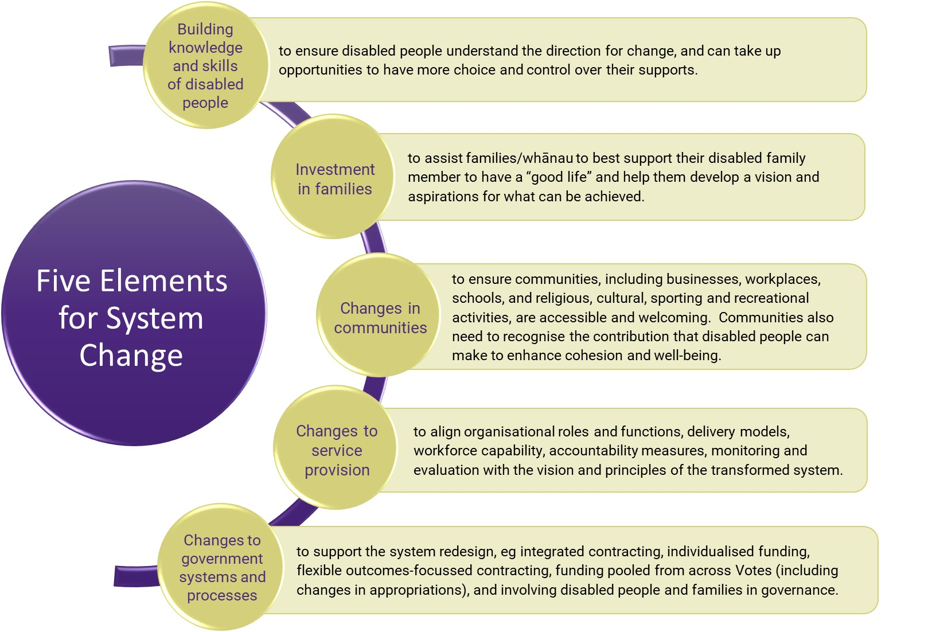

2.4 Oranga Tamariki – Ministry for Children
The Chief Executive of Oranga Tamariki has duties in relation to Te Tiriti o Waitangi under Section 7AA of the Oranga Tamariki Act. This includes having regard to mana of tamariki, the whakapapa of tamariki, rangatahi Māori, and the whanaungatanga responsibilities for their whānau hapū and iwi.
The vision of Oranga Tamariki is that all tamariki and rangatahi are safe, loved and nurtured by whānau, hapū, and iwi, supported by thriving communities. The purpose of Oranga Tamariki is to ensure that all tamariki are in loving families/whānau and communities where oranga can be realised.
The aim is that tamariki and rangatahi will be cared for by their families/whānau and that Oranga Tamariki and NASC or EGL teams will work together to support families/whānau to care for their tamariki/rangatahi. When this is not possible, tamariki or rangatahi may require an out-of-home placement on a temporary or long-term basis.

Core Role
Oranga Tamariki has two core roles. To support the vision of the Government vision, it must be:
- A high performing, highly trusted statutory care and protection and youth justice agency that works in an integrated way with other agencies and communities
- An enabler and coordinator for Māori and communities, to enable them to put in place the support, solutions, and services they know will work for their people to prevent tamariki coming to the attention of Oranga Tamariki.

Purpose
The purpose of Oranga Tamariki is to:
- Ensure that all tamariki in New Zealand are in loving whānau and communities where oranga can be upheld
- Uphold people’s rights, including those rights set out in the United Nations Convention on the Rights of the Child, the United Nations Declaration on the Rights of Indigenous Peoples, and the United Nations Convention on the Rights of Persons with Disabilities
- Support and work with tamariki and rangatahi for a range of reasons. It may be because of their family environment or their own complex needs. It may be because their wellbeing is at significant risk of harm now or in the future. Or it may be because they have offended or are likely to offend
- Work to enable communities and whānau to support the needs of tamariki and rangatahi and prevent the need for a statutory care or protection or youth justice response.
Tamariki and rangatahi Māori are disproportionately represented in the cohorts entering the care and protection system and the youth justice system. It is important that Oranga Tamariki works with whānau, hapū, iwi and communities to find ways of reducing disparities and achieving equitable wellbeing outcomes for tamariki and rangatahi Māori. (Refer to: Periodic review of legislation, policy, and other accountability arrangements Report to Parliament by the Minister for Children under section 448B of the Oranga Tamariki Act 1989 July 2022)

Key Responsibilities
Oranga Tamariki is the government agency with legal duties and powers to intervene to protect and help tamariki and rangatahi who are being abused or neglected, or whose needs are not, or are unable to be met within their whānau. Oranga Tamariki is responsible for the investigation and assessment of tamariki or rangatahi, to determine whether they are in need of care or protection. Oranga Tamariki also has statutory functions in relation to rangatahi who offend, via Youth Justice obligations, and has a role with domestic and international adoptions.
Oranga Tamariki may be involved with tamariki, rangatahi and their families/whānau in the following situations:
- Care or protection issues are being investigated or assessed under the provisions of section 15 or 19 of the Oranga Tamariki Act
- Tamariki or rangatahi are in need of care or protection and have been placed in the custody of the Chief Executive of Oranga Tamariki or another person or organisation pursuant to a court order or an agreement under the Oranga Tamariki Act
- Tamariki or rangatahi are in need of care or protection, but not subject to a custody order or a care agreement under the Oranga Tamariki Act, and the whānau are being supported via alternative provisions (e.g., a Family Group Conference plan or a Support Order under the Oranga Tamariki Act is in place)
- Tamariki or rangatahi have offended or are alleged to have offended and have matters before the Youth Court or are subject to youth court orders under section 283 of the Oranga Tamariki Act.

Receiving a report of concern
On receiving a report of concern of alleged ill treatment or neglect of tamariki or rangatahi, it is the role of Oranga Tamariki to understand the situation and determine if there is a need for further action to address any care or protection issues found. This is a particular area of social work expertise and a key statutory role of Oranga Tamariki under the Oranga Tamariki Act.
When a Social Worker forms a reasonable belief that tamariki or rangatahi are in need of care or protection, the Social Worker must refer the matter to a Care and Protection Coordinator for a Family Group Conference under section 18 of the Oranga Tamariki Act if it is determined this is the only way any concerns can be addressed.
A care and protection Family Group Conference (FGC) can also be convened:
- By referral by another person or by the court (section 19)
- To transition to independence planning for rangatahi leaving care.

Youth Justice
Most tamariki or rangatahi who allegedly commit offences will not come to the attention of Oranga Tamariki Youth Justice or the Youth Court but will be subject to police alternative action and diversion – unless their alleged offending is particularly serious or repetitive.
Tamariki or rangatahi who are charged with an offence will usually be directed to the Youth Court. The Youth Court is a specialist division of the District Court and operates in a less formal manner than the adult courts.
Tamariki or rangatahi will first appear in court, at which time a FGC will be directed.
The Youth Justice FGC process is outlined below:
- Tamariki or rangatahi have offended, or are alleged to have offended, and have matters before the Youth Court or are subject to youth court orders under section 283 of the Oranga Tamariki Act.
- Tamariki or rangatahi, their family, the victim, a youth justice coordinator, member(s) of the police, and any other relevant professionals meet to discuss:
  - The offending
  - The impact the offending has had on all involved
  - A possible plan to address the offending.
- Tamariki or rangatahi report back to the Youth Court with this plan. The Youth Court Judge will almost always approve the plan.
- The Court will oversee that the young person carries out the plan properly.
When a charge against a tamariki or rangatahi is proved, the Youth Court has a range of responses available to it, including to discharge the charge in accordance with section 282 or the Oranga Tamariki Act or impose an order under section 283 of the Oranga Tamariki Act.
Some rangatahi who are going through youth justice processes may become subject to Criminal Procedure (Mentally Impaired Persons) Act 2033 or Intellectual Disability (Compulsory Care and Rehabilitation) Act 2003 provisions. In those situations, liase with the Oranga Tamariki Regional Disability Advisor or the Forensic Coordination Services NASC liaison.

Oranga Tamariki Act 1989
Refer to Section 5 of this document for the types of orders and agreements under the Oranga Tamariki Act 1989.

Oranga Tamariki Key Roles

Social Worker
The Social Worker investigates to understand concerns about the care or protection of tamariki and rangatahi. The Social Worker works alongside whānau, hapū and iwi and often community agencies to develop plans that enable the oranga (safety and wellbeing) of tamariki or rangatahi.
Youth Justice Social Workers are the key people who work with children and young people, their whānau, police, youth advocates and essential government and community support services when a child or young person has committed or allegedly committed an offence.

Care and Protection Coordinator
The Care and Protection Coordinator convenes care and protection Family Group Conferences under other provisions in the Act (YJ or 18AAA). The duties of Care and Protection Coordinators are outlined in section 424 of the Oranga Tamariki Act.

Youth Justice Coordinator
The Youth Justice Coordinator convenes Youth Justice Family Group Conferences (YJFGCs) under Part 4 of the Oranga Tamariki Act (s280A(5), s281A, s281B). YJFGCs give tamariki or rangatahi, with their whānau, victims and professionals, a chance to help find solutions when they have offended.

Kairaranga ā-whānau
Kairaranga ā-whānau is a specialist Māori role. The literal meaning of the term is: a person who is a weaver of family connections.

Supervisor
The Supervisor provides clinical and line management support to social workers and can support in complex situations.

Practice Leader
The Practice Leader provides practice advice and guidance across the site.

Site Manager
The Site Manager has line management responsibility for all staff and activities at the site.

Youth Justice Manager
The Youth Justice Manager provides leadership to, and management of the Youth Justice multi-disciplinary team consisting of Youth Justice Supervisors, Youth Justice Social Workers, Court Officers, Court Supervisors, and Youth Justice administration staff. The Youth Justice Manager is responsible for championing Youth Justice within their community and for developing and maintaining appropriate stakeholder relationships.

Regional Disability Advisors
There are 11 Regional Disability Advisors (RDA’s) across the country whose role is to provide advice and assistance to sites and others when disabled tamariki, rangatahi, their whānau/caregivers, or disabled adults, become engaged with Oranga Tamariki. The RDAs are supported by a Principal Disability Advisor and Team Leader.
Oranga Tamariki contact details

Oranga Tamarki website
0508 326 459
enquiry@ot.govt.nz

Section 3: Working together
The heart of working together is the relationships we build with the tamariki, family/whānau, communities and partners we work with.
Improving the outcomes for disabled tamariki and rangatahi who access both Oranga Tamariki and disability support services requires a joint commitment between the agencies involved. The principles for achieving this are outlined in the MoU.
Collaborative activities that support this approach include:
- Building relationships between the organisations at all levels
- Focusing on shared goals
- Using shared approaches to assessment, planning, and decision-making
- Resolving differences in views as they arise.
The roles in Oranga Tamariki, NASC, and Whaikaha at local, regional, and national levels are listed below, and in table form:
Local level:
- Oranga Tamariki:
- Caregiver Liaison Social Worker
- Care of Protection Social Worker
- FGC Coordinator
- Practice Leader
- Site Manager
- Supervisor – Youth Justice or C&P
- Youth Justice Manager
- Youth Justice Social Worker
- Whaikaha:
- NASC:
  - NASC Manager
  - Needs Assessor / Assessment Facilitator
  - Service Coordinator
  - Team Leader
Regional level:
- Oranga Tamariki:
- Health and Education Senior Advisors
- Kairaranga ā-whānau
- Regional Manager
- Regional Child Disability Advisors
- Whaikaha:
- Portfolio Managers
- Regional Managers Operational Performance Team
National/Centralised Functions:
- Oranga Tamariki:
- Executive Manager, Operations
- General Manager – Specialist Services
- Manager – High Needs Service
- Principal Disability Advisor
- Senior Advisors – High Needs Services
- Whaikaha
- Group Managers
- Portfolio Manager, Tamariki and Rangatahi
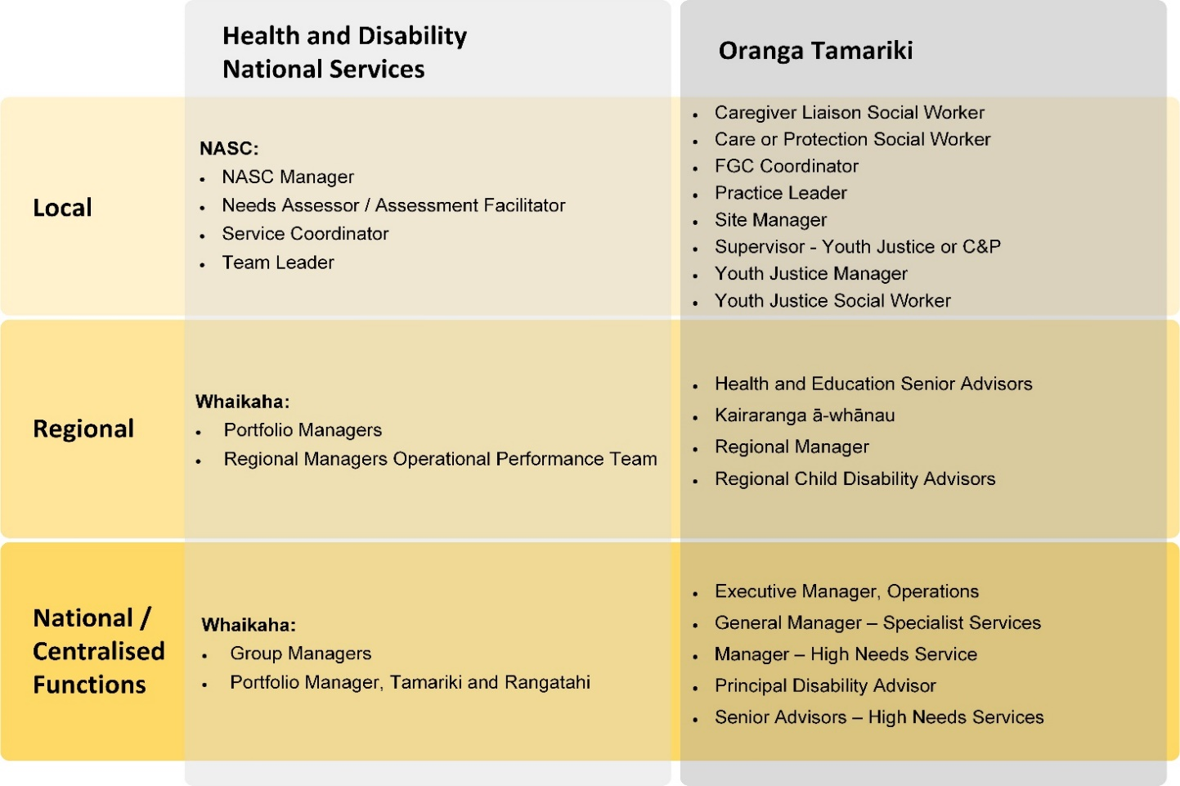
Refer to MOU:
Section 11: Information Sharing Provisions
Section 12: Confidentiality
Section 14: Mutual Cooperation

3.1 Regular Meetings
Regular meetings, discussions, and joint work between NASC, EGL teams and Oranga Tamariki are important to achieve the best outcomes for disabled tamariki and rangatahi, and their families or whānau. This applies to all work completed together by Oranga Tamariki, NASC/EGL and Whaikaha staff.

The local NASC or EGL team and Oranga Tamariki office need to work together to identify strategies to improve coordination between agencies and develop local solutions. Meetings between agencies should occur at least monthly. These meetings will usually be led by the Oranga Tamariki Site Manager, Youth Justice Manager, and the NASC or EGL Manager. Other staff likely to be involved could include the FGC co-ordinator, Practice Leader, Senior Advisor, Regional Disability Advisor, NASC Team Leader and the Operations Manager, Sector Operations.

The purpose of the meeting is to ensure consistency in approach by NASC,EGL teams and Oranga Tamariki in all situations, including the type of support packages developed and funding decisions. Other goals include sharing ideas and information and addressing any issues as they arise.

In some cases, the geographic area a NASC is responsible for will include more than one Oranga Tamariki site office. Where this occurs, liaison meetings should be held either with each site office at least once every three months, or monthly and with more than one site manager attending the meetings.

A record of regular agency meetings must be kept.

Refer to MOU: Section 11: Information Sharing Provisions – 11.1, 11.3, 11.6

3.2 Case Meetings/Multi-Disciplinary Meetings
Case meetings/multi-disciplinary meetings should be arranged to co-ordinate planning and monitor the progress of tamariki or rangatahi and their family or whānau. These meetings may be attended by the Social Worker, Supervisor, Care or Protection Co-ordinator, Kairaranga, Regional Disability Advisor, Senior Advisor, Needs Assessor or Service Coordinator, and any other agencies involved with the tamariki and whānau. Unless otherwise agreed, whānau, and where possible tamariki or their advocates should be involved in these discussions.
A record of case/multi-disciplinary team meetings must be kept by an agreed party. When holding meetings, bear in mind:
- The need for action-focused outcomes
- Timeframes must be specified
- Minutes should be circulated to relevant parties.

3.3 Joint assessments
It is good practice for the NASC and EGL processes and the Oranga Tamariki care and protection assessment to be completed together, to ensure all the needs of tamariki or rangatahi are met, and their family or whānau circumstances are understood. When a joint assessment is not possible, the Oranga Tamariki and NASC or EGL processes must be completed in parallel, with ongoing discussions between the Social Worker and the Needs Assessor.

3.4 Shared planning
There are many situations when Oranga Tamariki and the NASC or EGL team should undertake shared planning, These situations include:
- During the planning of an initial assessment.
- On completion of a core assessment
- In preparation for hui with whānau
- Prior to a Family Group Conference (FGC)
- As part of a court review process
- As part of a FGC review process
- When disabled tamariki or rangatahi are transitioning between care arrangements or returning home or to whānau
- When disabled tamariki or rangatahi are leaving the care or custody of Oranga Tamariki
When disabled rangatahi are leaving the custody of Oranga Tamariki and moving into adult services.

Where possible, tamariki, rangatahi and their whānau should be part of all shared planning.

3.5 Family Group Conference (FGC)

Care and Protection
Oranga Tamariki and NASC or EGL staff are required to meet before any FGC to ensure all options for supporting the disabled tamariki or rangatahi and their family or whānau have been explored, and that assessment and planning processes undertaken by NASC or EGL staff and Oranga Tamariki staff have been followed and completed.
Where possible all pre-FGC planning should include whānau and tamariki.

Goals
Goals for pre-FGC planning are to:
- Ensure a thorough and up-to-date understanding of the needs and circumstances of the tamariki and rangatahi and their family or whānau are available to support pre-FGC hui a-whānau/family meeting
- Explore all options for providing resources and supporting the family or whānau to care for their tamariki or rangatahi and agree information to be provided to whānau
- Ensure liaison with other agencies, including MoE, and NGO/iwi providers to assist in information provision to whānau
- Agree on timeframes for tasks (e.g., the completion of assessments)
- Develop an integrated support package to present to whānau as options
- Clarify and agree on funding responsibilities to reduce potential for confusion for whānau regarding next steps
- Ensure Oranga Tamariki and the NASC or EGL team have consistent and constructive options for whānau, and not to pre-empt the outcomes of the FGC itself and decision-making by the family or whānau and tamariki/rangatahi.

Process
Once a referral is made for a FGC, the Care and Protection Coordinator should facilitate a pre-conference planning meeting involving the Oranga Tamariki, NASC or EGL staff and others engaged with the tamariki or rangatahi.
A FGC is convened by Oranga Tamariki under sections 18, 19 or 145 of the OT Act.
The purpose of the meeting is to clarify roles and responsibilities which includes
deciding:
- Who will liaise with tamariki or rangatahi, and their family or whānau, and to ensure they are supported to participate in the FGC
- The methods and frequency for keeping all stakeholders updated
- The assessments required and identifying the person responsible for organising each activity
- Who is responsible for developing plans.

Clarifying needs and solutions
As part of the discussion, the needs of tamariki or rangatahi and their whānau will be identified, their views considered, and a range of support options discussed. The quality of the assessments and discussion between Oranga Tamariki, NASC and EGL staff will support collaborative working, enhance the pre-planning process and support whānau decision making.

Integrated support and resource packages
Support package options, based on the needs of the disabled tamariki or rangatahi and whānau, should be developed that integrate the resources provided by Oranga Tamariki and the NASC or EGL team.
Although it is important not to pre-empt the outcomes of the FGC, discussion with family or whānau, tamariki or rangatahi, other agencies and support service providers will be required to explore and develop support options for whānau to consider.
Depending on the needs of disabled tamariki and rangatahi, the support and resource package may include:
- The services required to meet the disability support needs of tamariki or rangatahi (e.g., equipment or therapy)
- The services required to meet the needs of the tamariki or rangatahi, family or whānau (e.g., respite or carer support)
- The services required to meet the needs of the caregivers (e.g., carer support or holiday programmes)
- A suitable placement with an approved section 396 service provider.

There needs to be approval for funding in principle for the different options to be considered before the conference. This will support the FGC to make decisions in the best interests of tamariki and rangatahi that can be implemented in a timely manner.

Out of home care
Refer to the Funding Schedule in the MOU
Refer to MOU:
Section 9: Funding
Appendix 1 – The Funding Schedule

3.6 Inter-Agency Referrals
NASC, EGL and Oranga Tamariki staff may contact each other at any time for advice, or if there is reason to believe they may have shared involvement with tamariki or rangatahi.

Timeframes for Responding to Referrals
The diagram below explains the timelines for responding to referrals.
Text description: First contact with the referrer should be made within two working days of the receipt of the referral or enquiry.
Times to complete a Facilitated Needs Assessment should be within:
• 24 hours for a crisis
• 24-48 hours for an urgent referral
• Within five working days for 40% of cases
• Within 14 working days for next 40% of cases
• Within 20 working days for 20% of cases

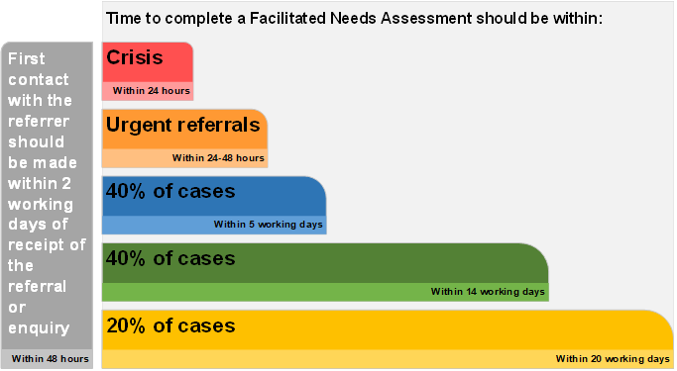
A response means that a Needs Assessor has been assigned and initial discussion between Oranga Tamariki and the Needs Assessor has taken place.

Service Access
The NASC or EGL team is expected to:
- Encourage and enable the person to take an active role in the needs assessment and service co-ordination process
- Ensure that there is full consideration of the person’s chosen lifestyle in all aspects of the assessment and service co-ordination process
- Determine with the person the appropriate level of NASC or EGL involvement. This may range from full involvement by the assessment facilitator through to minimal involvement and advice in situations where the person wants to take more responsibility for the process themselves, including accessing services which are funded or purchased outside the NASC or EGL process.
Needs assessment and service co-ordination will be conducted with the person in an environment comfortable to them. The NASC or EGL team will:
- Provide information about the NASC or EGL service and work to ensure people, providers, GPs, other community groups and potential referrers are aware of NASC and EGL service referral processes
- Promote access to services by Māori and Pacific peoples
- Identify, and build strategies into the service to overcome known barriers which will allow access for Māori, Pacific peoples, and other population groups with specific needs
- Operate from premises that are appropriate, accessible, and welcoming
- Have NASC and EGL premises open during normal business hours.

Eligibility Criteria
The NASC and EGL team will determine whether tamariki or rangatahi meet the eligibility criteria for Disability Support Services and will advise Oranga Tamariki in writing of the outcome. NASC services experience high demand and they must prioritise referrals.
A NASC or EGL service coordination process involves considering options, planning and reviewing the package of services. This process is required to meet the prioritised needs and goals of the disabled tamariki or rangatahi and their family, whānau and carers.
Budget management involves allocating cost-effective packages of services within an indicative budget.

3.7 Referrals to NASC and EGL Teams from Oranga Tamariki
Referrals to NASC and EGL teams from Oranga Tamariki may be required for a range of reasons.
Examples include:
- When tamariki and rangatahi are considered to have a disability/impairment that has not previously been referred to a NASC or EGL team for a needs assessment
- When disabled tamariki and rangatahi appear to have inadequate services
- When disabled tamariki and rangatahi have a changed personal situation.

Needs Assessments
Information about the story of tamariki or rangatahi is essential to coordinate support and ensure a service can be appropriately priced for tamariki and rangatahi that enter an ‘out-of-home service’.
The Needs Assessor will work with the family, whānau or carer to complete the Needs Assessment. This assessment should be holistic and consider the needs of the tamariki, rangatahi and their whānau or carer in the context of their environment. This aligns with oranga – an inclusive and holistic view drawing from Te Ao Māori wellbeing principles that include:
- Wairua – the dimension of values and beliefs
- Hinengaro – the dimension of intellectual and mental wellbeing
- Ngākau – the dimension of emotional wellbeing
- Tinana – the dimension of physical wellbeing
- Whānau - the dimension of family wellbeing.
The NASC or EGL team will contact the Oranga Tamariki referrer to confirm whether tamariki or rangatahi meet eligibility criteria as soon as the assessment is completed.

Additional Assessments
The Assessor may refer to appropriate specialised assessment services when this is required to inform the most appropriate support options for tamariki or rangatahi.
The Assessor can refer tamariki or rangatahi to a range of health and disability professionals, who are often employed by Child Development Services, for additional assessment. Examples include:
- A referral to a physiotherapist to assess mobility and equipment needs
- A referral for Behaviour Support Services.
Note: Existing services must not be withheld because of delays in accessing additional assessments.
Oranga Tamariki staff can help to reduce delays in the assessment process by including any diagnostic assessments completed at the time of referral to the NASC/EGL service. Examples of reports that are helpful include paediatric, psychological, psychiatric, physiotherapy and occupational therapy assessments.

3.8 Referrals to Oranga Tamariki from NASC and EGL Teams
NASC and EGL teams can refer to Oranga Tamariki through one of the following three paths:
- A report of concern under section 15 of the Oranga Tamariki Act to a Social Worker
- A referral for a Family Group Conference (FGC) via section 19 provisions.
- A referral for a section18AAA FGC.
A report of concern is made when a member of the public or a community, a professional or whānau or family has a concern for a tamariki or rangatahi and they share their concern with Oranga Tamariki. It is the role of Oranga Tamariki to:
- Consider the concern
- Determine the appropriate response for tamariki or rangatahi and their whānau
- Complete an assessment appropriate to the level of concern
- Put in place the support or intervention that tamariki or rangatahi and their whānau require if necessary.
Initial assessments must be completed within either one day, or within 10 days, depending on the criticality of the initially assessed risk to tamariki or rangatahi. Core assessments must be completed within 20 days, and a determination reached at that point about whether care or protection concerns are found. If care and protection concerns are found, a referral for a FGC will be made and a full assessment completed to support that referral.

Process Resources:
Intake and early assessment information
Assessing safety information
Reports of concern should all be made to the national contact centre – 0508 family (0508 326 459) or via the Oranga Tamariki Contact Us Page

National Referral Centre
Whaikaha contracts the National Referral Centre (NRC) to provide referral support to NASC organisations.
The NRC reviews relevant documentation, it confirms Disability Support Services (DSS) eligibility, and the level of DSS funding support based on the identified disability support needs. This ensures a nationally consistent methodology is used.
The NRC aims to process referrals within an indicative timeframe of 10-15 working days, following receipt of all the relevant information.
The NRC is also able to support NASC's with High and Complex cases.

3.9 Clarifying roles and responsibilities
When Oranga Tamariki and a NASC or EGL team are involved with a disabled tamariki or rangatahi, it is important that the following roles and responsibilities are clear:
- NASC and EGL teams are responsible for leading assessment and coordination of support for disabled tamariki and whānau when Oranga Tamariki has no formal intervention status
- Oranga Tamariki will lead required actions related to investigation or assessment of care and protection issues when these are underway.

Disabled tamariki and rangatahi engaged with Oranga Tamariki
Disabled tamariki and rangatahi engaged with Oranga Tamariki will still continue to access their disability supports while Oranga Tamariki is involved and after this involvement is completed.
A guiding principle agreed in the Memorandum of Understanding is that disability supports will not be reduced or curtailed as the result of an intervention from Oranga Tamariki.
It is a principle of the Oranga Tamariki Act that tamariki or rangatahi should only be removed from their family if there is serious risk of harm to tamariki or rangatahi. In many cases, care or protection concerns can be dealt with by other means and court intervention is not necessary.
In line with United Nations Convention on the Rights of Persons with Disabilities (UNCRPD) principles, no tamariki or rangatahi should be removed from the care of their whānau because of their own disability needs or that of one of their parents or caregivers.

When tamariki and rangatahi are in the care or custody of the Chief Executive Oranga Tamariki
Oranga Tamariki has the lead case management role when tamariki and rangatahi are in the care or custody of the Chief Executive, subject to FGC plans or Support Orders, or Youth Justice processes.
NASC and EGL teams are responsible for ensuring disabled tamariki engaged with Oranga Tamariki continue to receive any allocated disability support services. This includes all tamariki and rangatahi in the care or custody of Oranga Tamariki who are living with whānau or non-kin foster carers as detailed in the MoU.
Oranga Tamariki also has responsibility for ensuring compliance with the Care Standards for all tamariki and rangatahi in care; this includes ensuring all tamariki and rangatahi have an ‘All About Me’ plan and all appropriate cross agency resources are in place to meet their needs, including disability-related needs.
NASC and EGL teams will always have responsibility for ensuring the appropriate assessments or processes are followed to meet the disability support needs of tamariki and rangatahi, irrespective of the ‘status’ of the tamariki and rangatahi with Oranga Tamariki.
Resources:
All About Me plan
Oranga Tamariki policy on assessment

3.10 Transition Planning
Transition planning for disabled tamariki and rangatahi is required in the following situations:
- When tamariki and rangatahi in the care of Oranga Tamariki are transitioning between placements
- When care and protection issues have been resolved and Oranga Tamariki no longer need to be involved with tamariki or rangatahi and their whānau
- When disabled tamariki or rangatahi are being discharged out of Oranga Tamariki care (e.g. transitioning into adulthood, usually at 18 years of age).

Key Information for Transition Planning
Transition to adulthood planning for disabled rangatahi must commence when the rangatahi turns 15 years and will be led by Oranga Tamariki transition from care to adulthood processes. NASC/EGL services must be involved in these processes. A transition plan must be agreed and in place with the rangatahi and their whānau and supporting services at least six months before the young person is discharged from care.
NASC/EGL Services are responsible for identifying placement and adult disability support services for eligible rangatahi and the funding of services after the rangatahi turns 18 years old.
Rangatahi are eligible for Transition Support Service (through Oranga Tamariki) if they have been in care or youth justice custody for at least three continuous months between the ages of 14 years, 9 months, and 18 years old.
Rangatahi are entitled to:
- Support from an assigned transition worker who will maintain proactive contact and provide support (after they are discharged from care) until they turn 21
- Advice and assistance until they turn 25
- Remain or return to living with a caregiver from the age of 18 until they turn 21.
It is agreed that it is a joint agency responsibility to achieve care and/or support arrangements that will ensure a successful transition through to adulthood for disabled rangatahi. NASC and EGL teams will be closely involved in planning via hui or FGC processes to support tamariki or rangatahi to return home if agreed as a goal prior to their 18th birthday.
Refer to the Oranga Tamariki Practice Centre for further information about eligibility, entitlements, policy, and guidance regarding transition to adulthood for care-experienced rangatahi.
Oranga Tamariki Practice Centre
National Call Centre - 0800 55 89 89

Goals for Transition Planning
The goals for transition planning include:
- Co-ordinated planning between Oranga Tamariki and the NASC or EGL team
- A smooth transition between services and funding arrangements
- Reviewing existing care and services to ensure needs continue to be met
- Ensuring tamariki or rangatahi and the family or whānau are involved in the process and know what to expect
- Ensuring permanency and stability for tamariki or rangatahi
- Ensuring the interests of the rangatahi are protected in the transition to adult disability support services.

Supporting Vulnerable Rangatahi/Adults
Supported decision-making (SDM) is a way for people to make their own decisions based on their will and preferences so they have control of their life. This ensures the person who needs support is at the centre of all decisions that concern them.
SDM is considered best practice by the United Nations Convention on the Rights of People with a Disability (UNCRPD), which New Zealand is a signatory to, and is recognised as a right for everyone in New Zealand.
Consideration of the use of this process should be given in relation to all rangatahi and any decisions being made in relation to them.
Specific guidance can be found on the MSD website and/or advice can be sought from the Oranga Tamariki Regional Disability Advisor.

Protection of Personal and Property Rights Act (1988)
Depending on the situation of the rangatahi, transition planning may include ensuring their ongoing interests and rights are protected. One option for rangatahi over the age of 18 years is to apply to the Family Court for the appointment of a welfare guardian, or personal or property orders. The Court will determine whether the rangatahi is unable to understand the nature of, or foresee the consequences of, decisions relating to their personal care and welfare, or to communicate decisions. The Court will require the young person’s competence to be assessed, usually by a psychologist, psychiatrist, or other health professional.
Community law centres have developed kits to assist a family member to apply for orders. Alternatively, the forms are available from the Family Court or through the Ministry of Justice website.
If this option of applying for an order is being considered it should be raised as soon as possible within the transition to independence FGC planning process. An appropriate/safe adult needs to be identified to be supported to make the application. Ideally this would be someone already well known to the rangatahi like a whānau member or someone in their network of support.
Joint agencies should seek legal advice if consideration is being given to this process.
Resources:
Protection of Personal and Property Rights Act (1988)

3.11 Community-Based Disability Support Services
Whaikaha-funded community-based service providers have a critical role in implementing plans and delivering services to meet the needs of disabled tamariki/rangatahi and their family or whānau and should work collaboratively with NASC, EGL and Oranga Tamariki staff.

Service Providers
Providers of services for out-of-home placements must be approved under section 396 of the Oranga Tamariki Act.

Oranga Tamariki Act - Section 396
When tamariki or rangatahi have been placed for reasons of care and protection, the provider must be approved under the provisions of section 396 of the Oranga Tamariki Act. The provider may carry out care or protection activities on behalf of Oranga Tamariki, and these will be included in agreements made at the FGC and in any subsequent court orders.
These services can be provided in the following ways:
- Within a staffed home or residence
- With a caregiver or foster family contracted to the approved provider.
The disabled tamariki or rangatahi and their caregivers remain eligible for disability support services funded by Health and Disability National Services.

Health and Disability National Services (Safety) Act (2001)
The purpose of this Act is to promote the safe provision of health and disability services.
A caregiver or foster family who is contracted to a provider, as well as staffed residential services, must comply with this Act if they are providing health and disability services. Providers are required to be certificated to the Health and Disability Sector Standards. The organisation is likely to have a contract with the Ministry of Health (as of 1 July 2022 – Whaikaha) to provide disability support services.

3.12 Working with other disability-related agencies/organisations
Oranga Tamariki, NASC and EGL staff must work collaboratively with the other agencies and organisations involved in providing services and supports to tamariki and rangatahi and their family/whānau.
The following organisations and services are also responsible for meeting the health and disability-related needs of tamariki and rangatahi:
- ACC
- Child and Adolescent Mental Health Services
- Child Development Services
- High and Complex Needs Unit
- Ministry of Education
- Ministry of Social Development
- Strengthening Families/Whānau
- Te Whatu Ora Health New Zealand
- VOYCE – Whakarongo Mai
- Work and Income
Refer to MOU:
Section 9: Funding
Appendix 1 – The Funding Schedule

ACC
ACC’s legislation covers all New Zealanders who have an injury that is accepted by ACC, including sensitive claims. ACC provides treatments and supports to meet a person’s entitlements under the Act.
Examples of services are:
- Home-based rehabilitation
- Attendant care
- Support at school if related to accident
- Supported living
- Physiotherapy and occupational therapy
- Environmental supports, including aids and modifications.
ACC contact details
ACC website
0800 222 070
providerhelp@acc.co.nz
Child and Adolescent Mental Health Services (CAMHS)
Sometimes tamariki and rangatahi benefit from specialised input by mental health professionals. These types of services are provided by regional Child and Adolescent Mental Health Services (CAMHS). CAMHS treat young people with emotional, behavioural, or mental health difficulties. CAMHS support covers depression, problems with food and eating, self-harm, abuse, violence or anger, bipolar disorder, schizophrenia, and anxiety, among other difficulties.
To be eligible, the tamariki or rangatahi must have severe mental illness. This includes a range of disorders including autism spectrum disorders and conduct disorders.
CAMHS have a range of professionals with the skills needed to assess, treat, and provide ongoing evaluation of children, young people and their whānau.
They work together as a team which includes:
- Family therapists
- Occupational therapists
- Psychiatrists
- Psychologists
- Mental health nurses
- Social workers
- Psychotherapists
- Employment and study specialists

Child Development Services (CDS)
It is essential to know whether disabled tamariki or rangatahi are engaged with their local CDS. CDS are non-medical, multidisciplinary allied health and community-based services. They focus on early intervention for tamariki and rangatahi who are not achieving developmental milestones or who have disabilities. They also encourage and help each tamariki and rangatahi to achieve their potential. CDS also provides specialist assessment, intervention, and management services to ensure good rehabilitation/habituation results for tamariki or rangatahi who have an intellectual, sensory, or physical disability. NASC and EGL teams can refer tamariki or rangatahi to CDS with whānau consent if required.
Referral to CDS may be received from the following services:
- Needs Assessment Service Coordination (NASC) Organisation
- General practitioners and nurse practitioners
- Neonatal services and paediatric medical and surgical services
- Allied health professionals
- Community health services
- Other Ministry contracted health and disability services
- Ministry of Education funded allied health services
- Child Youth and Family.
CDS have strong links with their respective Whaikaha counterparts including hospital and community based paediatric services and other specialists such as dieticians, doctors, orthotics and seating and wheelchair services.
Helpful Resources:
Child Development Services

High and Complex Needs (HCN) Unit – Me mahi tahi tātou
The High and Complex Needs (HCN) Interagency Strategy was developed in 2001 as a joint initiative by the Ministries of Health, Education and Social Development, including Oranga Tamariki. The HCN vision is to improve outcomes for tamariki and rangatahi with high and complex needs through effective inter-agency collaboration.
The HCN Unit supports the High and Complex Needs inter-agency strategy by:
- Supporting inter-agency collaboration
- Collecting and managing information
- Allocating funding for locally developed and managed inter-agency plans
- Reporting to Ministers and stakeholders.
The HCN Unit, supports inter-agency management groups to identify and prioritise the tamariki, rangatahi and their families/whānau who have the highest and most complex unmet needs in New Zealand. Each year, between 70 and 100 tamariki and rangatahi will receive support from HCN funding, enabling them to access the right mix and type of services that will have the most impact on their lives.
High and Complex Needs contact details:

High and Complex Needs website
04 918 9092
hcn@ot.govt.nz

Ministry of Education (MoE)
Schools are required to be inclusive under the Education and Training Act 2020 and this is reinforced by the New Zealand Disability Strategy. The MoE provides learning support and specialist services to assist learning in schools for tamariki with physical and/or intellectual impairments, hearing or vision difficulties, learning, emotional or behavioural difficulties.
These services include:
- The Physical Disability Service works with teachers and schools to help them adapt the environment around tamariki or rangatahi to meet their needs
- Behaviour services to support schools manage challenging behaviour and address its impact on schools, families/whānau, and communities
- The Te Kahu Tōī, Intensive Wraparound Service (IWS) is a comprehensive, holistic, youth and family/whānau driven way of responding to tamariki and rangatahi who experience significant challenges in their lives.

When tamariki or rangatahi are receiving additional learning supports through the MoE the relevant professionals must be involved in all planning discussions to support tamariki and rangatahi remain with family/whānau, or in discussions about out-of-home placement.

Funding Option
The MOE provides an Interim Response Fund (IRF). The IRF can be accessed by schools to keep tamariki and rangatahi engaged in learning following a significantly challenging event. The IRF provides funding as a short-term response until a more comprehensive plan is developed.
Ministry of education contact details:

Ministry of Education website
0800 622 222
learning.supportmailbox@education.govt.nz
Helpful Resources:
Interim Response Fund (IRF)
Resource Teachers: Learning and Behaviour Services
Students with learning support needs

Ministry for Social Development – Te Manatū Whakahiato Ora (MSD)
MSD aims to support disabled people to live successful lives in a society where their contribution is valued, and they are included. Funding support from SD comes via Work and Income (WINZ). For more information around this funding please refer to the WINZ section.
Helpful Resources:

Ministry of Social Development website
Family Services Directory
Heartland Service Centres
MSD Services for Disabled People

Strengthening Families/Whānau
Strengthening Families/Whānau is a service offered in some areas which provides co-ordinated support approach for families/whānau with tamariki under the age of 18 who are working with more than two agencies. This service uses an inter-agency case management approach where all agencies and whānau work together to develop joint solutions. Meetings are independently facilitated, and these enable decisions to be made with the knowledge of all the issues and in consultation with everyone involved.
Any agency working with whānau can initiate a meeting. In regions which offer this service the first step will be to contact the Coordinator and set up a meeting.
Helpful Resources:
Strengthening families website
Oranga Tamariki Strengthening Families Service Guidelines Booklet
Stengthening Families Local contacts

Te Whatu Ora, Health New Zealand (Te Whatu Ora)
Te Whatu Ora, Health New Zealand (Te Whatu Ora) is responsible for funding and providing health services across regions. DSS and some health services are funded and purchased nationally by Whaikaha. Te Whatu Ora has a funding agreement with Whaikaha to provide some health and mental health services to tamariki and rangatahi. Te Whatu Ora also funds and contracts a wide range of community services provided by non-Government organisations.

VOYCE – Whakarongo Mai (VOYCE)
VOYCE – Voice of the Young and Care Experienced – was established in 2017. VOYCE is an independent charity organisation that advocates for approximately 6000 tamariki and rangatahi with care experience (tamariki in foster or whānau care) in New Zealand.
VOYCE exists to amplify the voices of these tamariki and rangatahi and ensure that they are heard. It aims to positively influence their individual care and to collectively affect change in the wider care system. This service is available for all tamariki and rangatahi in care, and for rangatahi up until the age of 25. The responsibility for referral to this service sits with the Oranga Tamariki Social Worker and is accessed via the Regional Disability Adviser.
Children’s voices need to be kept at the centre of all the decisions made about them.

Voyce website

Work and Income – Te Hiranga Tangata (WINZ)
WINZ is part of the Ministry for Social Development, Te Manatū Whakahiato Ora. WINZ may contribute to costs that support whānau caring for disabled tamariki and rangatahi. The following assistance may be available (depending on meeting eligibility criteria) through Work and Income.
Supporting rangatahi and whānau engagement with WINZ is a critical part of ongoing support planning, and of transition planning for rangatahi when they are leaving care.
Support includes:
- Child Disability Allowance (18 years or under)
- Unsupported Child’s Benefit
- Disability Allowance. (16 years plus)
Helpful Resources:
Work and Income Service Centres

Work and income website

3.13 Resolving Differences

The interface between Oranga Tamariki, Whaikaha and NASC is complex and requires all staff to work together to achieve the best outcomes for disabled tamariki and rangatahi and their families/whānau. Differences in views and disputes may arise from time to time between the agencies and individuals. It is critical that these differences are settled quickly to ensure the interests and needs of tamariki or rangatahi are met.
Refer to MOU Section 15: Problem Solving

Dispute and Resolution Process
The dispute resolution process is outlined below:
- Most differences between Oranga Tamariki site staff and a NASC or EGL team will be resolved at the local level. This may require the site manager and NASC/EGL manager to liaise and agree on an approach. Regional Disability Advisors should assist as early as possible in these processes
- If an issue is unable to be resolved at a local level, it will be referred to the Whaikaha Regional Contract Relationship Manager and the Oranga Tamariki Regional Manager
- If an issue remains unresolved it will be referred to the Joint Oversight Group (JOG) which comprises of representatives from the national offices of Whaikaha and Oranga Tamariki. Whaikaha and Oranga Tamariki can refer a matter to, and convene, the JOG to resolve differences.
If the Joint Oversight Group is unable to resolve an issue, it will be escalated to the Oranga Tamariki Deputy Chief Executive, Service Delivery and the Whaikaha Deputy Chief Executive, Operational Performance for resolution.

Additional principles
Once the dispute resolution process is underway, three additional principles will apply:
- The interests of tamariki and rangatahi must not be compromised while the dispute resolution process is underway
- No organisation will be financially advantaged by delaying the agreement
- Issues between the organisations will not get in the way of good case management, including when communicating with whānau and other organisations involved.
An interim funding and support arrangement must be put in place immediately, so there is no delay with putting in place supports for tamariki and rangatahi.
When a resolution is reached, any costs associated with supporting tamariki and rangatahi will be allocated (or re-allocated) in line with this agreement and backdated to the date the interim funding and support arrangement was put in place.
Refer to MOU Section 8: Principles

Summary of the Process for Resolving Differences
The diagram below shows the process for resolving difficulties.
Text description: When a difficulty arises you should first evaluate if this can be solved at a local level.
If you decide the issue can be resolved at a local level try to find a quick solution that maintains the working relationship. If this is unsuccessful, escalate the issue to your local Whaikaha Portfolio Manager and Oranga Tamariki Operations Regional Managers and Regional Disability Advisors.
If this is unsuccessful, escalate it further to the Joint Oversight Group for resolution.
If this is unsuccessful escalate the issue to the Whaikaha and Oranga Tamariki Deputy Chief Executives.
Alternatively, if you decide the difficulty cannot be resolved at a local level, either:
- Seek resolution by referring to the Local Whaikaha Portfolio Manager and Oranga Tamariki Operations Regional Managers and Regional Disability Advisors. If this is unsuccessful escalate to the Joint Oversight Group.
- Or alternatively you may decide to escalate the issue immediately to the Joint Oversight Group for resolution.
If the Joint Oversight Group is unable to resolve the issue refer it to the Whaikaha and Oranga Tamariki Deputy Chief Executives.

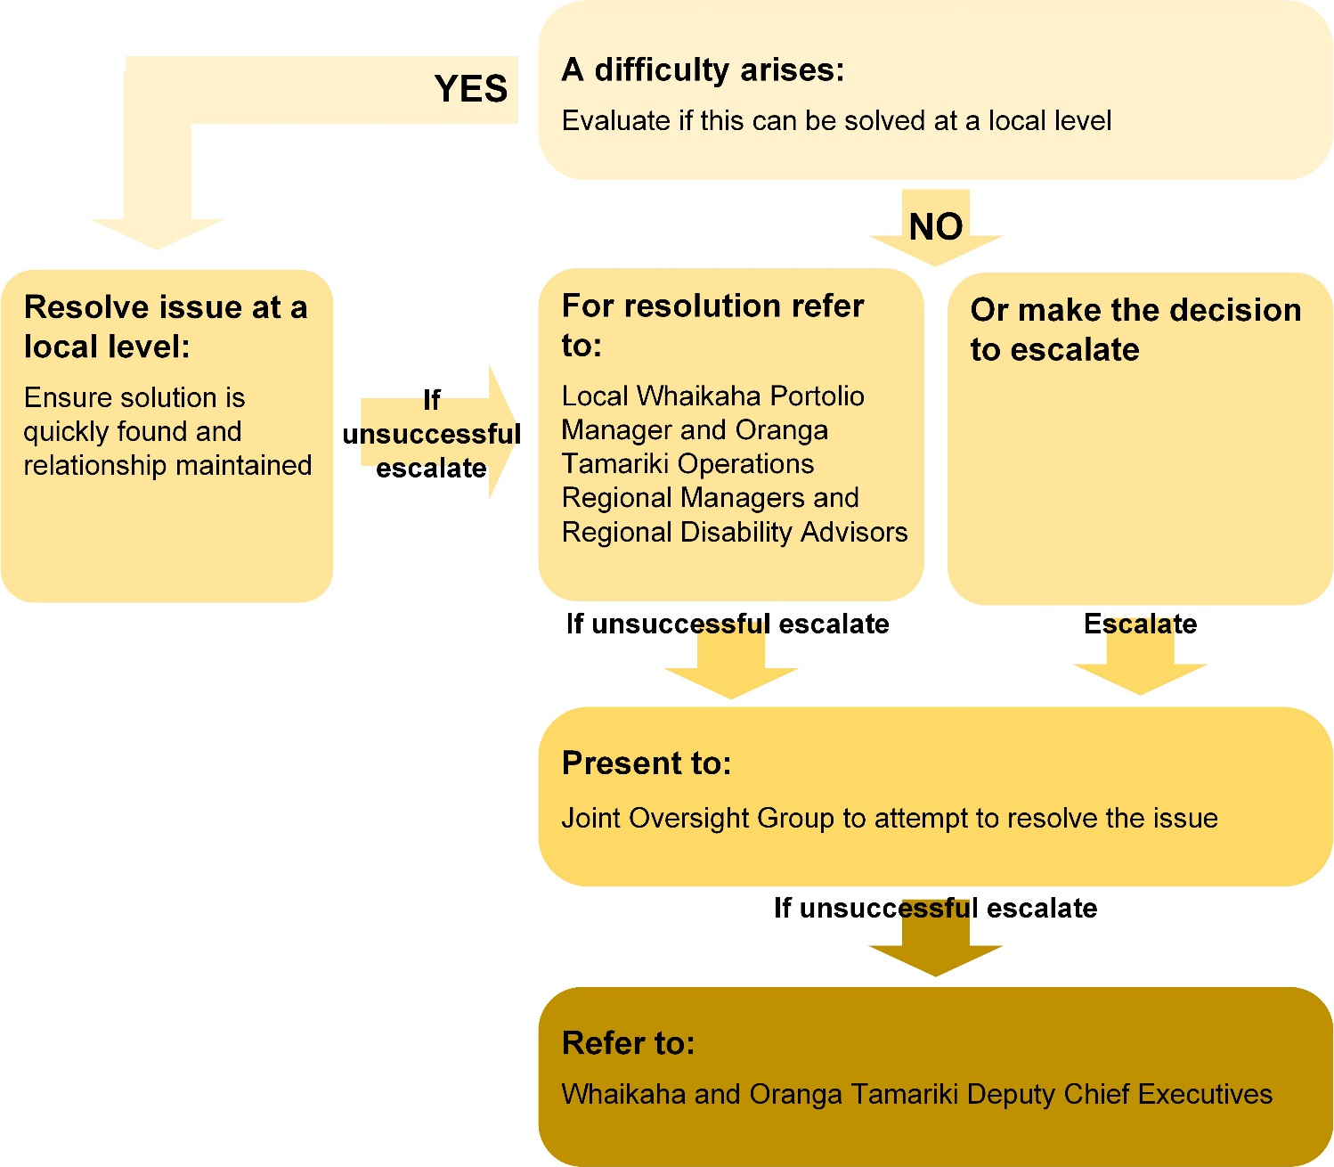

Section 4: Funding
Tamariki and rangatahi covered by the MoU funding schedule are eligible for disability support services and are placed in long-term out-of-home care, with staffing arrangements that are specific to meeting their disability-related needs (fully staffed 24/7 care arrangements).
The funding model covers tamariki and rangatahi who are in extended care or custody under the Oranga Tamariki Act 1989, are DSS eligible, and live in out-of-home services. Tamariki or rangatahi can be identified by either Oranga Tamariki, NASC, or Whaikaha and referred to their local NASC for assessment of eligibility for disability support services and to determine the level of support that will be funded.
The NASC will then refer all eligible tamariki and rangatahi in the care or custody of Oranga Tamariki, living in long-term staffed care arrangements to the NRC) The NRC reviews relevant documentation, confirms DSS eligibility, and the level of DSS funding support based on the identified disability support needs.
Once the level of disability support funding has been assessed, the details will be entered into the NASC payment system, and a Service Authorisation will be sent to the Oranga Tamariki High Needs Support (HNS) hub: (national_high_needs@ot.govt.nz) to confirm start dates and the level of funding. If there is any disagreement over the details, this will be discussed by Oranga Tamariki and the NASC.
Following confirmation of the Service Authorisation, Oranga Tamariki will add the details into the monthly comments sheet, which is sent to the Central Payments team: (centralpayments@health.govt.nz) at Te Whatu Ora by the 10th of the month for processing payment. The payment will be made, and notification sent to the HNS Hub by the 20th of the month.
Oranga Tamariki must notify the NASC and Central Payments Team at Te Whatu Ora when a tamariki or rangatahi exits their long-term residential care arrangement or is no longer in the custody of Oranga Tamariki. The funding contribution will cease at this point.
If tamariki or rangatahi are found to be ineligible for disability supports through the NASC or NRC under this Funding Schedule, the reason for ineligibility will be provided. If there is a disagreement over eligibility, further information may be required for a review. Should the eligibility issue remain unresolved after review of the additional information, an escalation process may be initiated by contacting the JOG meeting organiser and requesting time on the next meeting agenda to review the eligibility issues in question. If circumstances change for tamariki or rangatahi then their eligibility can be reviewed, for example when there is a move from temporary care arrangements to long-term residential care.
The graphic on the following page outlines the process to place tamariki and rangatahi on the Funding Schedule.

Refer to MOU:
Section 9: Funding
Appendix 1: The Funding Schedule

Process to place tamariki and rangatahi on the Funding Schedule
A text description is available after this diagram.
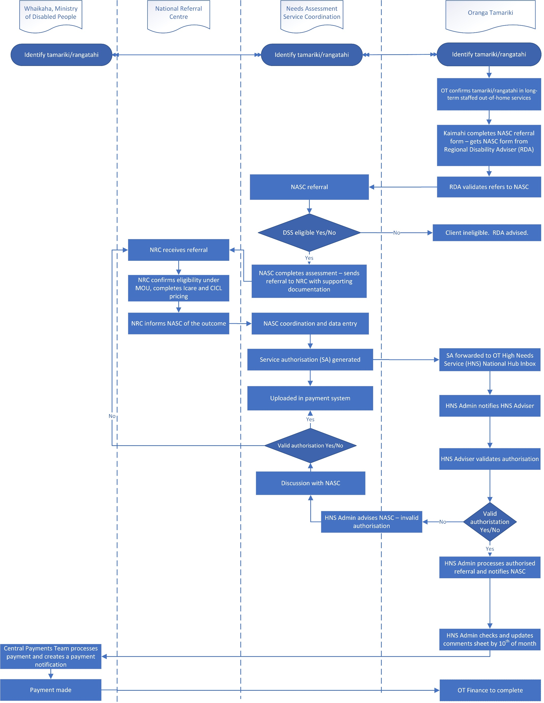

Text description of diagram explaining the process to place tamariki and rangatahi on the funding schedule
Whaikaha, NASCs and Oranga Tamariki can all identify tamariki and rangatahi who may meet the criteria to be placed on the Funding Schedule. Once identified Oranga Tamariki confirms the tamariki/rangatahi is in long-term staffed out-of-home services. Kaimahi completes the NASC referral form, which they receive from the Regional Disability Advisor (RDA). The RDA validates the referral and sends it to a NASC.
Once referred to the NASC, the NASC evaluates if the tamariki/rangatahi is eligible for Disability Support Services.
If no, the client (tamariki/rangatahi) is considered ineligible and the RDA is advised
If yes, the NASC completes their assessment and sends a referral to the National Referral Centre (NRC) with supporting documentation.
The NRC receives the referral and confirms the client’s eligibility under the MoU and completes the care and CICL pricing tools. The NRC informs the NASC of the outcome. The NASC completes coordination and data entry and a Service Authorisation (SA) is generated.
The SA is uploaded into the payment system and forwarded to the Oranga Tamariki High Needs Service (HNS) National Hub Inbox. The HNS Admin notifies the HNS Advisor. The HNS Advisor then validates the authorisation.
If the HNS does not receive a valid authorisation, the HNS Admin advises the NASC of the invalid authorisation. There is a discussion with the NASC about whether the authorisation is valid or not.
- If the authorisation is validated, it is uploaded into the payment system.
- If the authorisation is not validated, it is referred back to the NRC and the process of confirming eligibility and informing NASC is repeated.
If the HNS advisor validates the authorisation, the HNS Admin processes the authorised referral and notifies the NASC. The HNS Admin checks and updates the comments sheet by the 10th of the month. The Whaikaha central payments team will then process the payment and create a payment notification. The payment is then made by Whaikaha, and Oranga Tamariki Finance completes the process.

The Memorandum of Understanding includes a Funding Schedule and a Roles and Responsibilities Schedule.
The Public Services Act, (see schedules 9(2)(3) and 9(4)(1)), is being used to transfer most deeds, agreements, proceedings, instruments, documents, and notices that were the responsibility of the Ministry of Health Disability Directorate and the MSD EGL Waikato Demonstration to Whaikaha, Ministry of Disabled People on 1 July 2022.
The Funding Schedule 2.1
As per Section 1. Interpretation provided in the Memorandum of Understanding between Whaikaha and Oranga Tamariki 1 July 2021
‘Disabled people’ is an inclusive term used for the purposes of brevity when referring to a general group including tāngata whaikaha Māori, tāngata whaikaha, Deaf people and Pacific disabled peoples.
Terms such as ‘Needs Assessment’ and ‘Service Coordination’ may vary across individual NASC/EGL sites.
Reference: Periodic review of legislation, policy, and other accountability arrangements Report to Parliament by the Minister for Children under section 448B of the Oranga Tamariki Act 1989 July 2022
Section 15 of the Oranga Tamariki Act 1989 provides for any person who believes that a child or young person has been, or is likely to be, harmed (whether physically, emotionally, or sexually), ill-treated, abused, neglected, or deprived may report that matter to a social worker or a member of the police. See http://www.legislation.govt.nz
Section 19 of the Oranga Tamariki Act 1989 provides for the referral of care or protection cases to a care and protection co-ordinator by other persons or by court.
Section 13(2)
http://www.justice.govt.nz

