What People Can Buy with Disability Funding: Purchasing Rules
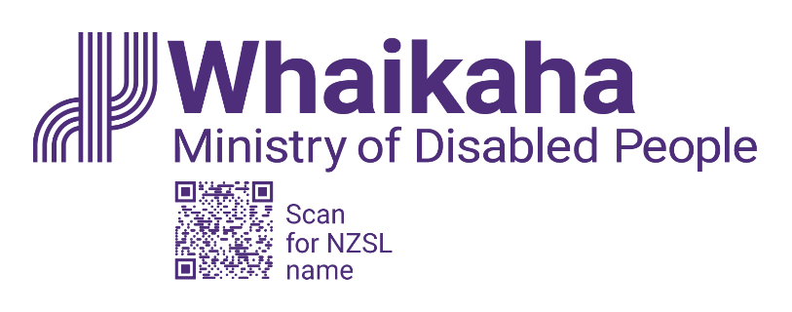
24 April 2024
This document describes what government disability support funding (funding) can be used to buy. It is for people using:
- Carer Support
- Individualised Funding
- Enhanced Individualised Funding (EIF)
- Choices in Community Living
- Enabling Good Lives (EGL) personal budgets
Disabled people who can make choices about how they use their funding are more likely to buy goods and services that make their lives easier and/or better. These purchasing rules aim to give disabled people as much flexibility as reasonably possible over the disability support they receive.
A disability support (support) is a good or service that helps a person overcome barriers that come with having an impairment within a disabling society.

Criteria
There are four criteria that must be met to be able to use funding to help buy a disability support.

One: It helps people live their life or makes their life better
The support should help people live a good life.
Each person has a different idea about what a good life is. The person’s goals and aspirations for a good life should be written out in a personal plan. This can be done with help from their Needs Assessment and Service Coordination (NASC) organisation or Independent Facilitator. Personal plans could include goals such as:
- having good relationships
- maintaining or improving skills
- being able to do everyday activities at home or in the community
- the person’s family/whānau being supported to continue their caring roles
- being able to live in a home of the person’s own choice

The purpose funding is used for must be within the scope of the service specification it was allocated under.
Allocations can only be used in line with the scope inclusions and exclusions set out in the section below ‘Scope of Supports by Allocation’

Two: It is a disability support
The support:
- is only needed because the person is disabled and/or
- costs more than would be the case if the person were not disabled and/or
- is in addition to, or complements, the goods and/or services the person would need if they did not experience disability.
Three: It is reasonable and cost-effective
Generally, the support should be ‘reasonable’. Here it means that the support should cost about the same as (or less than) the market price for comparable things.
‘Cost-effective’ here means the best available outcome for the money spent.
It might cost more than another type of support but will help the person more, it will last longer or mean that less is spent on some other support now or in the future.

Four: It is not subject to a limit or exclusion
People are not able to buy a support when funding for that support has been turned down by (or on behalf of) the responsible government agency, or if waiting times are too long.
A person should explore other funding options to help get a support. Examples of other options include:
- the Disability Allowance (from Work and Income)
- grants, charitable donations
- equipment funding (either by the Ministry of Education, the Ministry of Health or Whaikaha)
- specialist services (e.g. Behaviour Support Services, Child Development Services and Early Intervention Services either by the Ministry of Education, the Ministry of Health or Whaikaha)
- allied health and/or therapy managed and prioritised through the health system
- transport allowances (e.g. the Total Mobility transport scheme)
- Community participation (Ministry of Social Development)
The funding cannot be used for:
Anything illegal, alcohol, tobacco (or related products) or personal income, gambling, anything that is not a cost related to disability and would be considered something that every citizen has to pay for.

Scope of Supports by Allocation
Whaikaha is clarifying and limiting the scope of support available under each support option where these flexible purchase rules are used. The table below sets out what is included in the scope of support available, and what is excluded:

Scope inclusions and exclusions by service line, for use interpreting rule one
 | Carer Support | IF Respite | IF Household Management & Personal Cares | Enhanced Individualised Funding and Choices in Community Living | EGL Personal Budgets
Includes | - Contribution to the costs of substitute caring whilst the full-time carer takes a break  - Expenses that are a necessary part of supporting the disabled person while the full-time carer takes a break  - One-off purchases of:  - tablet devices;  - noise cancelling headphones;  - sensory items (such as fidget spinners etc.); and  - weighted blankets | - Contribution to the costs of substitute caring whilst the full -time carer takes a break (including wages etc)  - Expenses that are a necessary part of supporting the disabled person while the full-time carer takes a break  - One-off purchases of:  - tablet devices;  - noise cancelling headphones;  - sensory items (such as fidget spinners etc.); and  - weighted blankets | - Contribution to the costs of delivering HM and PC care (including wages etc. and intermittent care)  - Expenses that are a necessary part of supporting the disabled person  - Items that support the disabled person to carry out tasks more independently (except where those items are part of what is provided for or managed under EMS) and there is a corresponding reduction in ongoing funded support  - Ready-made food where it offsets the cost of funded support | - Contribution to the costs of delivering support work (including wages etc. and intermittent care)  - Expenses that are a necessary part of supporting the disabled person  - Items that support the disabled person to carry out tasks more independently (except where those items are part of what is provided for or managed under EMS) and there is a corresponding reduction in ongoing funded support  - Ready-made food where it offsets the cost of funded support  - One-off purchases of:  - tablet devices;  - noise cancelling headphones;  - sensory items (such as fidget spinners etc.); and  - weighted blankets | - Contribution to the costs of delivering support work (including wages etc. and intermittent care)  - Expenses that are a necessary part of supporting the disabled person  - Items that support the disabled person to carry out tasks more independently care (except where those items are part of what is provided for or managed under EMS) and there is a corresponding reduction in ongoing funded support  - Ready-made food where it offsets the cost of funded support  - One-off purchases of:  - tablet devices;  - noise cancelling headphones;  - sensory items (such as fidget spinners etc.); and  - weighted blankets
Excludes | - All purchases of items as a form of delivering respite, except those listed above  - All self-care services such as massages, pedicures and other appearance or therapeutic care that are not for the direct benefit of the disabled person.  - All expenses that are not a necessary part of supporting the disabled person while the full-time carer is taking a break.  - Gifts and other forms of recognition for support provided voluntarily.  - Travel related costs for disabled people, whānau, and/or persons providing support, including:  - Accommodation  - Overseas and domestic travel  - Food | - All purchases of items as a form of delivering respite, except those listed above  - All self-care services such as massages, pedicures and other appearance or therapeutic care that are not for the direct benefit of the disabled person.  - All expenses that are not a necessary part of supporting the disabled person while the full-carer is taking a break.  - Gifts and other forms of recognition for support provided voluntarily.  - Travel related costs for disabled people, whānau, and/or persons providing support, including:  - Accommodation  - Overseas and domestic travel  - Food | - All self-care services such as massages, pedicures and other appearance or therapeutic care that are not for the direct benefit of the disabled person.  - Gifts and other forms of recognition for support provided voluntarily.  - Travel related costs for disabled people, whānau or support worker/s, including:  - Accommodation  - Overseas and domestic travel  - Food. | - All purchases of items as a form of delivering respite, except those listed above  - All self-care services such as massages, pedicures and other appearance or therapeutic care that are not for the direct benefit of the disabled person.  - Gifts and other forms of recognition for support provided voluntarily.  - All expenses, that are not a necessary part of supporting the disabled person, where those expenses are intended to be part of providing respite.  - Travel related costs for disabled people, whānau or support worker/s, including:  - Accommodation  - Overseas and domestic travel  - Food | - All purchases of items as a form of delivering respite, except those listed above  - All expenses, that are not a necessary part of supporting the disabled person, where those expenses are intended to be part of providing respite.  - All self-care services such as massages, pedicures and other appearance or therapeutic care that are not for the direct benefit of the disabled person.  - Gifts and other forms of recognition for support provided voluntarily.  - Travel related costs for disabled people, whānau or support worker/s including:  - Accommodation  - Overseas and domestic travel  - Food

