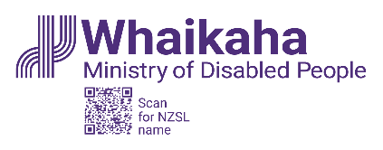

Purchasing Guidance:

How to spend your

disability support funding

Updated: 24 April 2024

What you will find in here

Page number:

What this document is about 2

What disability support funding
is for 4

Rules for spending
disability support funding 7
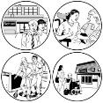

What you can use the different
types of funding for 15

What you cannot use
disability support funding for 24

More information 26

What this document is about

This Easy Read document is from Whaikaha – Ministry of Disabled People.

In this Easy Read document:
Whaikaha – Ministry of Disabled People is called Whaikaha
when you see the words we / us it means Whaikaha
disability community means:
- disabled people
- tāngata whaikaha Māori
- whānau / family
- carers.
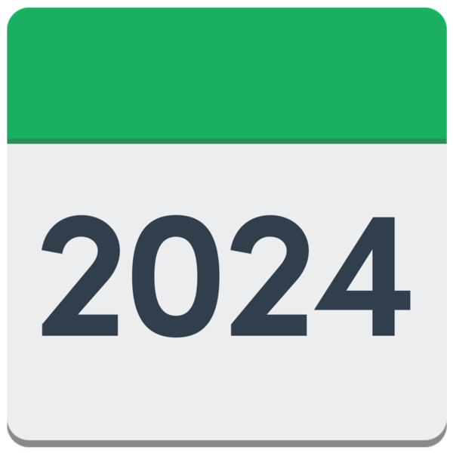
From 24 April 2024 we are making changes to the purchasing rules for disability support funding.

Purchasing rules say what people can buy with disability support funding.

Purchase means to buy something.

A purchase can also mean something you buy.

We are making these changes so that the rules about how people can use their disability support funding are clearer.
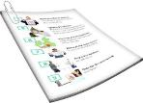
We will look at these rules on
pages 7 to 14 of this document.

What disability support funding is for

Disability support funding is for some:
disabled people
tāngata whaikaha / Māori disabled people.

Disability funding can also be used to support the families / whānau of disabled people.

The funding can be used to:

give you more chances to live a good life
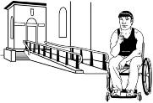
take away barriers that stop you from being able to do the things you want.
Barriers are things that make it harder for disabled people to live a good life like:
buildings that they cannot use / get into
information that is hard to understand
not being able to get the things / support they need to have a good life.

Disability funding can also be used for respite.

Respite is a way to give whānau / family a break from caring for someone.

You can find out more about respite on our website:

https://tinyurl.com/2vku3vpc

This information is not in Easy Read.

Rules for spending
disability support funding

There are 4 rules that tell you how you can spend your disability support funding.

The 4 rules are the same for:

          - Carer Support

          - Individualised Funding / IF

          - Enhanced Individualised Funding / EIF

          - Choice in Community Living
Enabling Good Lives Personal Budgets.

Rule 1. The funding / purchase:
helps you live a good life
makes your life better.

Everyone has different ideas about what makes a good life.

You will have made a plan about what you need with your:
needs assesment coordinator / NASC coordinator
independent facilitator.

A needs assessment coordinator / independent facilitator is someone who supports you to work out what you need for a good life.

Your plan might be about:
having good relationships
things you want to learn
choosing where you live
doing everyday things:
- at home
- in your community.

Anything you use the funding for has to fit with the way the funding is meant to be used.

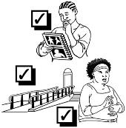
Rule 2. The purchase is a disability support.

Anything you buy has to be something you need because of your disability.

You cannot use the funding for things you would still need if you were not disabled like:
groceries
power bills.

Rule 3. The purchase must be:
reasonable
cost effective.

Reasonable means that it costs what you expect.

Cost effective means it is the best way to use the money.

This does not mean that the thing you buy must be cheap.

It is better to buy something that costs more money if it:
works better for you
will last a long time.
Rule 4. The purchase is not subject to limits or exclusions.

Limits / exclusions means the things you cannot use your funding for.

You cannot use your funding to buy:
anything that is against the law like drugs
things people who are not disabled also need
anything that does not follow the rules for your funding.

You cannot use you funding just to get something faster than usual.

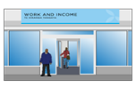
You cannot use your funding to buy things another government agency like Work and Income would usually pay for.

This is true even if the usual government agency has said no.

There are some other ways to pay for things you cannot use your disability support funding for like:
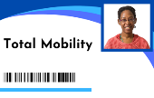
allowances / grants from Work and Income
transport schemes like Total Mobility
donations - which are when people give you money.

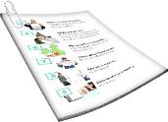
There is more information about the things you cannot use your disability support funding for on pages 24 to 25 of this document.

What you can use the different types of funding for

Carer Support

Carer Support funding is to let someone who cares for a disabled person full time take a break.

Carer Support funding can be used to pay someone else to care for the disabled person while their main carer takes a break.

It can also be used for other things to support the disabled person while their main carer takes a break.

Carer Support funding can be used for one-off purchases of:
tablet devices like iPads
noise-cancelling headphones
sensory items like fidget spinners
weighted blankets.

One-off purchases means that you can only buy these things 1 time.

These things are to support the disabled person to:
cope with stress
manage their feelings.

Individualised Funding

Individualised funding is funding for disabled people to manage their own supports.

Individualised Funding is to pay for things you need because of your disability.

There are 2 types of Individualised Funding:
household management and personal cares
respite.

Household management and personal cares funding can be used to pay people to support you with:
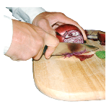
housework
making food
taking care of yourself like:
- washing
- dressing.

It can also be used for things to support you to be more independent.

Independent means doing things for yourself.

You can sometimes use this funding to buy ready-made food.
You can use respite funding to pay for the support you need while your main carer has time off.

You can also use respite funding for one-off purchases to support you to:
cope with stress
manage your feelings.

Enhanced Individualised Funding / Choice in Community Living

Enhanced Individualised Funding is funding that gives disabled people more choices about how they manage their supports.

Choice in Community Living is funding to support disabled people to live in a home they can:
rent
buy.

You can use this funding for things you need because of your disability.

You can use this funding to pay for things you need to be more independent.

You can also use this funding to pay your carers / support workers.

You can use this funding for one-off purchases to support you to:
cope with stress
manage your feelings.

You can sometimes use this funding to buy ready-made food.

Enabling Good Lives Personal Budgets

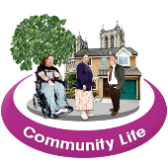
Enabling Good Lives is a way to support disabled people to:
make their own choices
be part of the community.

Enabling Good Lives Personal Budgets is funding for disabled people to use for things they need:
because of their disability
to have a good life.

Personal budgets can be used to pay for:
things you need because of your disability
paying carers / support workers
things that support you to be more independent.

Personal budgets can be used for one-off purchases to support you to:
cope with stress
manage your feelings.

Personal budgets can sometimes be used to buy ready-made food.

What you cannot use disability support funding for

You can only use your funding for the things that fit with the way the funding is meant to be used.

You cannot use your funding for things that people who are not disabled also need.

You cannot use your funding for things that are not for disability support like:
massages
pedicures.

You cannot use the funding for gifts for volunteers who support you.

Volunteer means someone who does work for no money.

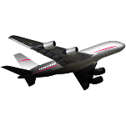
You cannot use the funding to pay for travel costs like:
plane tickets
food
hotels.

You cannot use the funding for anything that is against the law like drugs.

More information

You should ask your host if you have questions about how you can use your funding.

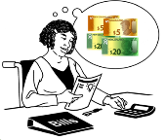
Your host is the organisation that supports you to manage your funding.

For any other questions you can get in touch with Whaikaha.

You can get in touch with Whaikaha on this website:

www.whaikaha.govt.nz

You can also contact Whaikaha by:
- phone on:

0800 566 601
- text message on:

4206

You can call us on the phone:
- from 8 am to 5 pm on:
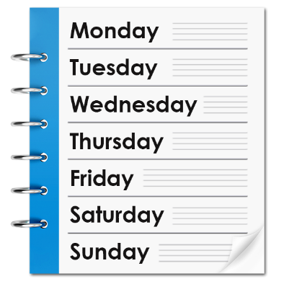
- Monday
- Tuesday
- Thursday
- Friday
- from 9.30 am to 5 pm on:
- Wednesday.
You can also use the New Zealand Relay service to get in touch with Whaikaha.

If you find it hard to use the phone the New Zealand Relay service is for people who are:

- Deaf / hard of hearing

- deafblind

- speech impaired / find it hard to talk.

You can find out more about the New Zealand Relay service at:

www.nzrelay.co.nz

This information has been written by Whaikaha Ministry of Disabled People.

It has been translated into Easy Read by the Make it Easy Kia Māmā Mai service of People First New Zealand Ngā Tāngata Tuatahi.

The ideas in this document are not the ideas of People First New Zealand Ngā Tāngata Tuatahi.

Make it Easy uses images from:

- Changepeople.org

            - Photosymbols.com

- SGC Image Works
- Huriana Kopeke-Te Aho
- T.Wood.
All images used in this Easy Read document are subject to copyright rules and cannot be used without permission.

