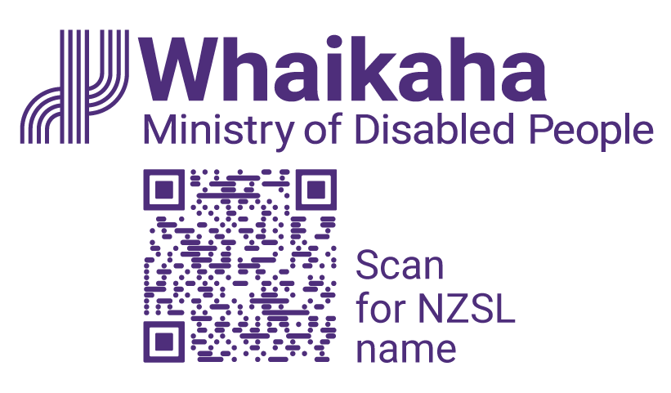
National Pacific Disability Action Plan Survey
Adapted in 2024 by Accessible Formats Service,
Blind Low Vision NZ, Auckland

TN: The logo on the top of the page is Whaikaha Ministry of Disabled People.

National Pacific Disability Action Plan Survey
Kia Ora, Mālo ni, Fakaalofa lahi atu, Kia orāna, Tālofa lava, Mālō e lelei, Talofa, Noa'ia, Ni sa bula vinaka, Mauri, Tēnā koutou katoa and warm greetings to you all
Whaikaha—Ministry of Disabled People is developing a National Pacific Disability Action Plan and we want your help!
The National Pacific Disability Action Plan will help guide changes to the disability support system and services for Pacific people that Whaikaha manages.

Who can take part in this survey?
You can take part in the survey if:
- You self-identify as a Pacific Disabled Person/Pacific person with disabilities
- Or you are family, whānau, aiga or carer of a Pacific Disabled Person/Pacific person with a disability
- You are at least 16 years of age OR are supported by your caregiver to fill out the form if you are under 16 years of age
- Other terms for "disabled people" that you may be more familiar or comfortable with include "person living with a disability" "tāngata whaikaha Māori" or "whānau hauā"
- Some people prefer to say they have an impairment or live with the ongoing impacts of an injury or illness.
Information about the survey
The information you give us will also enable Whaikaha to accurately reflect and advocate for the changes that Pacific disabled people/Pacific people with disabilities and their families have been calling for.
- The survey will take approximately 30-120 minutes to fill out.
- You can answer as many or as little questions as you would like to.
- The more you can share with us, the better the plan we can create together to improve the wellbeing of our Pacific disabled community.
- The closing date of the survey will be on our webpage www.whaikaha.govt.nz/NPDAP
From the in-person talanoa and this survey we will gather everyone's thoughts and opinions and develop the National Pacific Disability Action Plan.
The information you provide will be kept confidential, and if we wish to quote you in the Action Plan, we will contact you to ask for your permission.
Once the plan is completed it will be published on our website, with alternate formats available.
Other ways to complete this survey
If you would prefer to respond to our survey by sending a video, audio message, or email you can email it to us at pacificpeoples@whaikaha.govt.nz
If you would prefer to print the word document of the survey and post it to us, you can send it to:
- Tofa Suafole Gush
- Whaikaha—Ministry of Disabled People
- Reply Paid: 262204
- PO Box 1556. Wellington 6140
If you have any questions email pacificpeoples@whaikaha.govt.nz or text 4206

Consent
- Are you filling this survey out on behalf of someone else?
☐ Yes
☐ No
- Please confirm if:
- you have the consent of the person you are filling this survey out on behalf of to share this information with us
- they understand who this information is being shared with
- they understand for what purpose this information is being shared
- they understand that the information will be stored confidentially.
Please also tick yes for this question if you are filling this survey out for yourself.
☐ Yes
☐ No
- Do you confirm that by participating in this survey, you agree to have the information you provided in this survey stored at Whaikaha?
We will only keep your personal information for as long as necessary to achieve the purpose for which we collected it. For more information, please have a look at our Privacy Notice on our website at www.whaikaha.govt.nz/privacy-notice/ (http://tinyurl.com/cb8ua39x) (Please note that the privacy statement is not available in Easy read or alternate formats).
☐ Yes
☐ No

Survey Questions
- How old are you? (Please select the option that applies or delete the options that are not applicable.)
☐ 0-18
☐ 18-24
☐ 25-34
☐ 35-44
☐ 45-54
☐ 55-64
☐ 65+
- What is your ethnicity? (Please select the option that applies or delete the options that are not applicable.)
☐ Samoan
☐ Tongan
☐ Cook Island
☐ Fijian
☐ Kiribati
☐ Niuean
☐ Tokelauan
☐ Tuvaluan
☐ Māori
☐ Rotuman
☐ Other (please specify below) _____________________
_______________________________________________
- What is your gender? (Please select the option that applies or delete the options that are not applicable.)
☐ Prefer not to say
☐ Female
☐ Male
☐ Another gender (Please specify below) _____________
_______________________________________________
- What type of services do you access? (Please select the options that apply or delete the options that are not applicable.)
☐ Disability services
☐ Health services
☐ MSD
☐ ACC
☐ Informal Supports
☐ Other (please specify below) _____________________
_______________________________________________

- What are some things that make you feel good and confident as a Pacific Disabled person/Pacific Person with a Disability?
____________________________________________________________________________________________________________________________________________________________________________________________
- What are your goals for the future?
____________________________________________________________________________________________________________________________________________________________________________________________
- How can communities and organisations better support you in achieving your goals?
____________________________________________________________________________________________________________________________________________________________________________________________
- What are some of the difficulties you experience in accessing disability, health or social services?
____________________________________________________________________________________________________________________________________________________________________________________________

- How can disability & health services be improved to support you and your family's wellbeing?
____________________________________________________________________________________________________________________________________________________________________________________________
- What other support would improve your quality of life?
____________________________________________________________________________________________________________________________________________________________________________________________
- How can disability support and services for Pacific disabled people/Pacific people with disabilities be more welcoming to include pacific cultural values and traditions?
____________________________________________________________________________________________________________________________________________________________________________________________
- How can disability supports and services for Pacific disabled people/Pacific people with a Disability incorporate cultural values and reduce bias?
____________________________________________________________________________________________________________________________________________________________________________________________
- How can support services better address the unique needs and concerns of MVPFAFF+ (Footnote ), rainbow, or takatāpui within the Pacific disabled community in Aotearoa New Zealand?
____________________________________________________________________________________________________________________________________________________________________________________________
- What difficulties do you face while participating in daily activities/community and how would you change them? (Please select the options that apply or delete the options that are not applicable)
☐ Transport
_____________________________________________________________________________________________________________________________________________
☐ Healthcare
____________________________________________________________________________________________________________________________________________________________________________________________
☐ Education
____________________________________________________________________________________________________________________________________________________________________________________________
☐ Employment
____________________________________________________________________________________________________________________________________________________________________________________________
☐ Housing
____________________________________________________________________________________________________________________________________________________________________________________________
☐ Sports
____________________________________________________________________________________________________________________________________________________________________________________________

☐ Social events
____________________________________________________________________________________________________________________________________________________________________________________________
☐ Public spaces
____________________________________________________________________________________________________________________________________________________________________________________________
☐ Other (Please specify below)
____________________________________________________________________________________________________________________________________________________________________________________________
- How can we grow Pacific disabled leadership within communities?
____________________________________________________________________________________________________________________________________________________________________________________________

- Do you feel that your voice and needs are well represented in decisions made by local and national decision-makers and why?
____________________________________________________________________________________________________________________________________________________________________________________________
- If you are a Carer, what do you want to share about supporting (the client/participant) and help to make your work manageable.
____________________________________________________________________________________________________________________________________________________________________________________________
- If you are a Carer: What is your relationship to the person you care for? (e.g. Mother, brother, paid carer for the client etc.)
____________________________________________________________________________________________________________________________________________________________________________________________

- Do you have a back-up for the person(s) you look after if you weren't able?
____________________________________________________________________________________________________________________________________________________________________________________________
- Is there anything else you would like to share about your experience?
____________________________________________________________________________________________________________________________________________________________________________________________
- What is your email or contact number? ____________
_______________________________________________
- What type of disability(ies), impairment(s), or health condition(s) or injury(ies) do you have?
____________________________________________________________________________________________________________________________________________________________________________________________
- What region, town, or city do you live in? __________
_______________________________________________

End of National Pacific Disability Action Plan Survey

Pasifika families have long included Mahu, Vakasalewalewa, Palopa, Fa'afafine, Akava'ine, Fakaleiti or Leiti, Fakafifine. The term MVPFAFF+ was coined by Phylesha Brown-Acton, to centre and bring forward discussions that include Pasifika Rainbow peoples and the terms they identify with. The "+" symbol acknowledges that there are other Pacific Island cultures who also have terms that describe gender identities, gender expressions and sexualities.

